FI_How to make the “Post with Clearing” in FB05
- T-Code/Function/Menu
Application | Menu/Func./Tcode | Description
SAP-FI | FB05 | FB05 (Post with Clearing) is used in SAP Financial Accounting (FI) to clear open items for Customers, Vendors, and G/L Accounts.
- How to make the Vendor open items clearing
  - The Documents 2600001144 and 2600001145 of the Vendor 1034904, Company code TH10 are clearing in FB05. (See FBL1N for 2 open items.)
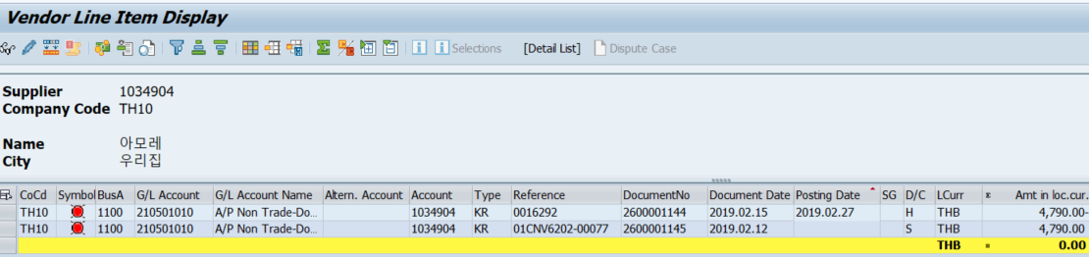
  - Enter header information (Electric/Evidence/Document Type/Company Code/Call/Document Header Text) and click the "Choose open item" button.
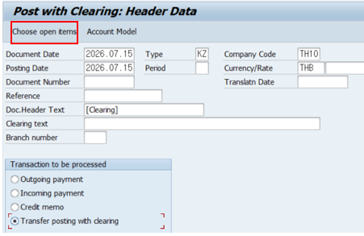

2.3 Enter the Vendor account and Account type(‘K’) and Click the "Process Open items" button.
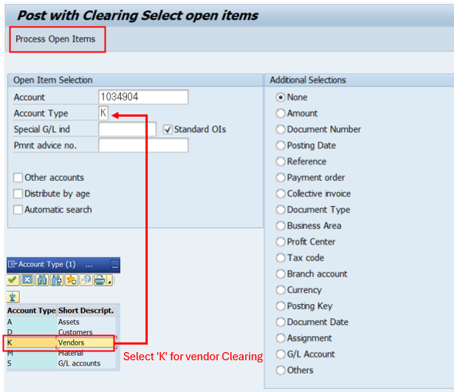

2.4 Double-click the amount of the documents number to be cleared and Click the "Save" button.
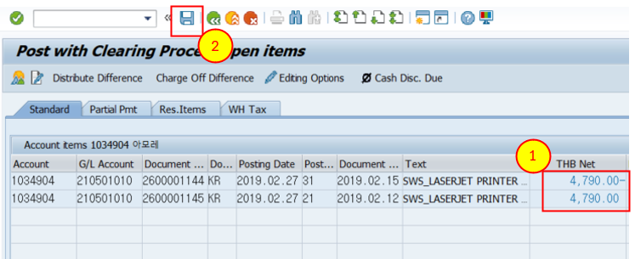
- How to make the Custormer open items clearing
  - The Documents 4200003000,9179574572, 9180288111of the Customer 52000078, , Company code 5200 are clearing in FB05. (See FBL5N for 3 open items.)
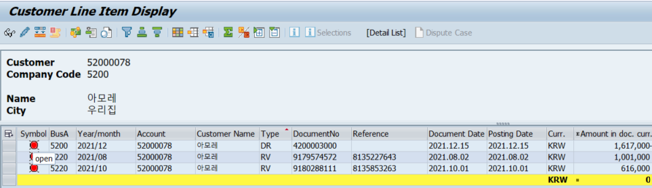
  - Enter header information (Electric/Evidence/Document Type/Company Code/Call/Document Header Text) and click the "Choose open item" button
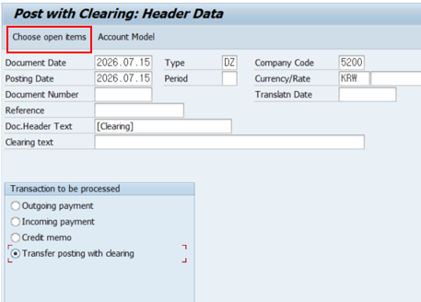

3.3 Enter the Customer account and Account type(‘D’) and Click the "Process Open items" button.
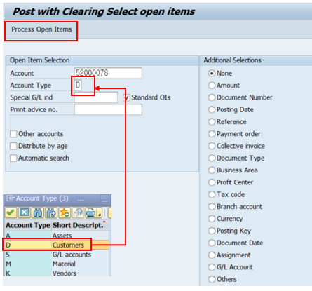

3.4 Double-click the amount of the documents number to be cleared and Click the "Save" button.
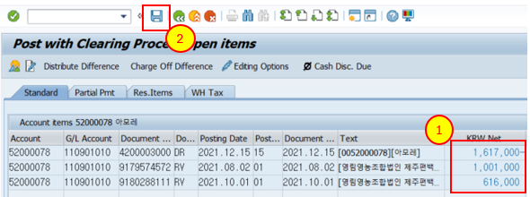
- How to make the G/L open items clearing
  - The Documents 6300002800, 6300002801of the G/L 110105030, Company code 1300 are clearing in FB05. (See FBL3N for 2 open items.)
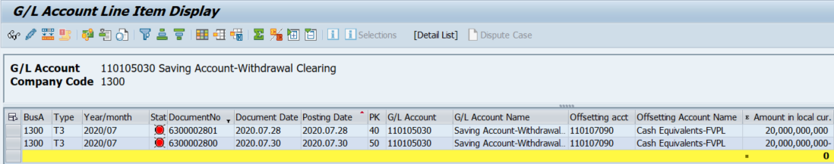
  - Enter header information (Electric/Evidence/Document Type/Company Code/Call/Document Header Text) and click the "Choose open item" button
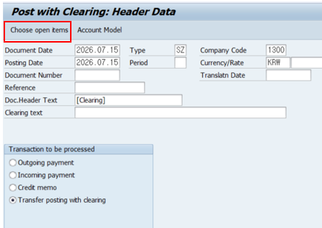

4.3 Enter the G/L account and Account type(‘S’) and Click the "Process Open items" button.
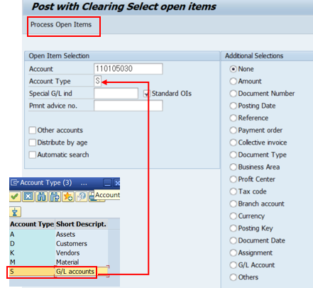

4.4 Double-click the amount of the documents number to be cleared and Click the "Save" button.
