SD_How to check the cause of the Listing/Exclusion error when registering a sales order (SO)
- T-Code/Function/Menu
Applications | Menu/Function/T-Code Name | explanation
SAP-SD | VB01/VB02/VB03 | Create/Change/Display

Executives and execution Status
  - Error situation
    - Situations where an order-to-create order is caused by an Listing/Exclusion error and the order cannot be created
    - When creating a sales order (SO), an error related to Listing/Exclusion occurred, and the order cannot be registered.
  - Inquiry Keywords
    - When creating a sales order (SO), "Customer is not Defined for Listing " An error occurs and the order cannot be created.
    - When creating an order "Customer can't create order about Material listing group " An error occurs and the order cannot be created.
    - When registering a sales order (SO), an error occurs that says, “The order cannot be create because the material is not allowed for the customer.
    - When registering a job, an error will occur saying, “The material is not allowed to customer, so the order cannot be create"

How to Resolve Listing/Exclusion Error
  - In order to create a sales order, the brand group of the material corresponding to the customer's Listing group must be defined. In the case of the domestic corporation, you should contact the Demand Planning Team (DSP Team) to register the Listing/Exclusion master that matches the customer's Listing group.
  - In the case of overseas subsidiaries, please contact IT Helpdesk > General Inquiry > SAP-SD and after receiving guidance from the SAP operations team, proceed with the registration.

How to check your Listing/Exclusion settings
The Listing/Exclusion settings can be found in the transaction code VB03, and both allowed types ZL00 and ZL01 must be registered before ordering can be placed.
  - Acceptance Type ZL00: Material Listing Group/Customer Listing Group is checked as follows:
    - In the transaction code VB03, input ZL00 and press Enter.
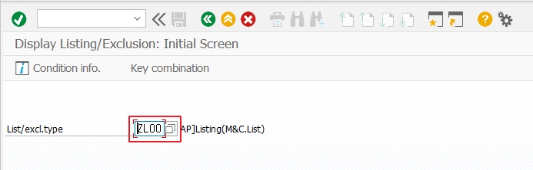
    - Enter the sales organization and Listing group, and then enter.
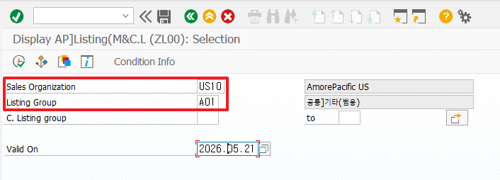
      - The material Listing group checks and enters the value entered in view 2 of the sales organization in the transaction code MM03.
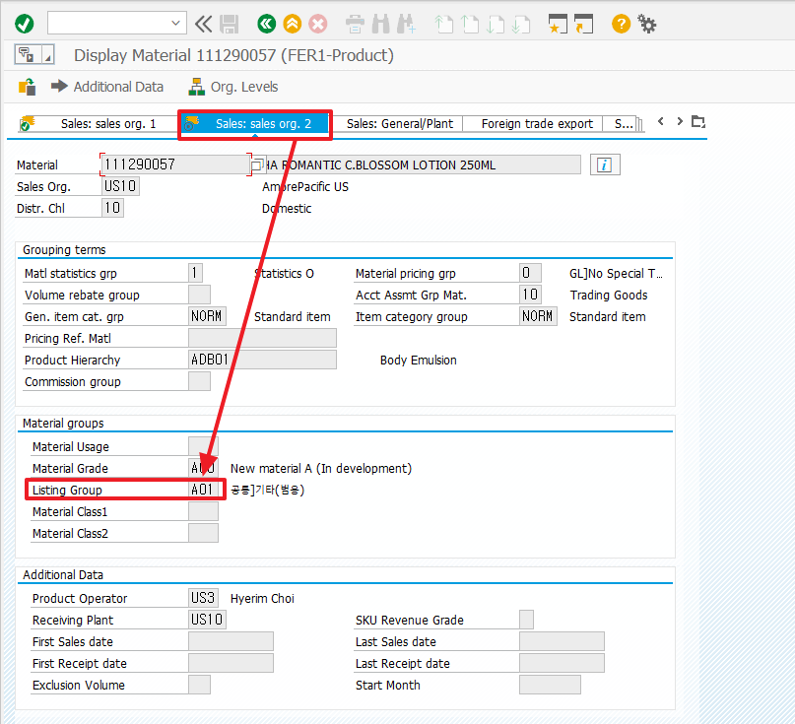
    - Check the results of the Listing/Exclusion query to see if the customer listing group in the material listing group is registered.
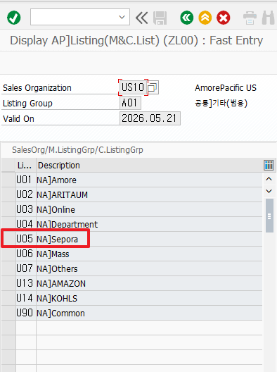

      - To check the customer listing group, check the value in the Additional Information tab in Transaction Code XD03 . Make sure that customer listing group exists on the screen viewed above. If it does not exist, in the case of a domestic corporation, you must request registration with the DSP team (demand planning team) or the material operator of the brand.

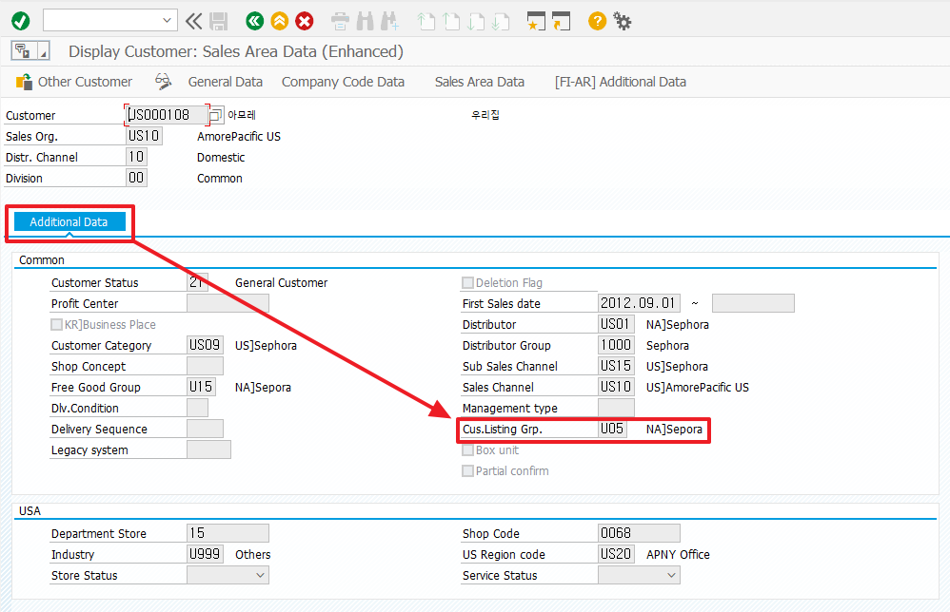

  - Listing/Exclusion Type ZL01: Sales Organization/Brand Code/Customer Listing Group is confirmed as follows.

    - In the transaction code VB03, enter ZL01 and Enter.
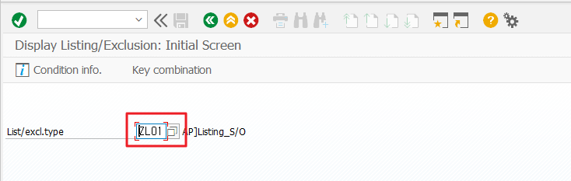
    - In the pop-up window, select Sales Organization/Brand code/Customer Listing Group
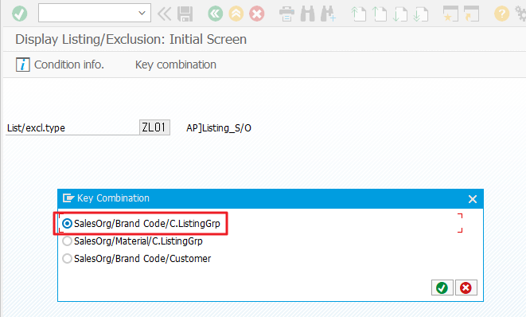

    - Enter the sales organization and brand code and press the execute button.
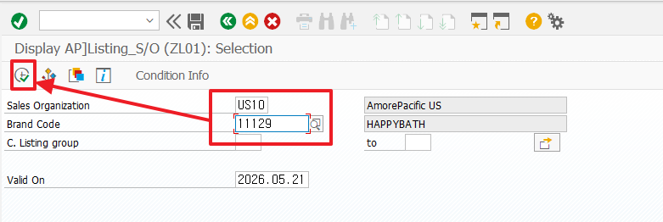
      - The brand code can be found in view 1 of the basic data in the transaction code MM03.
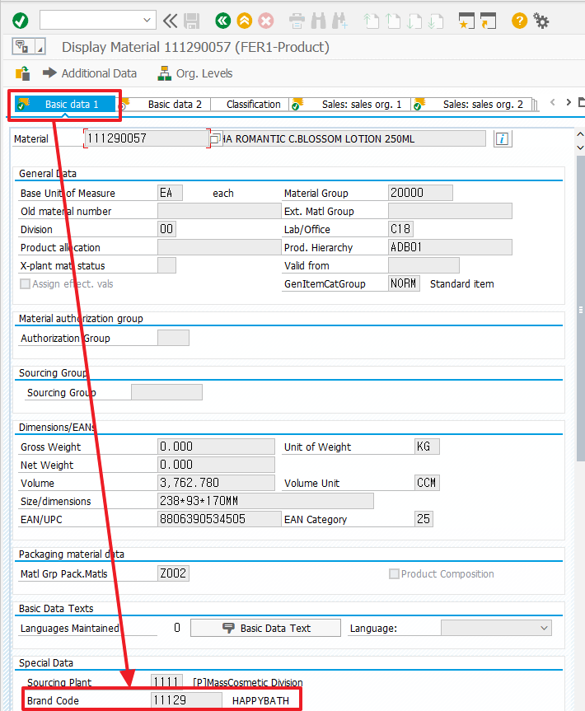
    - Check the results of the exclusion lookup to see if the customer listing group is registered within the brand code.
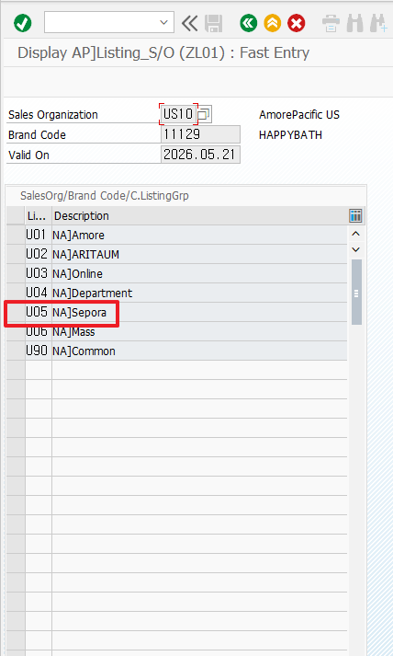
      - To check the customer listing group, check the value in the Additional Information tab in Transaction Code XD03. Make sure that the customer listing group exists on the Screen viewed above. If it does not exist, in the case of a domestic corporation, you must request registration with the DSP team (demand planning team) or the material operator of the brand.

