BW/BI – Analysis Office - How to resolve authorization errors when viewing queries in Analysis Office for BW
- T-Code/ Function/Menu
Application | Menu/Func./Tcode | Description
SAP-BW | Analysis Office | BW A-Office reporting tool
- Executor & Inquiry Details
  - Executor: A user who wants to check the permissions they have.
  - Inquiry Details: When a 'no authorization' error message occurs and the user wants to check their permissions.
  - Inquiry Type:
    - How can I check the list of permissions I have?
    - What should I do when a 'User does not have authorization' or ‘You do not have sufficient authorization’ error occurs?
    - I received the authorization approval email after applying for BW/BI access, but I am still experiencing authorization issues.
- How to check authorization for BW.
  - Click [Analysis] > [Prompts] button at your BI file. If you get prompt display, you have authority for report access. In this case, you need to check company code, sales organization condition in your prompt.
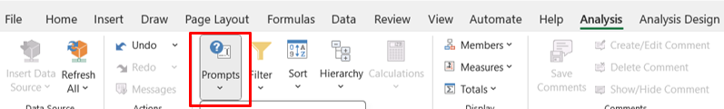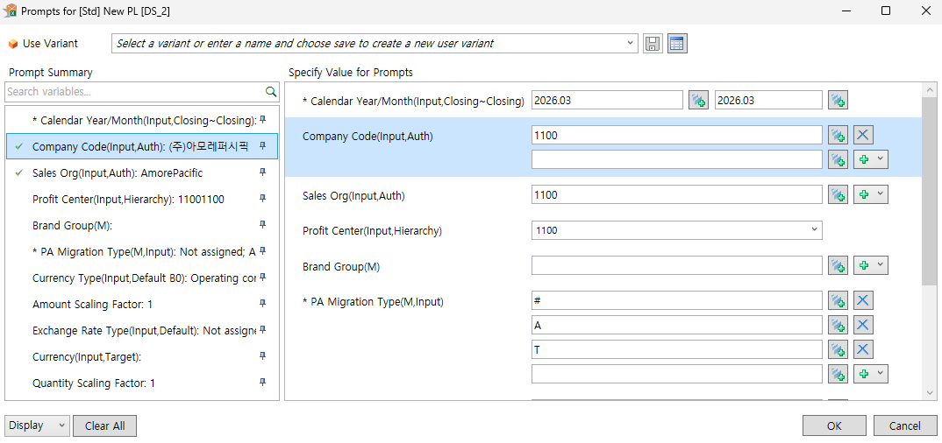
  - Check “Company Code” condition in your prompt. You can find your own authorities by clicking + button on right side (Show Value Help). By referring to this information, please remove company code which you do not have permission. *You can get authority problem when any value is not entered. Because system checks all company code authorities when this condition is empty.
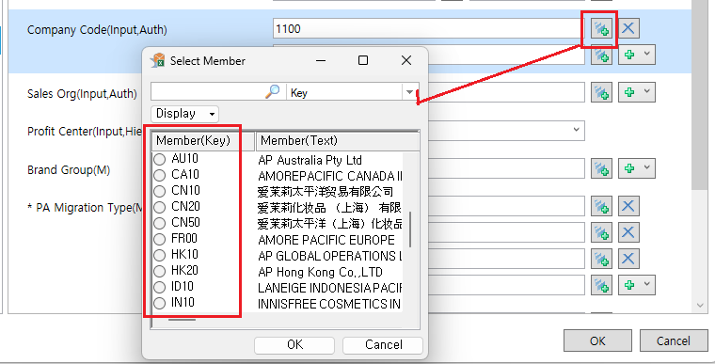
  - Check “Sales Org” condition in your prompt. You can find your own authorities by clicking + button on right side (Show Value Help). By referring to this information, please remove sales organization code which you do not have permission. *You can get authority problem when any value is not entered. Because system checks all sales organization authorities when this condition is empty.
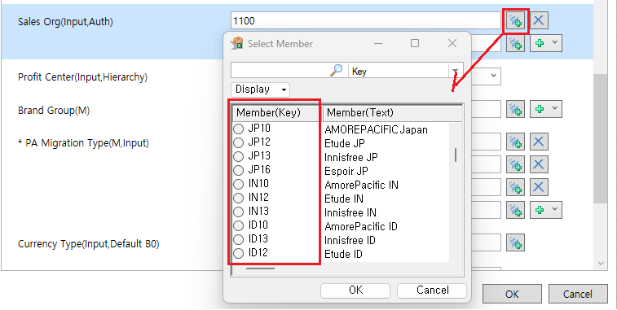
  - You can add multiple values at once by using "Add Lines Using Filter By Member" button.
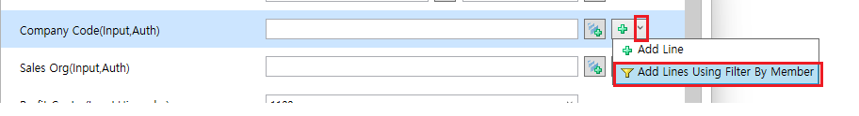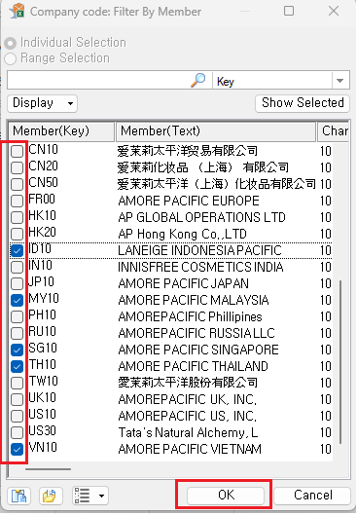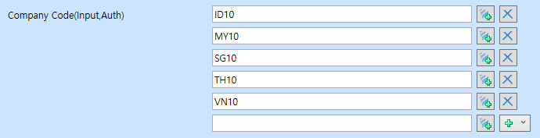
  - If you need to add BI authorities, please go to AP-ON > IAM system > change SAP-BI authority menu. Check all authority options that you need. (Corporation, Special authorities). And please confirm “Period of use” condition in special authority. You can access special authorities during this period only. It can be extended for 1 year from start date.
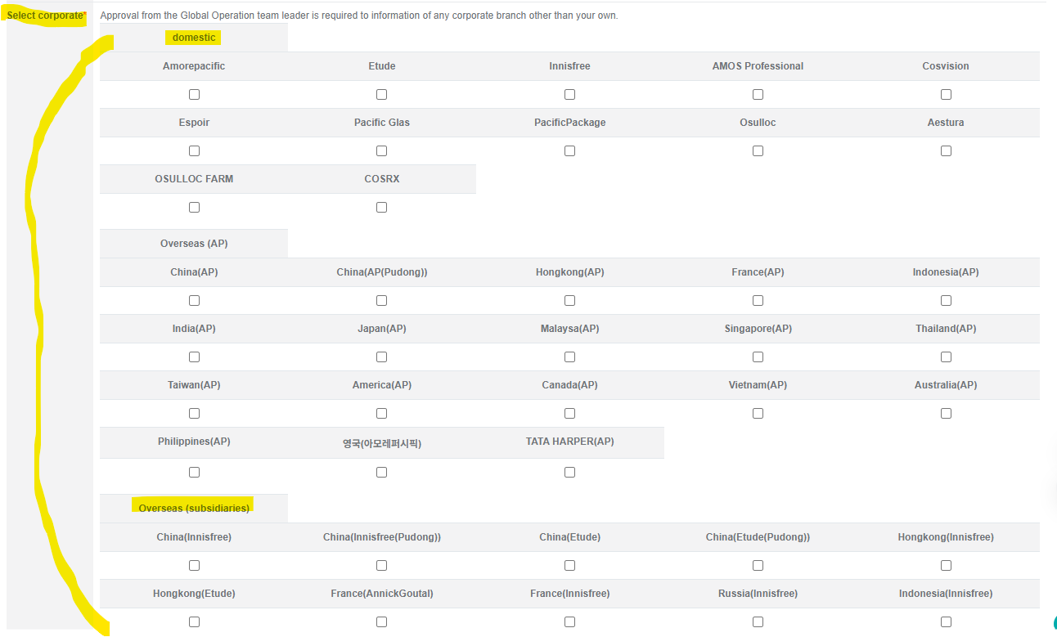
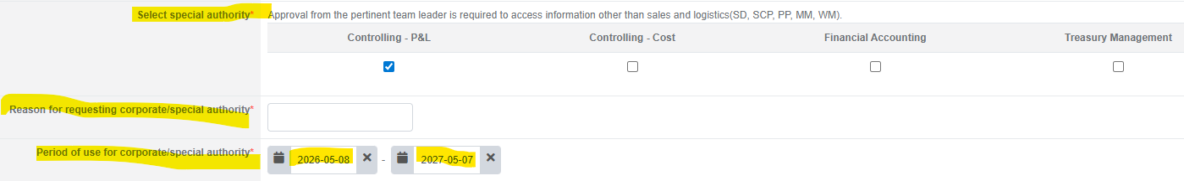
  - Submit the request. you don’t need to modify approval stage manually.
  - IAM system assigns secondary approval line automatically after 1st line approval. After all approval stage is completed, SAP-BI authority will be updated.

