
AMOREPACIFIC

Sales & Distribution (SD) User Manual

[03.03.03.80 Return Order Management-FOC]

T-Code/Functions/Menu
Application | T-Code/Functions/Menu | Description
SAP-SD | ZSD10130 | Check GI Data of FOC return item
SAP-SD | ZSD10130 | Create FOC return order
SAP-SD | ZSD10110 | Display FOC approval request status

Check GI date of FOC return item (SAP)

Check GI date of FOC return item –ZSD10130
Description | Check the GI date of FOC stock to return and check if the order and billing  are processed within 7 days after GI.
Menu Path
System | SAP R3

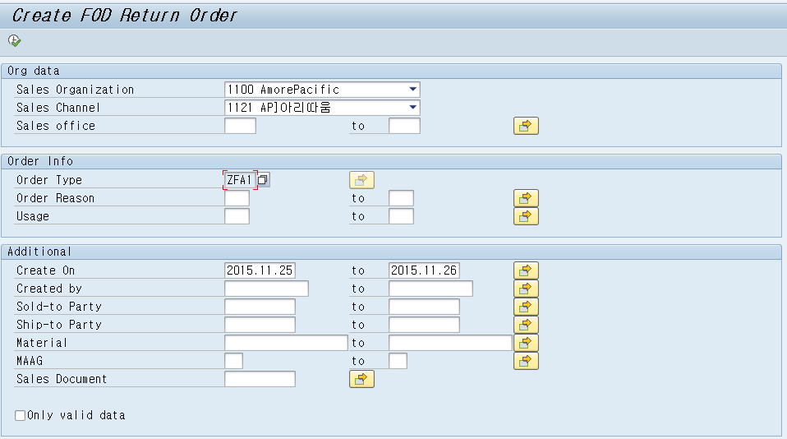


[Display FOC return item]
FOC return is a process of displaying FOC orders already created and registering a return for items subject to FOC return.Items subject to FOC return are limited to GI for event and not promotional products delivered to each customer. (In the cases of Korea, Return is possible only for FOC order reasons F0A - F0J and impossible forF01 - F07.)

1

2

3

4
① Enter the organization information for FOC return item display/order creation. (Sold-to party information when registering FOC order)
When the sold-to party is an internal organization such as the HR team, PR team, TM team, select ‘1190 AP] Others’ for Sales Channel.
② Select the FOC return order type/order reason. The order type is set as ZFA1 as a default since return is processed by displaying existing FOC orders.
③ You can display items subject to FOC return with additional conditions such as Create On,
Created by, Sold-to Party, etc. of the existing FOC order.
④ Only valid data: You can proceed with FOC return only when1) FOC order is F0A - F0J, 2) and it’s within 7 days after GI. 3) It is limited to documents for which billing is completed.So when you click [Only valid data], you can display only items with possible FOC return which
satisfy these 3 conditions.
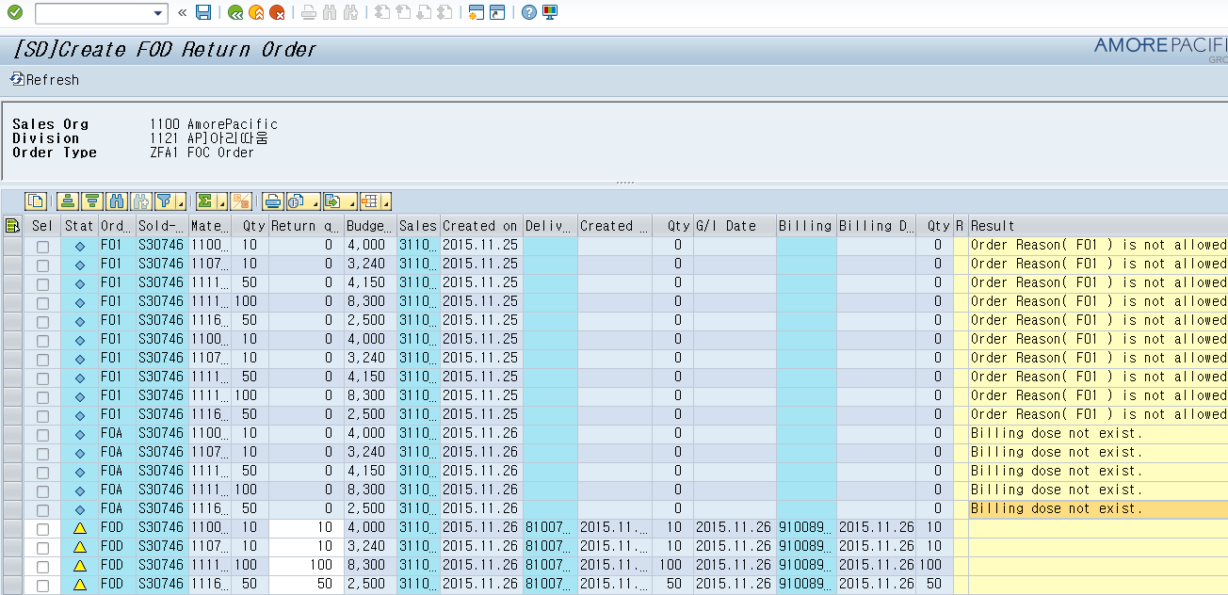




[Execution Screen 1]Check GI date of items subject to FOC return.

1 3

4

2

You can display FOC order details already created to register FOC return.
① You can register FOC return orders if the status is . If the status is , it means that the FOC return order is already created. (Return document number exists.)
※ If the status is , you cannot register return order since it doesn’t correspond to FOC return conditions.
② In the cases of Korea, You can register FOC return only when FOC order reason is F0A - F0J. (It is activated only in case of F0A - F0J.)
③ The return is possible only when GI date is within 7 days from the FOC return registration date.
④ The return is impossible for FOC for which billing is not completed.

Create FOC return order (SAP)

Create FOC return order –ZSD10130
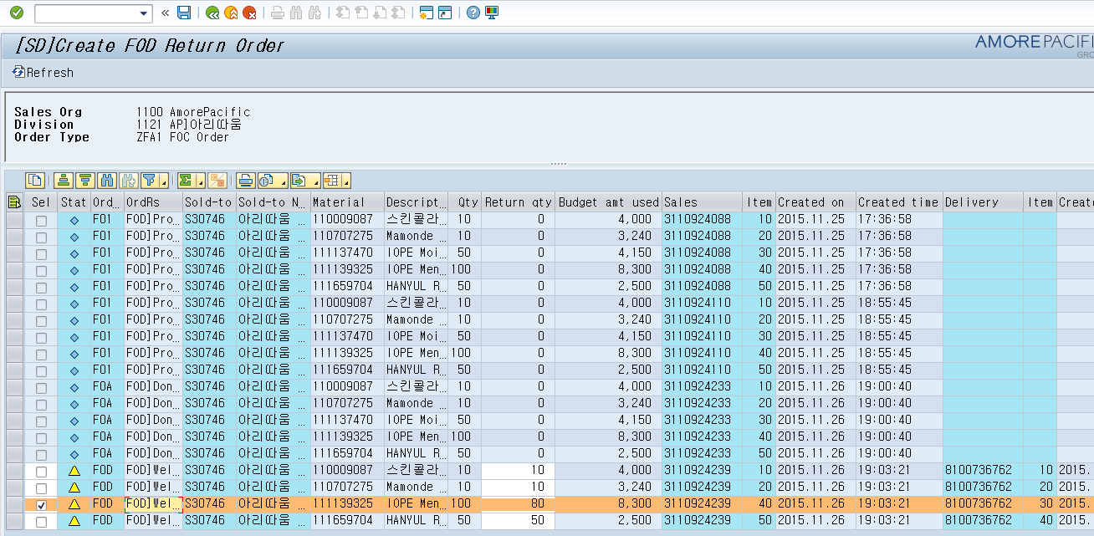


3

1
2
① Enter the return quantity of items subject to FOC return.
(You can enter the quantity different from that of original order.)
② Select the target line to process FOC return.
(When selected, it is automatically marked in color.)
※ For orders of which FOC return is possible, the field is activated so that it can be selected.
③ Execute [Save] to create FOC return order.

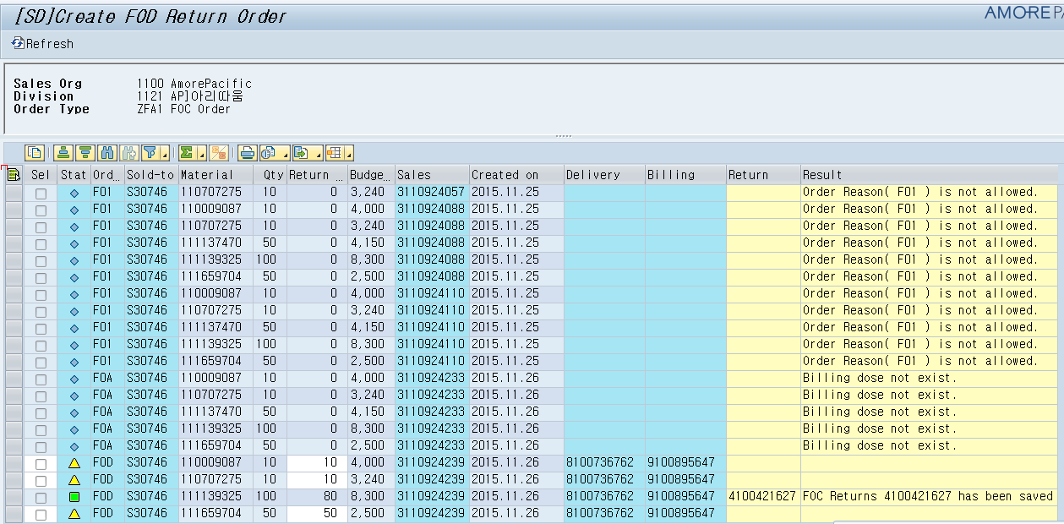
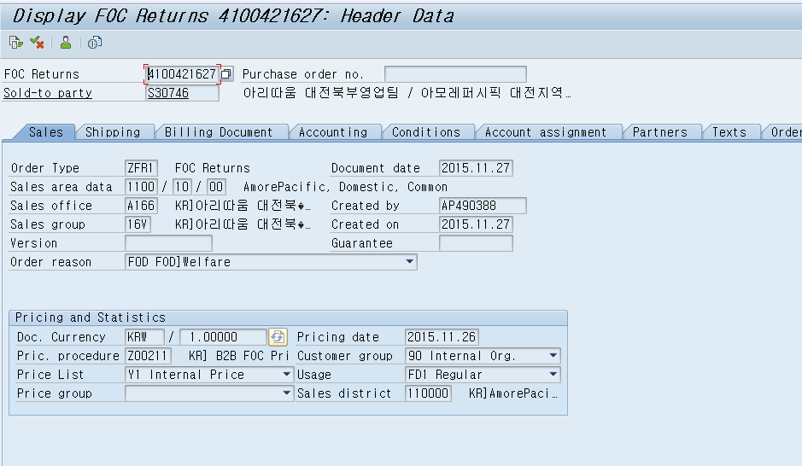
[Execution Screen 1]FOC return order is created.

1
① When FOC return order is completed, return document is created, a message is displayed and then the status is changed to .
[Result Screen] Display FOC return order document.

When displaying FOC return document, you can check that the order type ZFR1 (FOC Order-Return) is applied. (The same order reason as original order is applied.)

Request FOC return approval (SAP)
Description | Display the registered detail after registering FOC return to request  approval. After the approval, DN for FOC return can be created.
Menu Path
System | SAP R3

Display FOC approval due list& request –ZSD10060
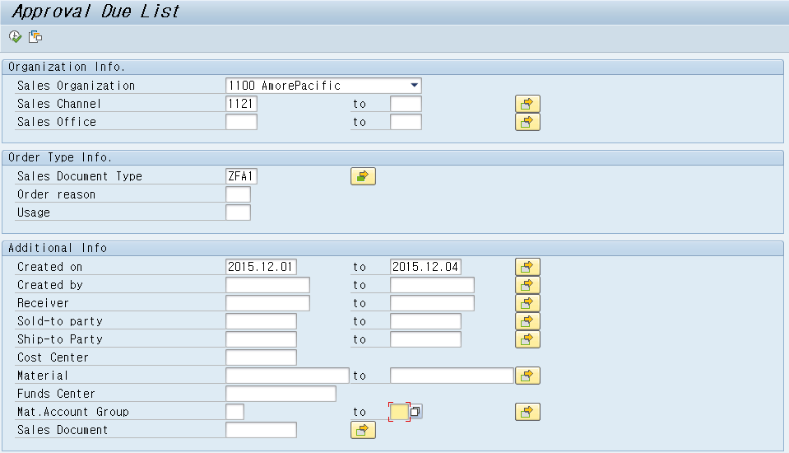

1

2

Proceed with a request for FOC return approval by using the same program as FOC order approval program (ZSD10060).
Consultation approval must be completed for the created FOC return order to create return GI order.
① Enter the organization and order type information.
You can select FOC (ZFA1, ZFA2) or FOC return (ZFR1, ZFR2) for Order Type and all FOC order types are set as a default.
②You can display approval due list by entering additional information such as Created

on, Created by, Sold-to party, etc.
[Execution Screen] Display FOC return approval due list.
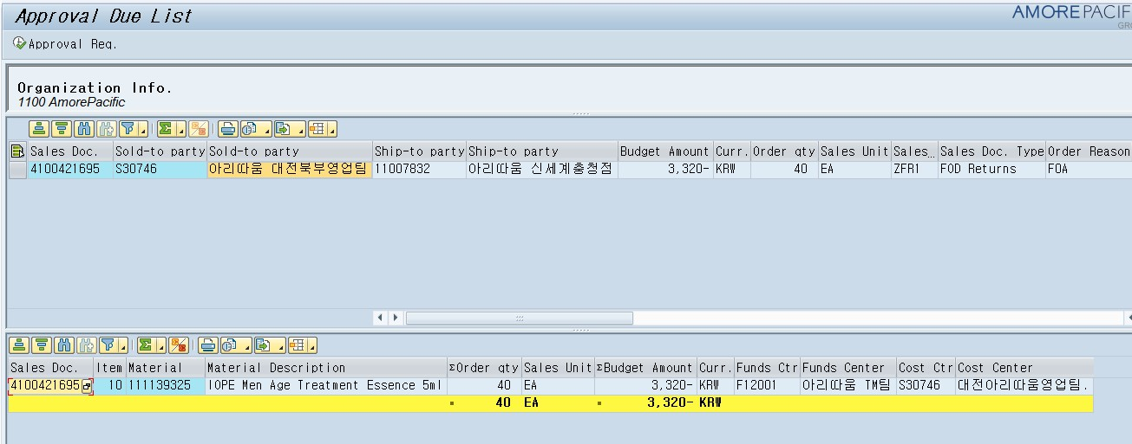
2

1

The details of registered FOC return are displayed. You can check that the order type is created as ZFR1 (FOC Order-Return).
① Select the FOC return details to request approval.
② Execute [Approval Req.] to request approval. When requesting approval, the corresponding detail is linked to AP-ON and the process of requesting approval is carried out.
※ Double click the FOC return details and the detailed information is displayed below.
[Execution Screen] Request FOC return approval.

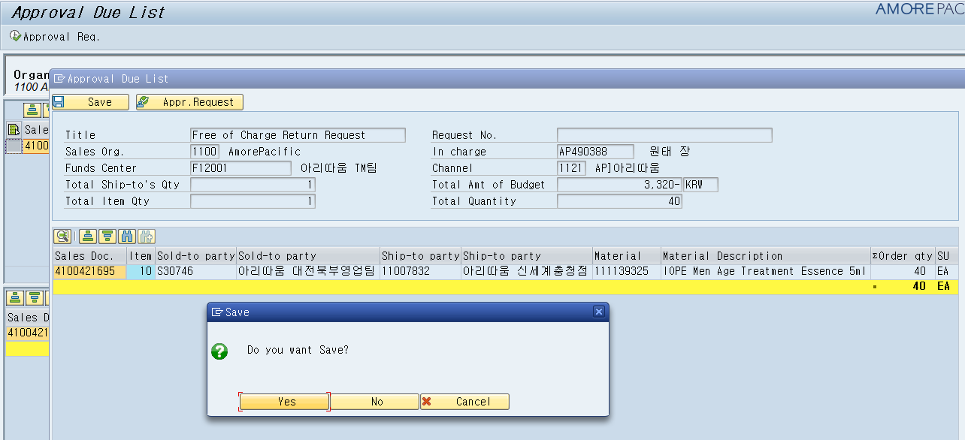

1

① In this screen, the corresponding details are displayed and you should create the approval request number by executing [Save].
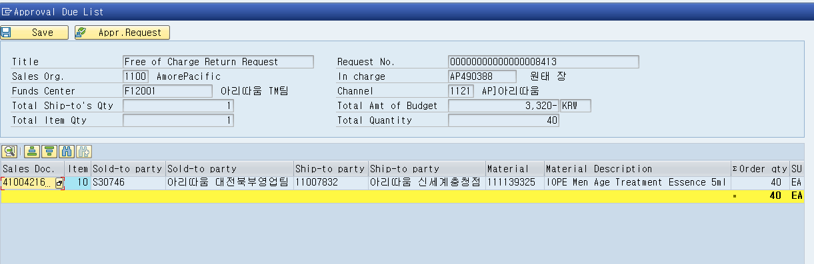

2
1

① When executing [Save], the approval request number is created.
② When the approval request number is created, execute [Request Approval]. When [Request Approval] is executed, it is linked to AP-ON to get the approval of decision-maker.

Approve FOC return(AP-ON)

AP-ON approval
Description | The decision-maker gives the approval for FOC return approval request via AP-ON. When the approval is completed, the status of the corresponding  FOC return order is changed to DN possible status.
System | SAP R3

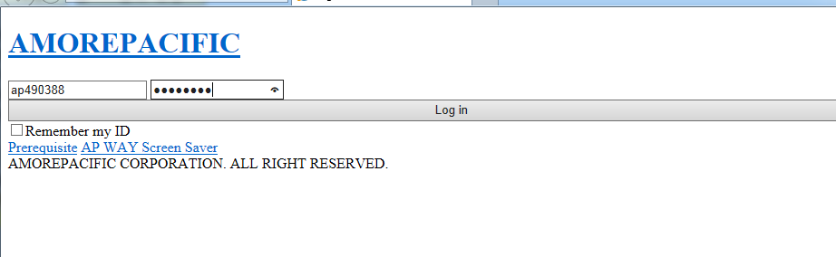
[FOC approval request] AP-ON login

1

When requesting approval for FOC order/FOC return order, AP-ON logon screen is linked.
① Enter the AP-ON employee number and password of the approval requester.
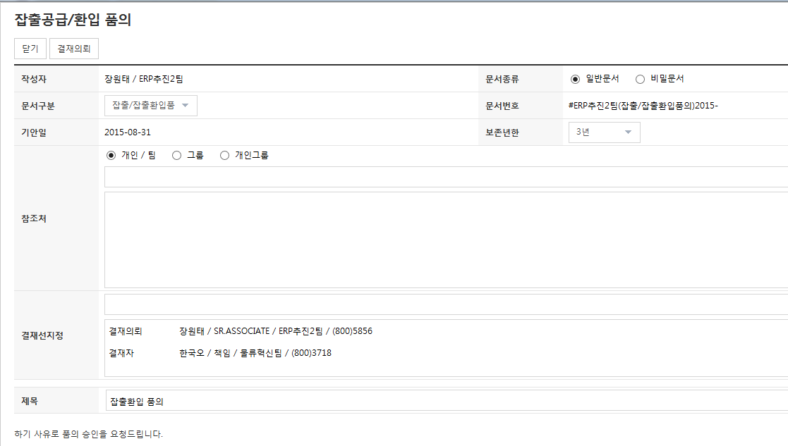
[FOC approval request] Approval line designation

1

Designate the approval line for approval (team manager in charge) and escalate an approval (request approval).

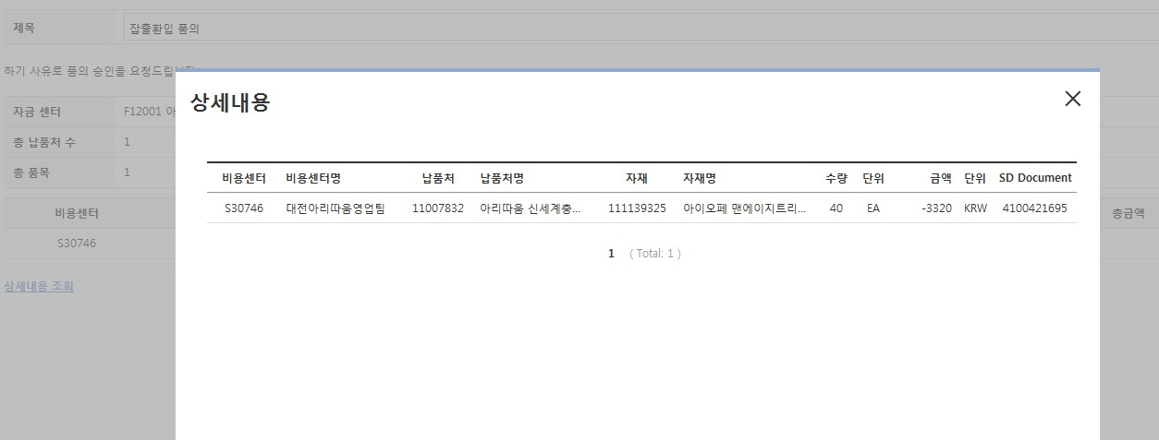
[Approval request display in detail]

You can check the detail by clicking Details.

Display FOC approval request status– ZSD10110
Description | You can display the progress status of approval request for FOC or FOC  return order. When approved, it is changed to DN possible status.
System | SAP R3
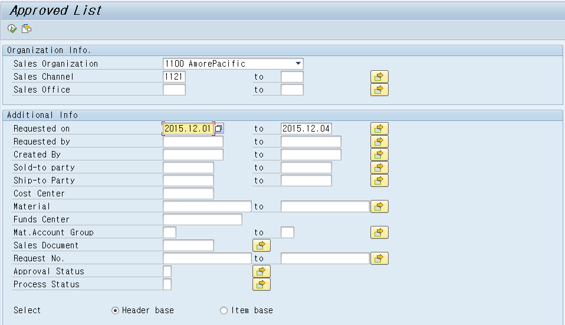
[FOC approval request status display]

You can display the approval status by entering the information such as Sales Organization, Created on, Created by, etc.

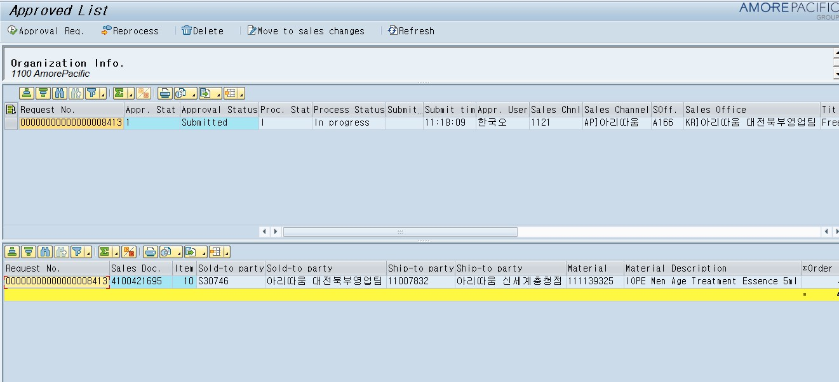
[Execution Screen] Display FOC approval status.

1

2

You can check the approval status and order type, etc. for FOC order/FOC return order.
Double-click the relevant approval request and check the order details below.
[Approval status classification]
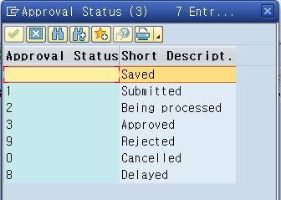
The classification is as follows according to the FOC approval status.
- Saved: The request for approval of FOC (FOC return) is saved and the request number is created.
- Submitted: The user escalated an approval (approval request) via AP-ON
- Being processed: The approval request is in progress. (Decision-maker is giving approval.)
- Approved: The approval is completed by the approver – DN possible status

Request budget restoration (sales promotion expenses) (manual)
Description | Check that the FOC return process such as logistic inspection and billing is completed for FOC return order and request restoration of the budget/sales promotion expenses. (Request to the Planning Team.)  *You can check it by steps through ‘Create FOC return order (ZSD10130)’ or  ‘Display order progress status (ZSD1003)’.
System | Manual

