SAP Sales and Distribution - What price is used for FOC budget?

T-Code/Function/Menu
Applications | Menu/Function/T-Code Name | explanation
SAP-SD | MM60 | Materials List
- Executives and execution status
  - Executives – Sales or support department that handles FOC order registration and management
  - execution status – After registering FOC orders, it is necessary to check the amount spent against the budget
  - Inquiry Keywords
    - "What price is used for FOC budget?"
    - " On what basis is the FOC expense amount spent? "
    - " I want to check the cost information of the materials. Where can I find it? "
- The solution
  - When creating an FOC order, the budget is reflected based on cost rather than the material's internal Y1 price.
  - To check the material's cost, you can use transaction code MM60.
  - Go to transaction code MM60 to check material cost information
(The FOC amount unit price is not Y1 price. It’s the cost amount.)
Input the material code and execute
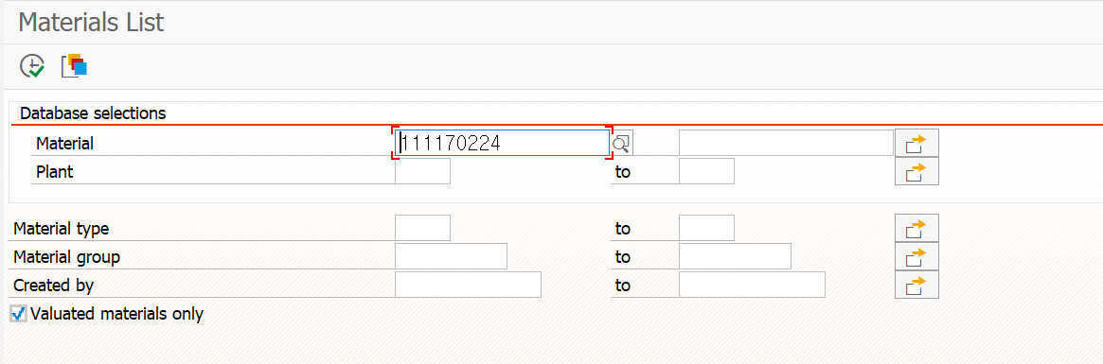
  - You can check the cost information using Transaction code MM60.
  - The FOC budget amount can be used within the cost basis, and the price seen in MM60 is the cost.
