SAP Sales and Distribution, MB52 screen format changed to ALV GRID.
- T-Code/Function/Menu
Applications | Menu/Function/T-Code Name | explanation
SAP-SD | MB52 | Current Warehouse Inventory List
- Executives and execution status
  - Executives – Person responsible for performing inventory inquiries using the MB52 transaction code
  - execution status – When checking inventory using the MB52 transaction code, the data is displayed in a text-based format rather than the ALV GRID screen. Therefore, User want to change the output on the MB52 transaction screen to a hierarchical representation.
  - Inquiry keywords
    - “ How to change MB52 screen format to ALV GRID “
    - “ The stock overview output screen of MB52 looks strange.”
  - The next screen is not an ALV GRID screen, and it is difficult to dynamically adjust data analysis.
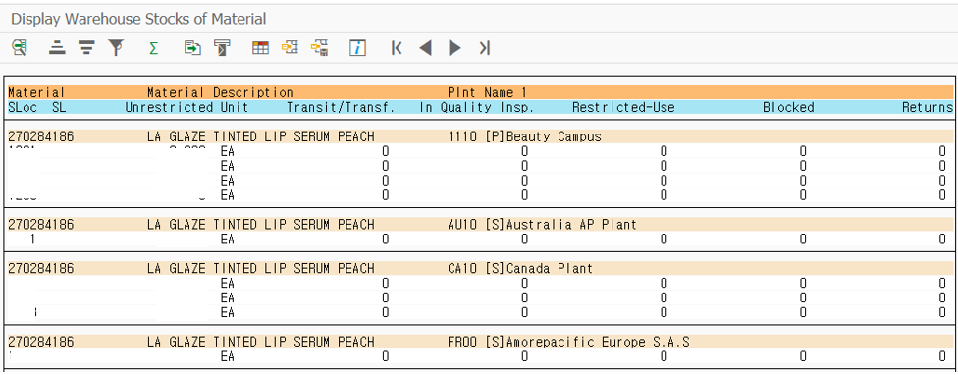

- The solution
  - T-code : MB52- Display Warehouse Stocks of Material
  - Perform the following steps to switch to the ALV screen.
  - Select Non-Hierarchical Representation for the radio box below and run it.

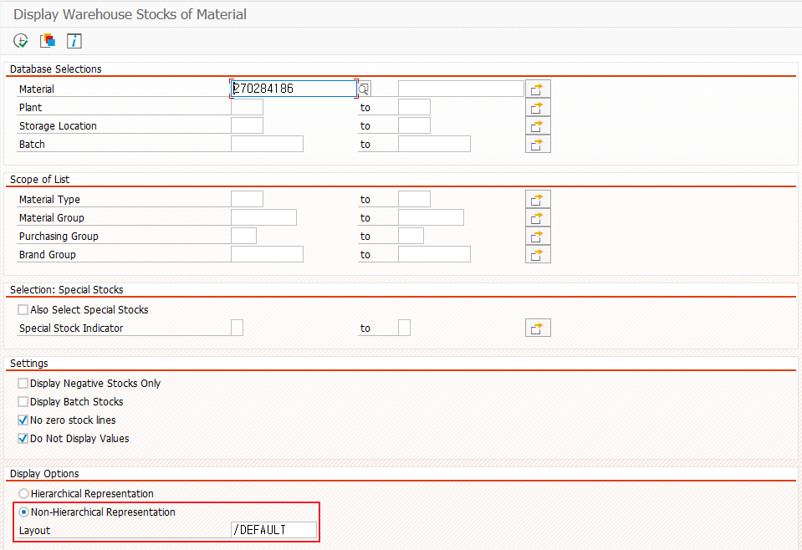
  - The inventory data is displayed on the ALV GRID screen as follows.
