SAP Sales and Distribution - How to fix error code 918 “The posting period is closed” in ZSD22180.
- T-Code/Function/Menu
Applications | Menu/Function/T-Code Name | explanation
SAP-SD | ZSD22180 | Direct sales performance I/F error inquiry
- Executives and execution status
  - Executives – Person responsible for checking data and reprocessing in case of discrepancies in sales amounts at the end of business
  - execution status – The following error occurred when creating sales order "The Posting period is closed".
- How to Fix Error Code 918 on ZSD22180
  - If the "The Posting period is closed" errors occur when processing sales order.
  - You can resolve it through reprocessing at zsd22180.
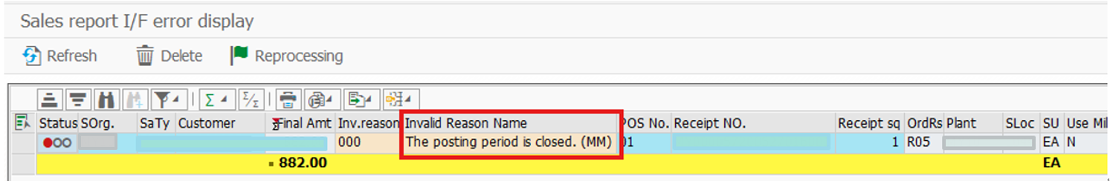
  - If the data for the current month has not yet been closed, the finance team will contact the finance team to reopen the posting period and “reprocess” it in the ZSD22180 after the finance team mistakenly closes the posting period.
  - Move to transaction code ZSD22180 and in put the Sales Organization and Sales date
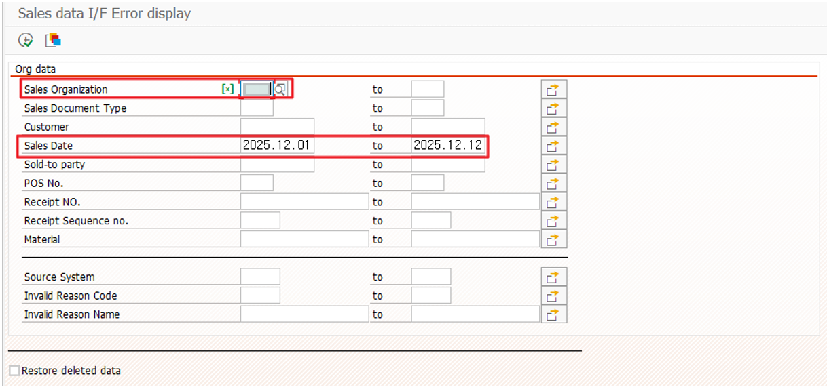
  - Once the data is display, reprocessing is performed.
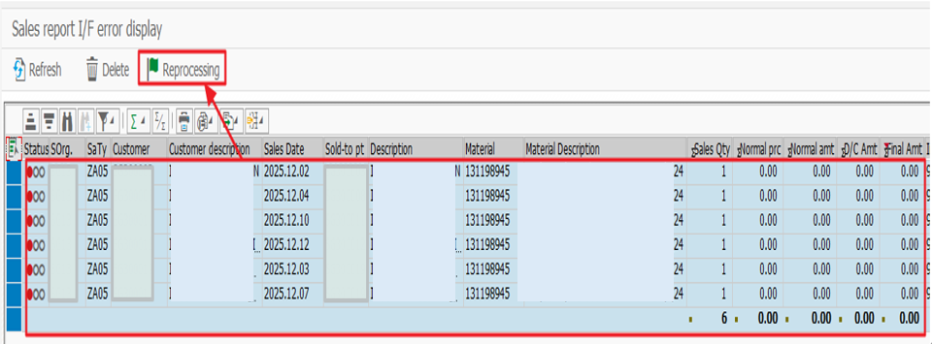

3.5 If the sale’s date is past month, it must be deleted from the ZSD22180 and then resent by changing the sale’s date (FKDAT) in the POS system.

