SAP Sales and Distribution – How to Check Sales Price(Sales condition).
- T-Code/Function/Menu
Applications | Menu/Function/T-Code Name | explanation
SAP-SD | ZSD00650 | Condition Master Display
- Executives and execution status
  - Executives – Sales or support departments that want to know about product price information
  - Inquiry Keywords
    - "I want to check the material's price information when creating a sales order."
    - "I want to know the price information for each condition type."
    - " I want to know internal price information "
    - " I want to know the consumer price of the materials "
- How to Check sales price
  - Go to transaction code ZSD00650 to check the price.
  - Input the necessary values to display list prices and channel prices.
Sales Organization/Condition Type/ Condition Table/ Valid On / Material
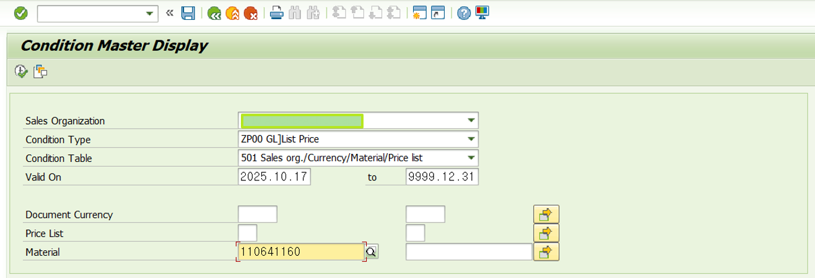
  - Checking the price information
  - You can check the sales price(sales condition) for each price list on the price on the ZSD00650.
  - PL (Y1) is Internal price and PL(Z1) is Consumer Price

