SAP Sales and Distribution - How to cancel sales order(SO).
- T-Code/Function/Menu
Applications | Menu/Function/T-Code Name | explanation
SAP-SD | ZSD10020 | Change Sales Orders
- Executives and execution status
  - Executives – A person who want to cancel Sales orders(SO)
  - execution status – A situation where you want to delete an incorrectly created Sales order(SO)
  - Inquiry Keywards
    - " I want to cancel a Sales order(SO) document. How do I cancel it?"
    - " I created a Sales order(SO) by mistake. How can I cancel it? "
    - " I want to cancel all Sales orders(SO) at once. How do I do that? "
- The solution
  - Go to transaction code ZSD10020 and search for the Sales order(SO) document you want to cancel.
  - Select the Sales order(SO) document you want to cancel.
If you need to cancel a single item, select one line, and if you need to cancel multiple items, select all the Sales order(SO)documents you want to cancel.
  - If the Sales oder(SO)document you want to cancel is selected, click the Rej.Reason button at the top of the screen to proceed with the cancellation.
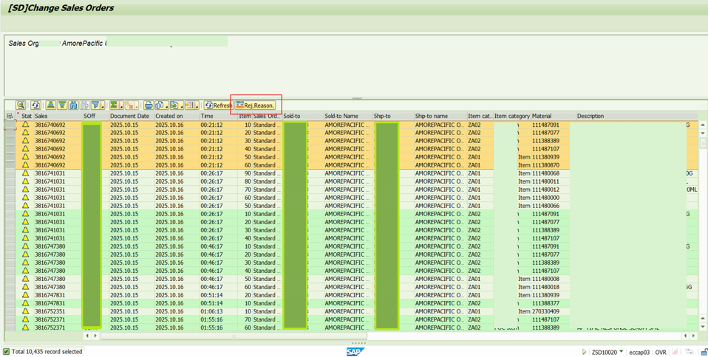
  - When the pop-up appears, select the Reject Reason to apply and confirm, and the Reject Reason will be applied to the selected line.
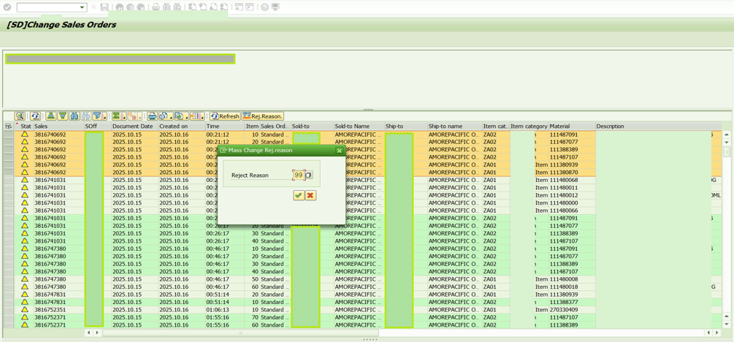
  - If you save later, the process will be canceled.

