SAP Sales and Distribution - FOC Order Approval Reprocessing Process.
- T-Code/Function/Menu
Applications | Menu/Function/T-Code Name | explanation
SAP-SD | ZSD10110 | Display approved list
- Executives and execution status
  - Executives
    - Sales staff requesting approval for FOC orders
    - Sales team in charge of creating FOC order
  - Execution status – An error occurred when approving the FOC order, requiring reprocessing
  - Error Situation
    - "Please let me know how to retry when a FOC order approval error occurs."
    - "Where do I reprocess FOC order approval?"
- Cause
  - Approval for the FOC order was requested through AP-ON, but due to an interface error, the approval status was not updated in SAP.
- Solution
  - You can move to transaction code ZSD10110 and process the approval request again.
  - Enter the information to proceed with the approval request again, then search.
Ex) sales organization, creation date, and FOC order number.
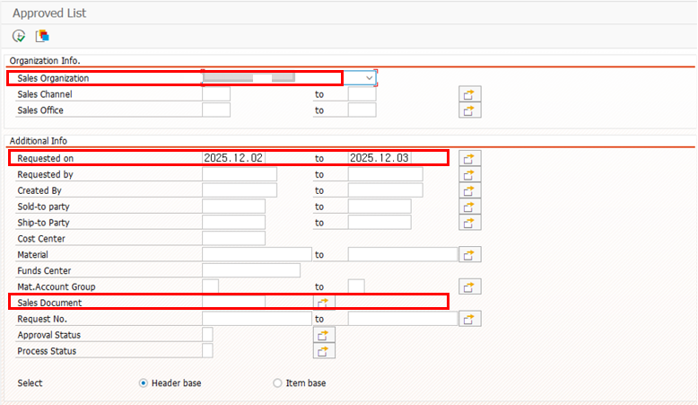
  - Select the line that requires a re-approval request and click the approval request button again to submit a re-approval request.
