SAP Sales and Distribution - Approval process after FOC creation.
- T-Code/Function/Menu
Applications | Menu/Function/T-Code Name | Explanation
SAP-SD | ZSD10060 | Display approval due list
- Executives and execution status
  - Executives
    - Sales staff requesting approval for FOC orders
    - Sales team in charge of creating FOC order
  - Execution status – After creating an FOC order, it is necessary to check the approval list and process the approval.
  - Error Situation
    - After creating an FOC order, it remains in a confirmed status and delivery does not occur.
    - "After creating an FOC order, the delivery cannot be generated. What could be the problem?"
    - "The FOC order cannot be approved after creation. It is necessary to check the approval status."
- Cause
  - After creating an FOC order, the subsequent process will not proceed unless a request for approval is made.
- Solution
  - After creating a FOC, you can initially query it in the ZSD10060 and request approval.
  - Enter the sales organization, creation date, and FOC order number, then search.
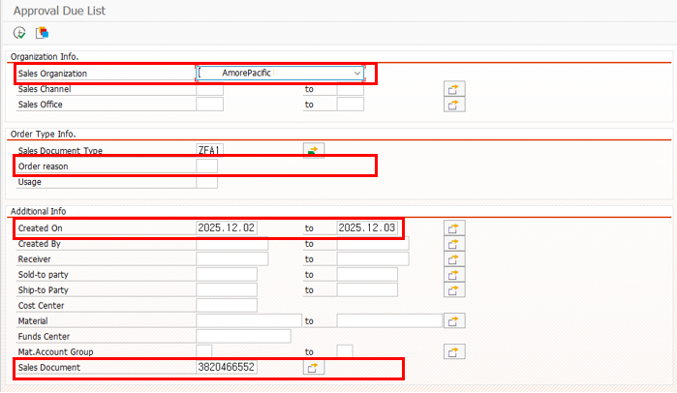
  - Based on the input value the data for FOC approval data is listed
  - Select the approval request data and click the 'Approval Req' button at the top of the screen to proceed with the approval request.
