SAP Materials Management – How to Resolve ZCM1 commission discount amount is not applied
- T-Code/Function/Menu
Applications | Menu/Function/T-Code Name | Explanation
SAP-MM | MM03 | Display Material
- Executives and execution status
  - Executives – Sales team in charge of creating Sales order(SO)
  - execution status – When the ZCM1 commission amount is missing during sales order creation, the discount is not applied
  - Inquiry keyword
    - What could be the reason that the ZCM1 discount is not being applied?
    - The ZCM1 commission discount amount is not applied after the order is created.
- Cause
  - If the volume rebate group in the material master is not maintained, the commission amount in ZCM1 will not be applied.
- Solution
  - The main reason why the ZCM1 commission discount amount is not applied is often that the volume rebate group in the material master is not maintained.
  - Move to transaction code MM03 and check if the volume rebate group is correctly registered in the Sales org. 2 view of the material master.
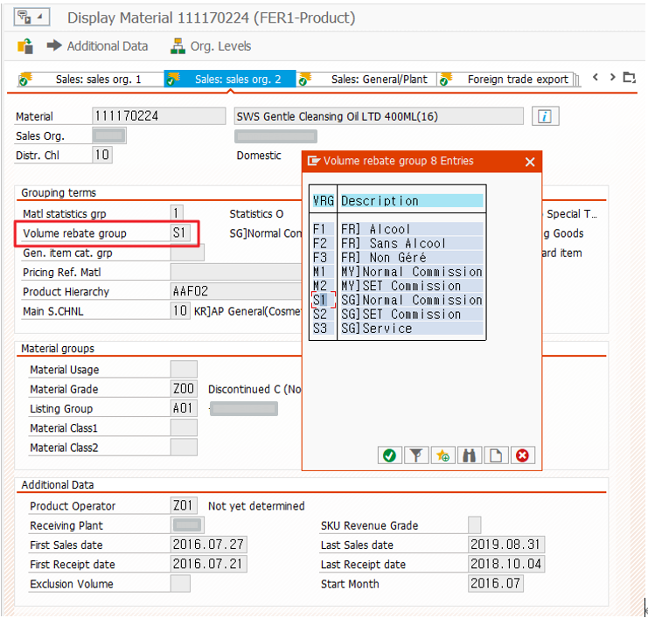
  - If the Volume rebate group has not been maintained, please contact the Material operation part.

