SAP Sales and Distribution - The meaning and process of confirm the sales type
- T-Code/Function/Menu
Applications | Menu/Function/T-Code Name | explanation
SAP-SD | XD02 | Change Customer
- Executives and execution status
  - Executives – Customer master manager or sales department representative
  - execution status – After creating a new customer master, the sales type must be confirmed in order to make sales order. If you want to know the meaning and function of the sales type, as well as the department responsible for its management
  - Inquiry Keywords
    - “May I know what it means to confirm the sales type”
    - "If the type of sales isn't confirmed, can't make sales order?"
    - "How should I determine the sales type? "
    - "What is the 'sales Type Conf.' field?"

- Definition of Sales Types and Management Department
  - When you move to transaction code XD02, you can check [FI-AR] Additional Data tab.
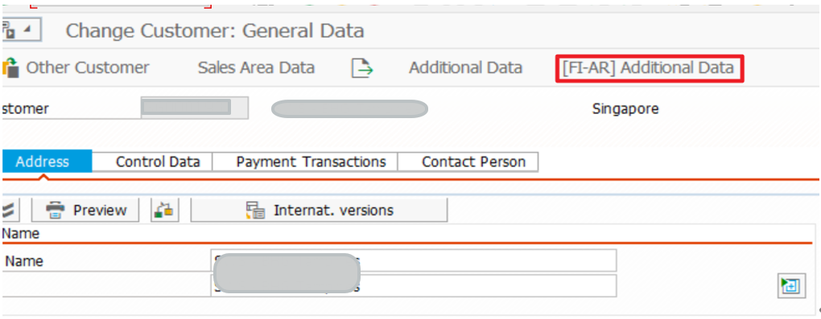
  - If you click the [FI-AR] Additional Data tab at the top of screen, you can see ‘ Sales Type Conf.’ check box.
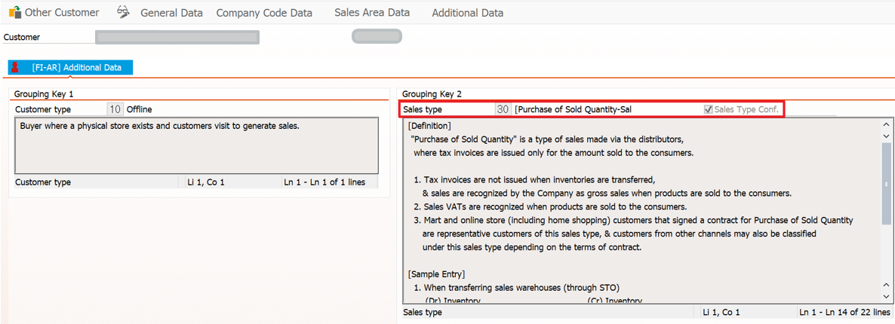
  - When creating a customer master, the sales type of that customer must be defined and confirmed. Since the sales type affects the accounting journal entries, it is necessary to set and confirm the type according to the customer's sales type. Sales orders can only be registered once the sales type has been confirmed.
  - The finance team leader final checks whether the sales type is correct.
  - If the sales type is not checked, this customer code will not be able to create a sales order.
  - To confirm the sales type for a new customer, you need to contact the relevant finance team to carry out the confirmation process.

