SAP SD - A billing document has been generated, but the sales amount is not reflected.
- T-Code/Function/Menu
Applications | Menu/Function/T-Code Name | explanation
SAP-SD | ZSD10030 | Display sales order
SAP-SD | VFX3 | List Blocked Billing Documents
- Executives and execution status
  - Executives – Person who needs to check when there is a difference by system when comparing sales amounts for closing
  - execution status – If there is a discrepancy between the sales figures in the SAP system and BW or POS, it is possible to check the cause of the difference and reprocess it.
  - Inquiry keywords
    - “The billing amount shown in the ZSD10030 and BW's sales amount are different.”
    - " There is a discrepancy between SAP and POS sales amount "
    - "A billing document has been generated, but the sales amount is not reflected "
    - " The billing document has been created, but the accounting document has not been generated. How can this be handled?"
- The cause
  - The cause is that the billing document was created but the sales slip was not generated normally, and the discrepancy occurred, which can be checked and resolved in the order below.
- The solution
  - When you display data in the ZSD10030, the POSTING field would have been displayed in red as shown below.
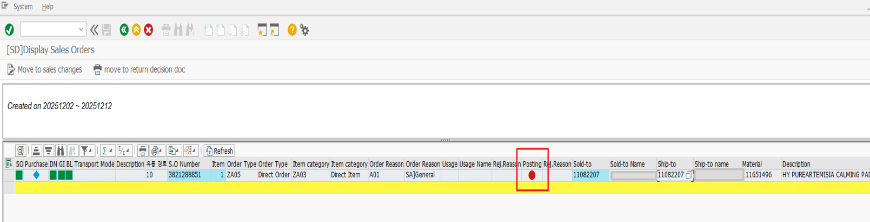
  - In this case, since the billing data has not actually been posted in the accounting system, go to transaction code VFX3.
  - Input Sales Organization, Created On and delete Created By. Select all check box of “Imcomplete Due to”.
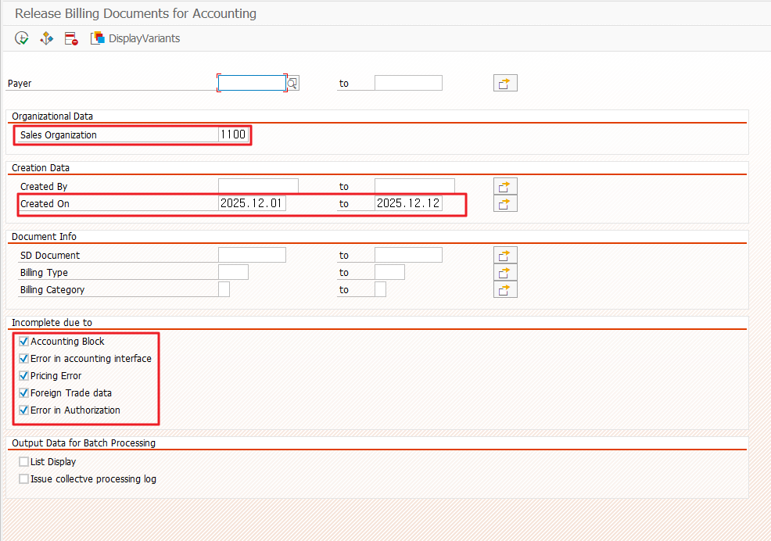
  - When the list appears, select it and click on the green flag
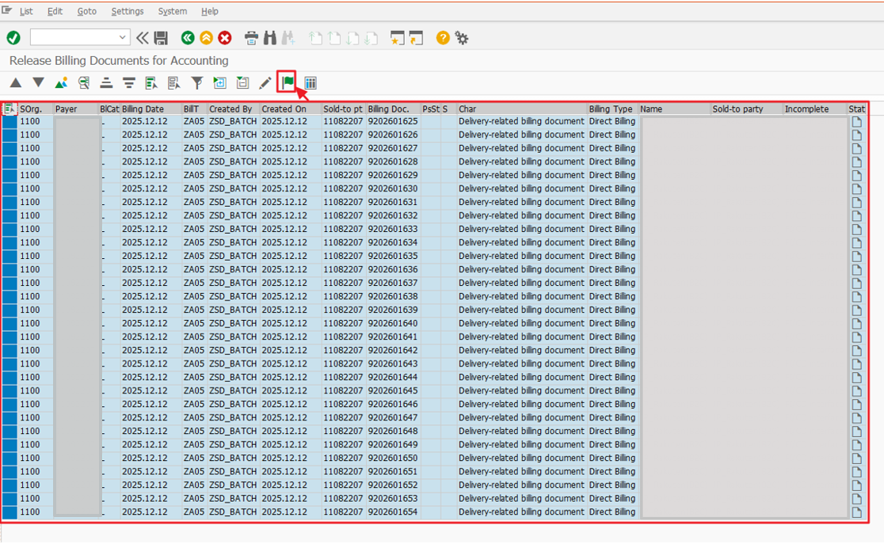
  - If the status field is green, it is normal.
  - If it is red, it means that something has occurred, and to check the error, click the square icon on the right side of the green flag.
  - You can determine the cause of the error.
  - If you don't know the cause of the error or can't solve it, register a request in the IT HELPDESK.

