BW/BI-Analysis Office-‘Requested system could not be found in logon.ini’ error
- T-Code/Function/Menu
Application | Menu/Func./T-CODE | Description
SAP BW | Analysis Office | Analysis Office
- Executor & Inquiry Details
  - Executor: Analysis Office User
  - Inquiry Details: User get ‘Requested system could not be found in logon.ini’ error when try to log-on the service.
  - Inquiry Type:
    - I can’t log-on BI/BW services with ‘Requested system could not found in ‘logon.ini’ message.
    - I can’t log-on Analysis services with ‘Requested system could not found in ‘logon.ini’ message.
- Error Message: ‘Requested system could not found in ‘logon.ini’’.
- How to adjust logon.ini setting
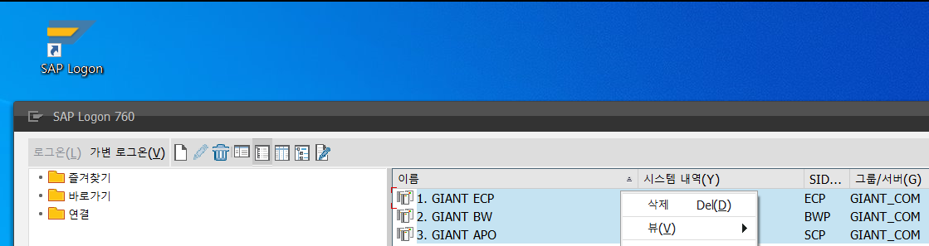
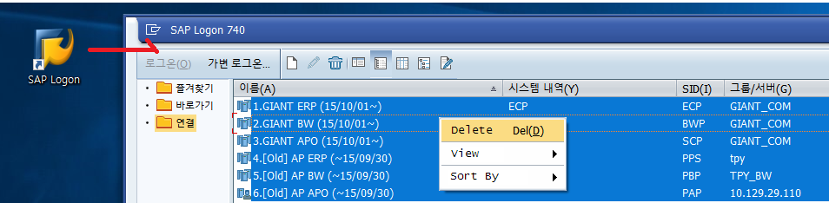
  - Execute [SAP Logon] application, and Delete all server connections.

  - Right Click on [Connections] > [Add New Entry].
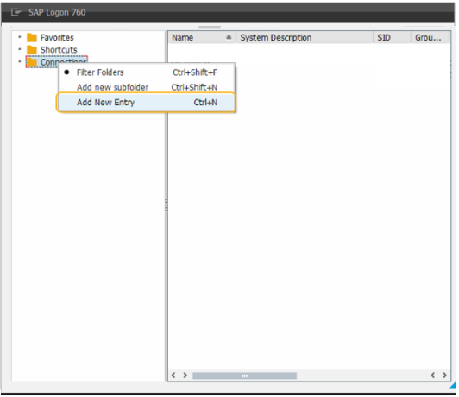
  - Select [User Specified System] > [Next].
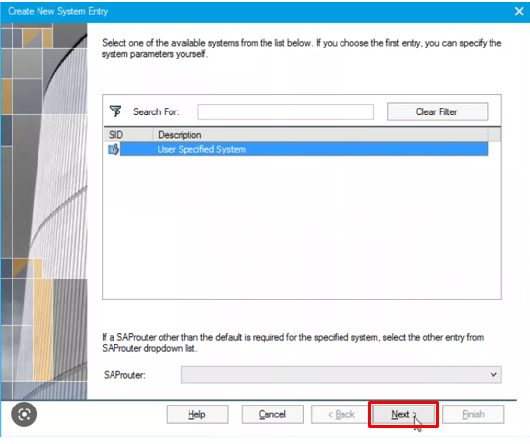

  - Change connection type as [Group/Server Selection] and Enter below information after then Click [Finish].
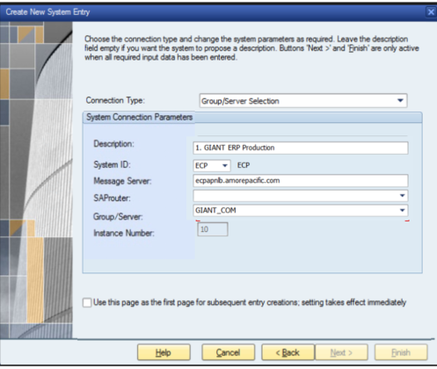
    - ERP Server (General SAP)
Description: 1. GIANT ERP (ECP)
System ID: ECP
Message Server: ecpapnlb.amorepacific.com
Group / Server: GIANT_COM
    - BW Server (Analysis Office)
Description: 2. GIANT BW (BWP)
System ID: BWP
Message Server: bwapnlb.amorepacific.com
Group / Server: GIANT_COM
    - SCP Server (Demand Planning)
Description: 1. GIANT ERP (ECP)
System ID: ECP
Message Server: ecpapnlb.amorepacific.com
Group / Server: GIANT_COM
    - EWM Server
Description: 4. GIANT EWM (EWP)
System ID: EWP
Message Server: ewpapnlb.amorepacific.com
Group / Server: GIANT_COM
  - Check whether you can access the server or not. 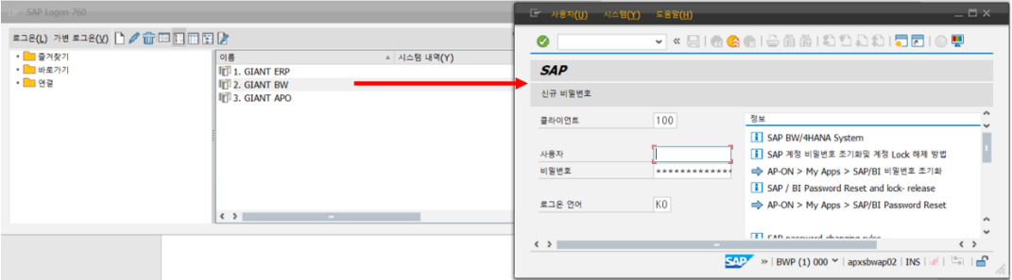
  - Try log-on the analysis office service again.
