HR_How to change the beginning date for position designation

T-Code/Function/Menu
Application | T-Code/Function/Menu | Description
SAP-HR | PA30 | Personnel master data maintenance
SAP-HR | PPOSE | view the organizational and position structure

- Scenarios
  - Inquiry Types
    - “Can you please advise me how to modify the date for a position change”
    - “How can I change an employee’s position begin date?”
    - “What is the process to update and verify an employee’s position assignment date?”
- How to Change Position begin date
  - Check the Current Status of the target Position
- Execute transaction code PPOSE.
- Double-click Structure Search.
- Double-click target Organization.
- Check the current status of the position to be changed.
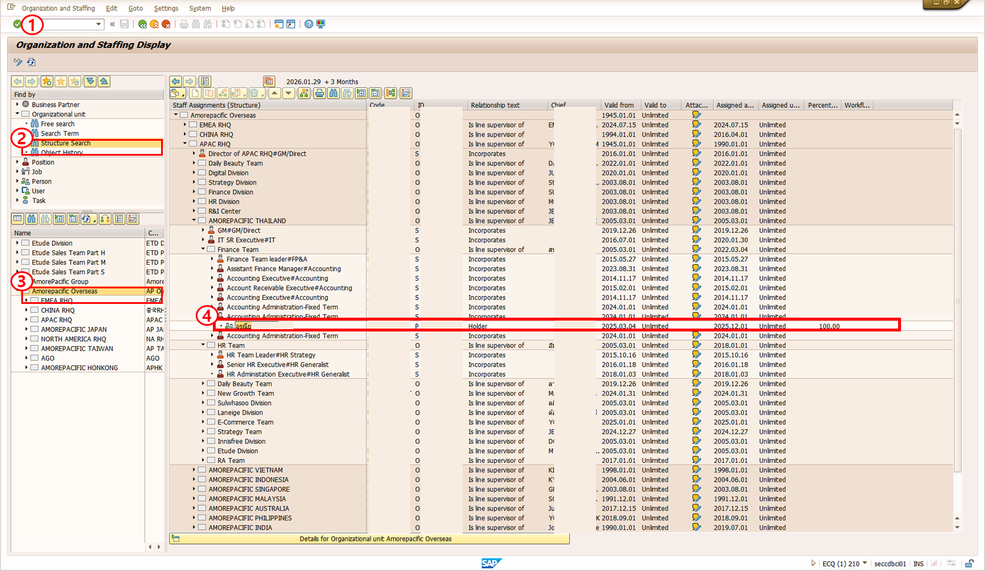
  - Navigate to the Position Holder Information Change Screen
- Execute transaction code PA30.
- Enter the employee number of the position holder to be changed.
- Select left button by 0001 – Organizational Assignment from the Infotype Text list.
- In the Period field, select All.
- Click the Overview button.
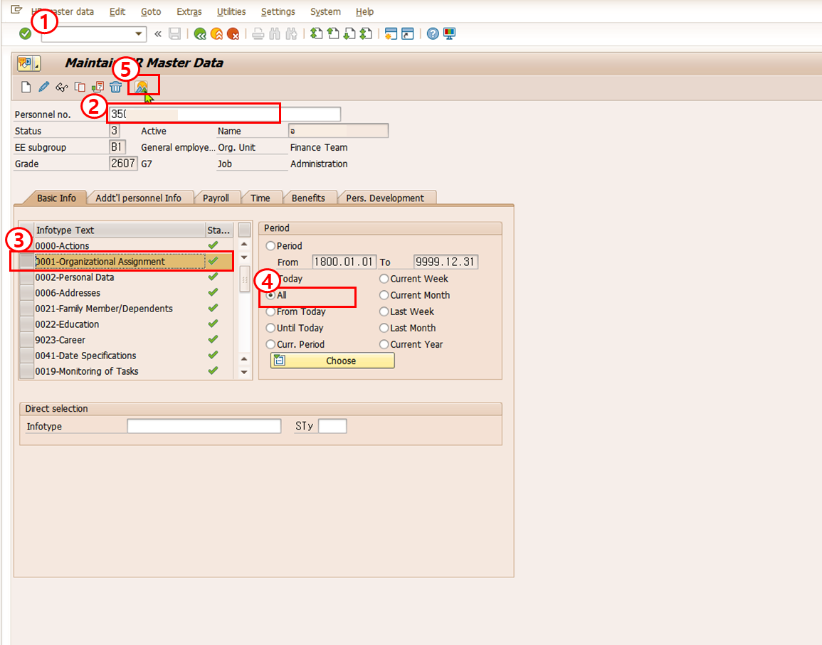
  - Move to the Change Screen
- Select the item to be changed from the list (Click left box of the list).
- Click the Change button.
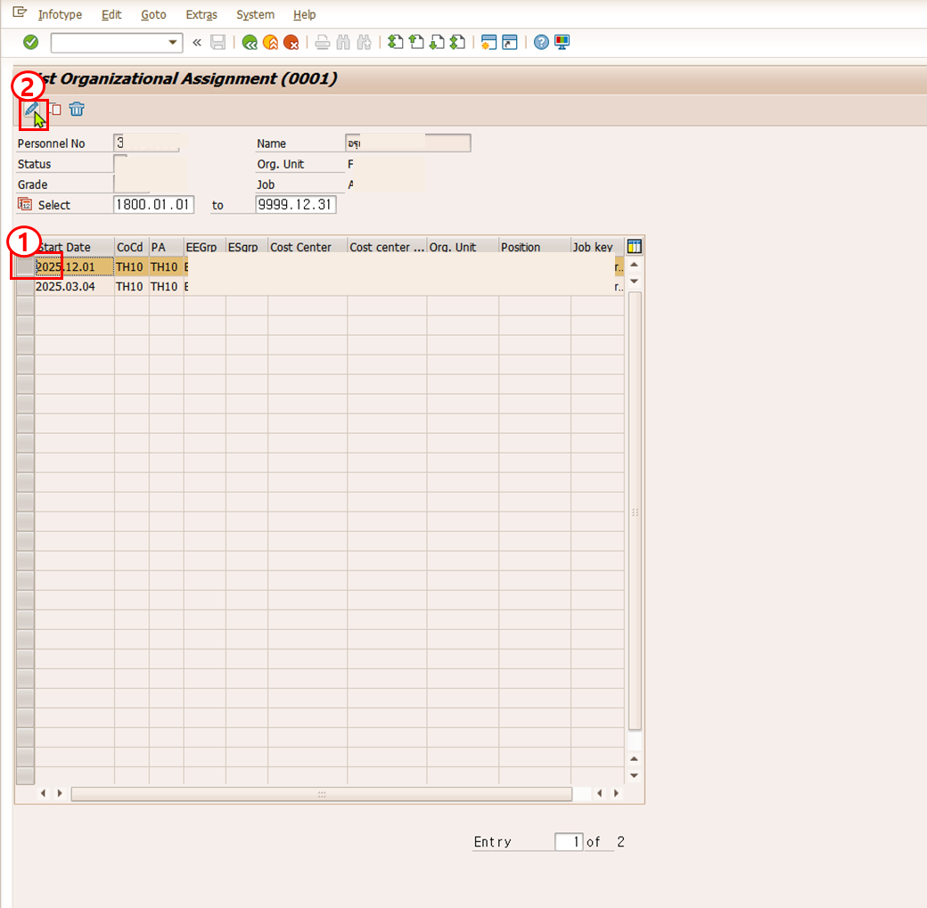

  - Change the Position Begin Date
- Update the Begin Date.
- Click Save Button.
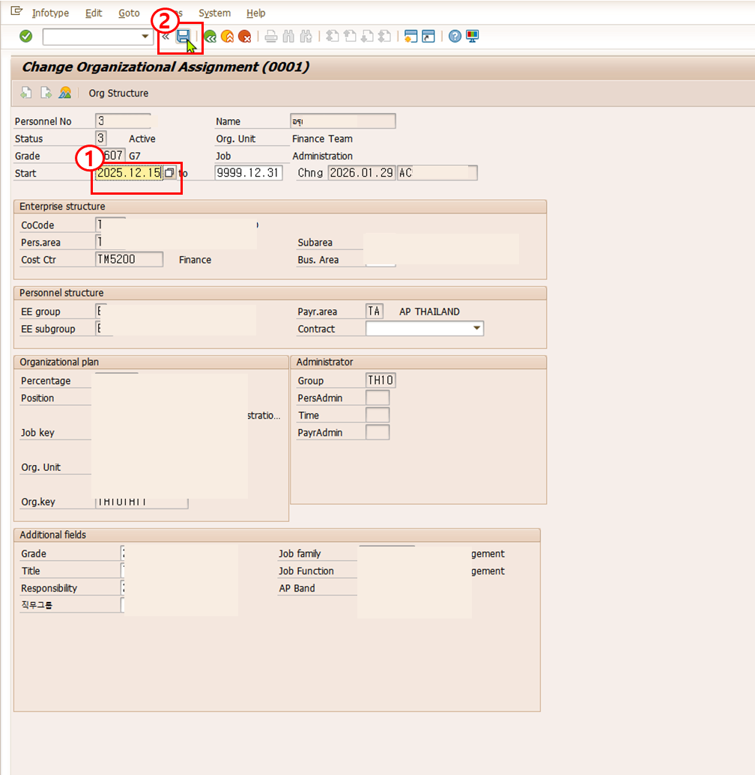

  - Verify the Change
- Execute transaction code PPOSE.
- Double-click Structure Search.
- Double-click Organization.
- Verify that the begin date of the position holder has been updated correctly.
