HR_How to change the cost center of HR organization

T-Code/Function/Menu
Application | T-Code/Function/Menu | Description
SAP-HR | PPOME | Modify Cost Center
- Scenarios
  - Inquiry Types
    - “how to change the master cost center code of HR organization in our SAP system”
- How to Execute
  - Execute transaction Code PPOME. To run transaction code PPOME, you must have the required authorization. Overseas subsidiaries typically perform this directly. In the domestic environment, users can also make changes directly if they have execution authorization.
  - Select the Target Organization
Execute transaction code PPOME and follow the steps below to select the target organization:
- Expand Organizational Units.
- Double-click Structure Search.
- Double-click the Parent Organization.
- Confirm that the target organization is selected.
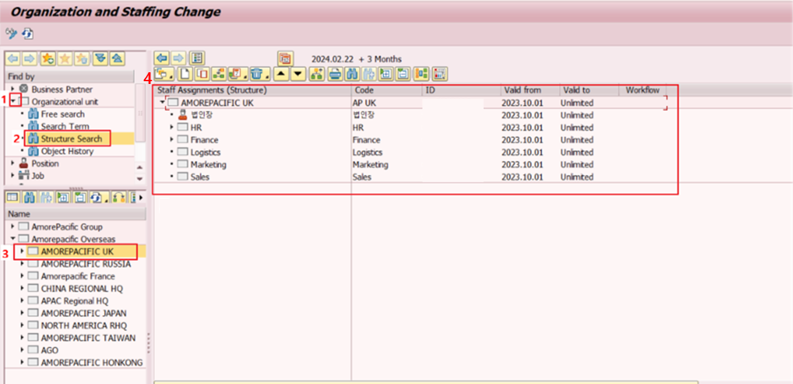
  - Change Cost Center
- Specify the start date for the cost center change.
- Click “Date and preview period” Button
- Set Start Date
- Click Execute Button
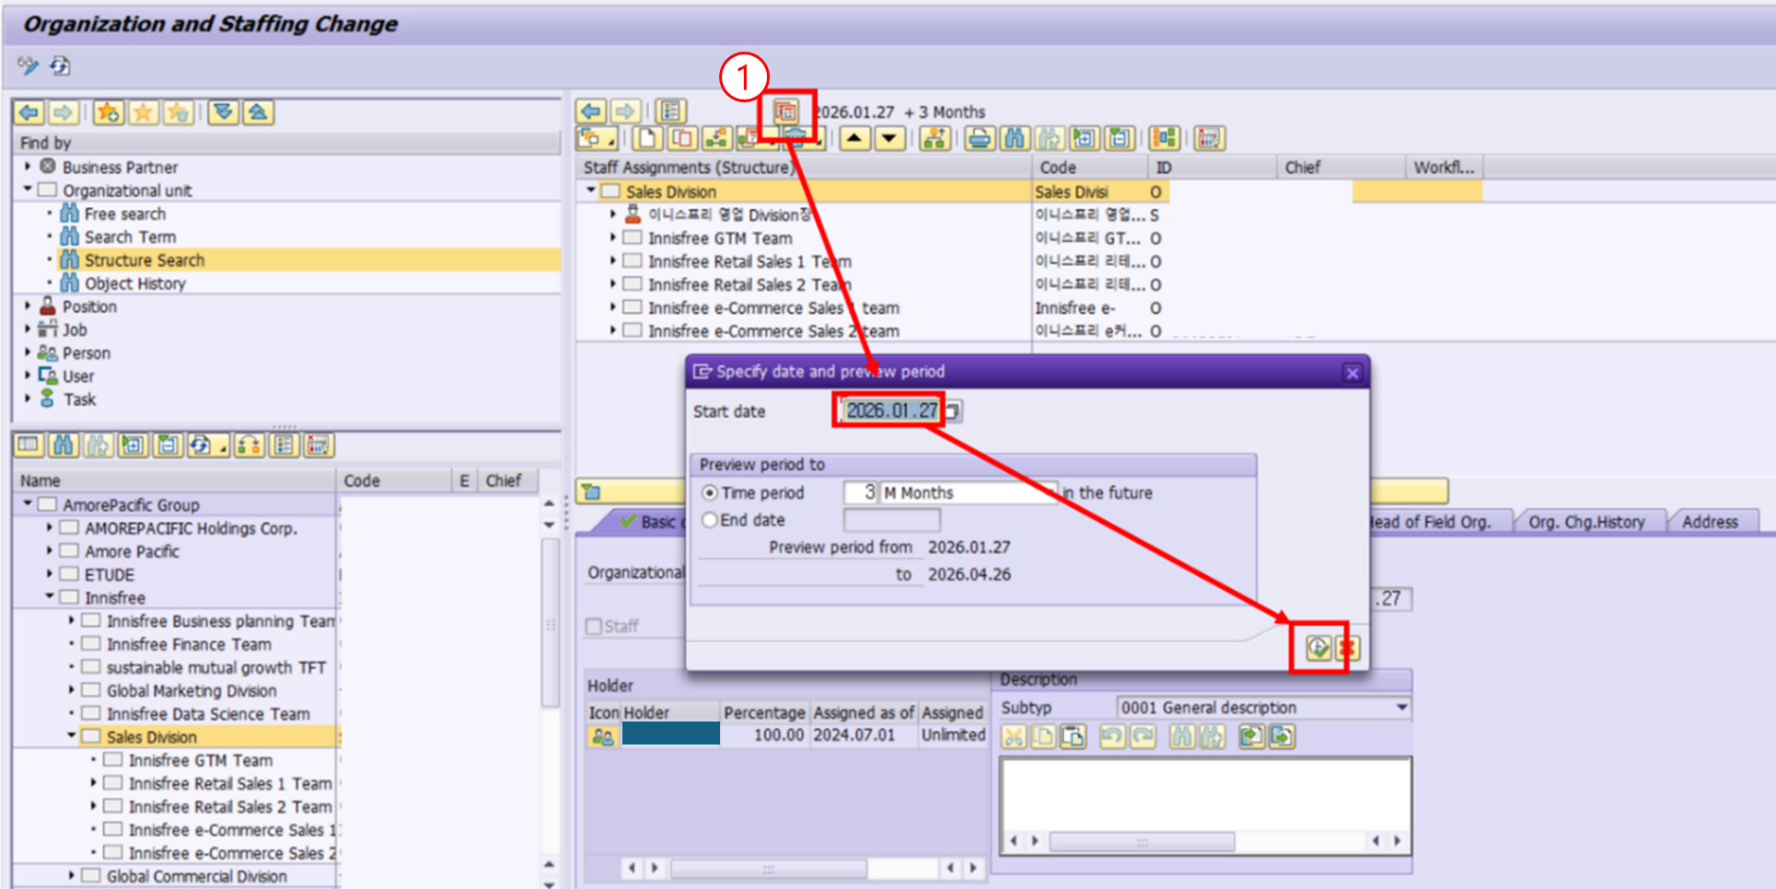

- Double-click the organization to change the cost center.
- Enter the new cost center.
- Click the Save button.

