HR_Guide to Creating Organizations and Positions

T-Code/Function/Menu
Application | T-Code/Function/Menu | Description
SAP-HR | PPOME | Create/Modify Organizations and Positions
- Scenarios
  - Inquiry Types
    - “Request to modify an organization in SAP PPOME that does not have a root organization.”
    - “Request to open PPOME organization FR00
- How to Execute
  - Execute Transaction Code PPOME. To run transaction code PPOME, you must have the required authorization. Overseas subsidiaries typically perform this directly. In the domestic environment, users can also make changes directly if they have execution authorization.
  - Select the Target Organization
Follow the steps below to select the target organization:
① Expand Organizational Units.
② Double-click Structure Search.
③ Double-click the Parent Organization.
④ Confirm that the target organization is selected.
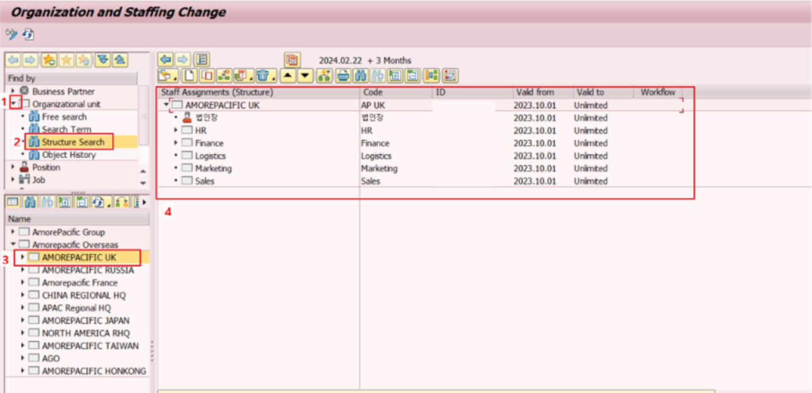
  - Create an organization Unit
    - Steps to Create an organization unit
① Enter the Key Date.
② Right-click the target organization.
③ Click Create.
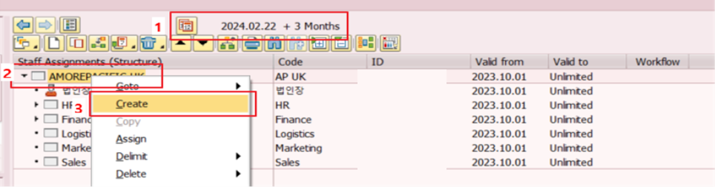
Then select Organizational Unit and click the Confirm (√) button.
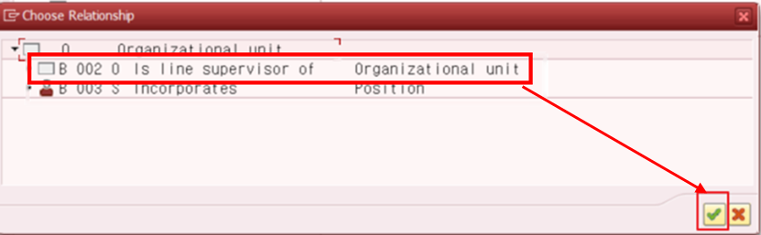

    - Enter Basic Data
Basic Data tab
- Organizational Unit: Enter the organization name (abbreviation/full name)
- Department: Check whether it is a department (real/virtual organization, Check if it is virtual organization)
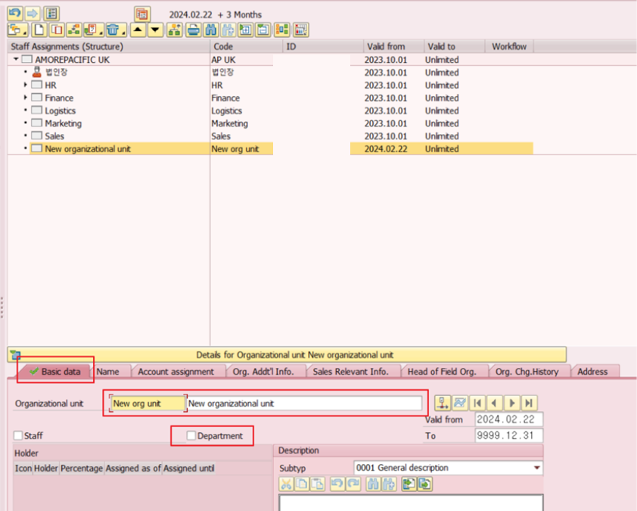

    - Enter Account Assignment Information
Account assignment tab
- Company Code: Enter the company code
- Personnel Area: Enter the personnel area code
- Pers. Subarea: Enter the personnel subarea code
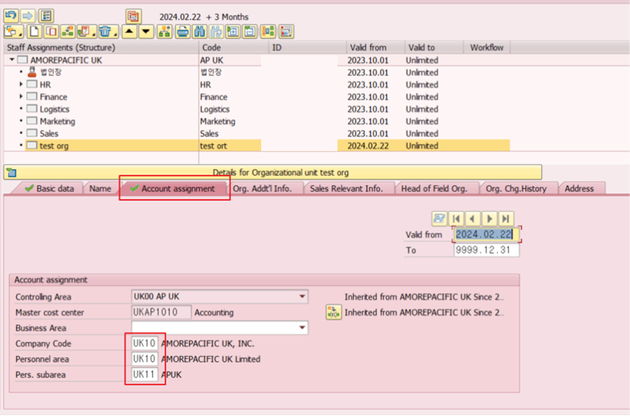

    - Enter Additional Organization Information
Org. Addt’l Info. tab: Click the Create button in the upper‑right corner to activate the fields.
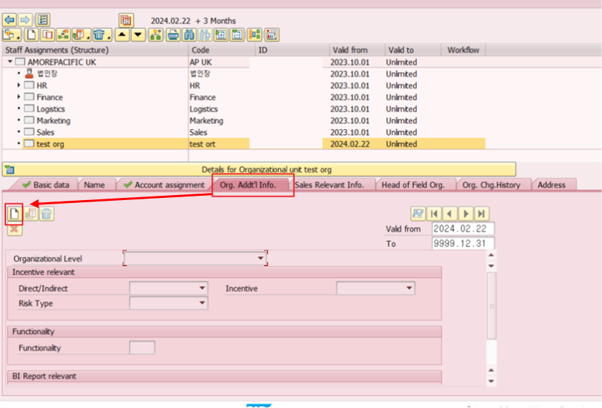
Select Organization Level.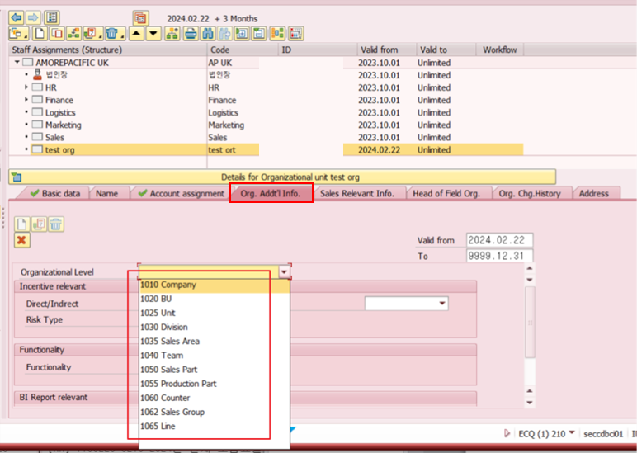
    - Save changes
Press Save button on top of the window to save changes.

  - Create a Position
    - Steps to Create a Position
① Enter the Key Date.
② Right-click the target organization.
③ Click Create.
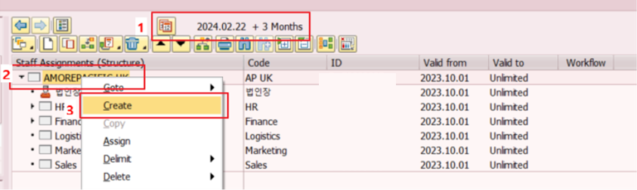
Then select Position and click the Confirm (√) button.
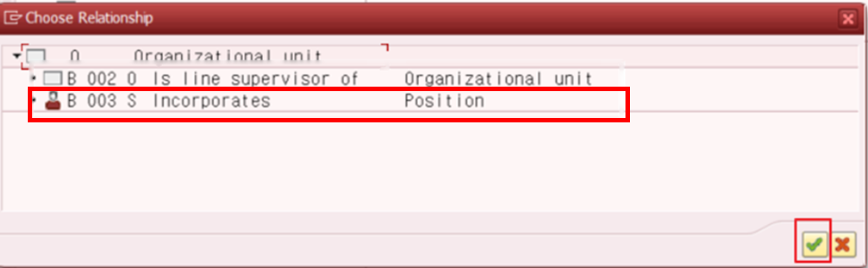

    - Enter Basic Information
Basic Data tab
- Position: Enter the position name (abbreviation/full name)
- Staff: Check if this is a staff (advisory) role that is not part of the regular reporting line
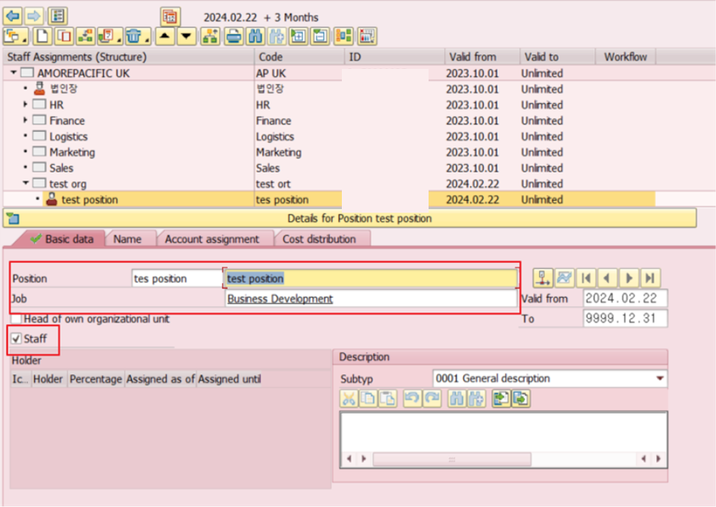
Job: Click Job input box > press F4 (Pop up appeared) > Choose the relevant job
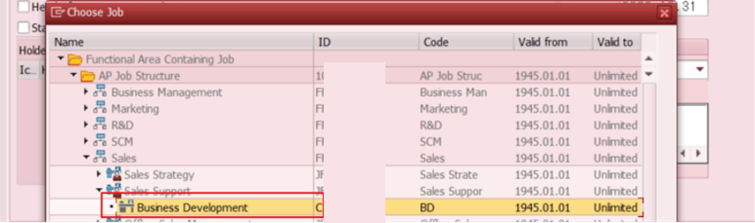
    - Save changes
Press Save button on top of the window to save changes.

