SAP-HR How to change Entry/Termination date
- T-Code/기능/메뉴
어플리케이션 | 메뉴/기능/티코드 명 | 설명
SAP-HR | PA30 | change Entry/Termination date
- How to change Entry/Termination date
  - Enter t-code PA30
  - Input Personnel no.
  - On upper Menu bar, Select Utilities > Change entry/leaving date
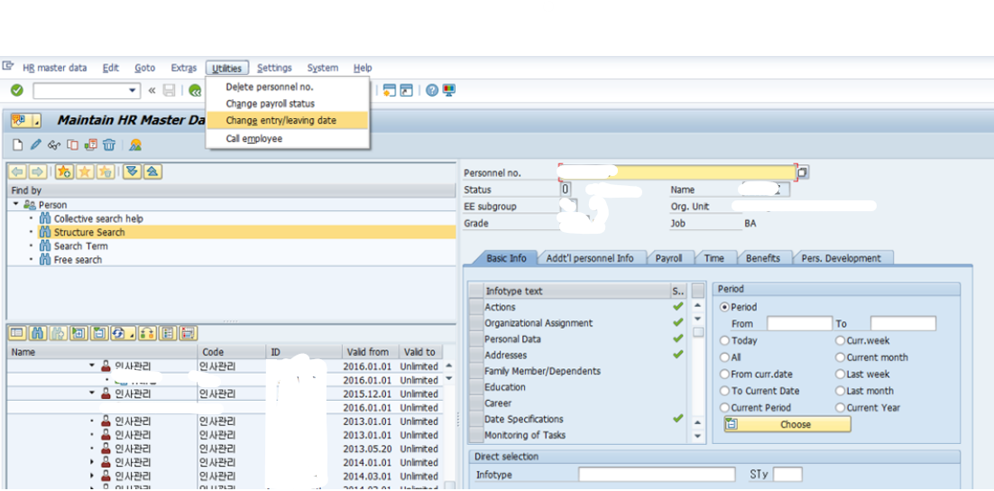
  - Change start date and Save(Disk shape button on menu bar)
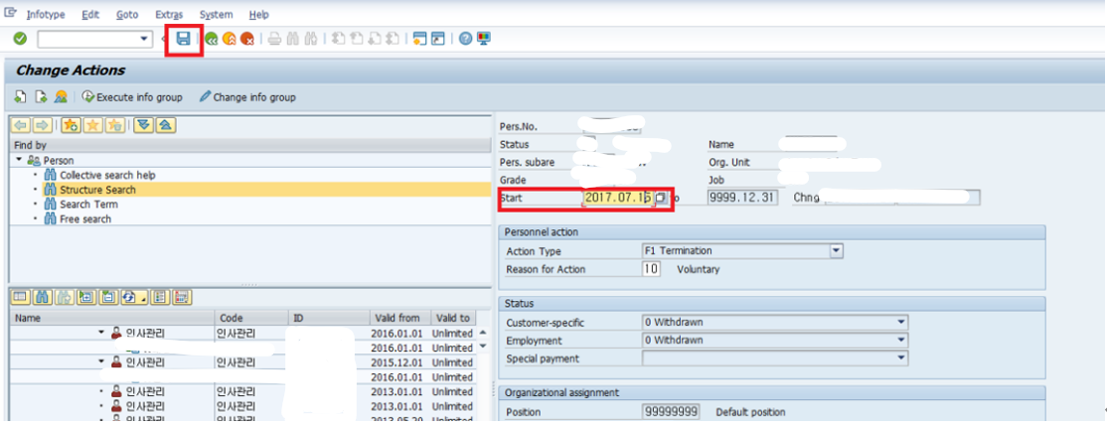
  - Checking actions

On Change Actions view, Check the information.

Enter to continue
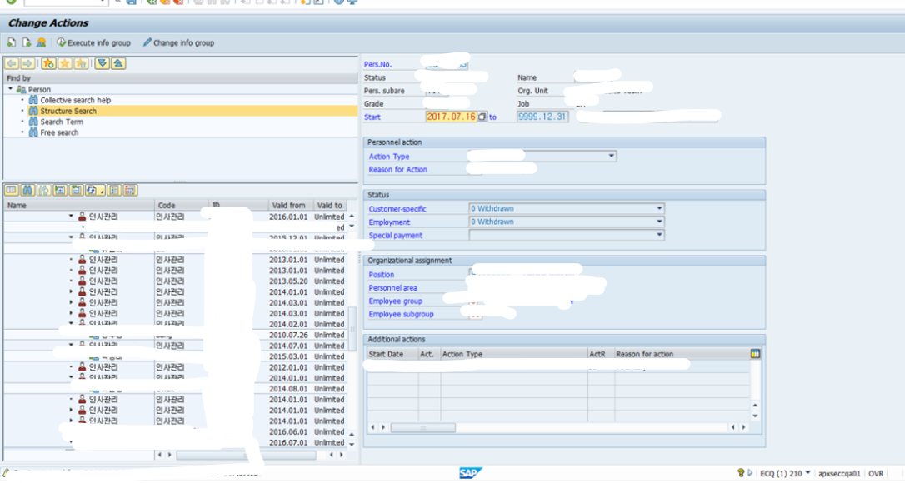

On Change Leaving Data View, Check the information.

Click Check button Down side of the window to continue
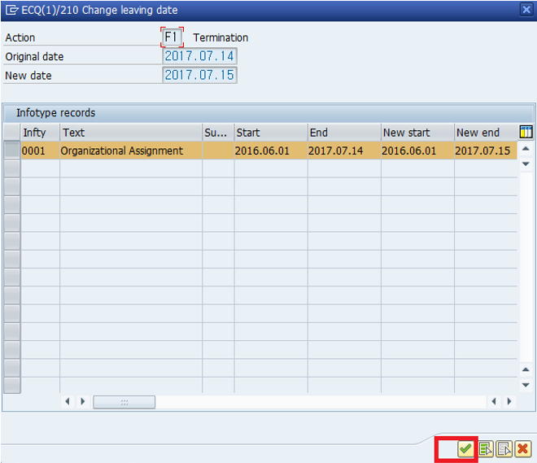
    - On Alert Window, Click Continue when finish checking
