AMOREPACIFIC

Pre-Quality Check for New Products
User Manual

[07.03.02.04 Pre-Quality Check for New Products-Finished Product-General]

Version | V1.0
Draft Date (Final) | Aug 20, 2015

Document History

Version | Draft/Revision | Draft Date | Drafter
1.0 | First Drafted | 2015-08-20 | Kyongyeon Hwang

Table of Contents

1. T-Code/Functions/Menu 1
2. New Product Check (Legacy) 1
2.1. New product check 1
3. Finished Product Initial Packaging Attendance (Manual) 3
3.1. Finished product initial packaging attendance 3
4. Inspection Specification Setting (Legacy) 3
4.1. Inspection specification creation 3
5. Inspection Execution (Manual) 12
5.1. Inspection execution 12
6. Results Entry (Legacy) 12
6.1. Results entry 12
7. Standard Item Settings (Manual) 12
7.1. Standard item settings 12
8. Entering Precautionary Items in Packaging (SAP) 13
8.1. Entering Precautionary items in packaging – ZPP10170 13
9. BOM Quantity Adjustment (SAP) 20
9.1. BOM Quantity Adjustment – ZQM20050 20
9.2. Check Filling Quantity Entry and QA Check – ZPP10601 22
10. Inspection Specifications Change (Legacy) 26
10.1. Inspection specification change 26
11. Preparation of Product Specification Certificate (Legacy) 27
11.1. Preparation of Product Specification Certificate 27
12. Approval of Product Specification Certificate (Legacy) 28
12.1. Approval of Product Specification Certificate 28

- T-Code/Functions/Menu
Application | T-Code/Functions/Menu | Description
SAP QM | ZPP10170 | Entering Precautionary items in packaging
SAP QM | ZQM20050 | BOM Quantity Adjustment
SAP QM | ZPP10601 | Check Filling Quantity Entry and QA Check

- New Product Check (Legacy)

  - New product check
Description | Process of the QI PIC identifying the contents new product status through production meetings, pilot tests and AP_WIN
Menu Path | AP_WIN – Project – Consultation Group Management
System | AP_WIN

    - AP_WIN production materials display
Check new product information regarding the AP-WIN and production meeting results using the method below.
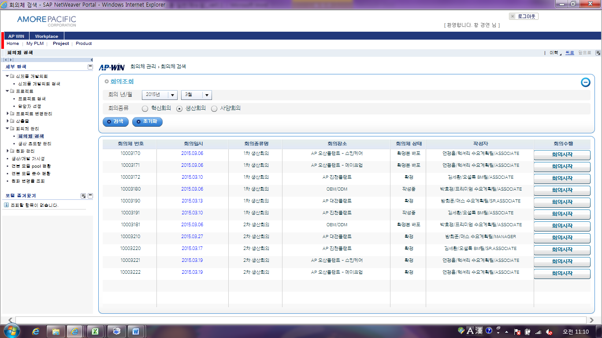
5
4
3
2
1
- Open the AP_WIN system.
- Open Consultation Group Management-Consultation Group Search.
- Select the year/month of the meeting.
- Select the meeting type.
- Click “Search.”

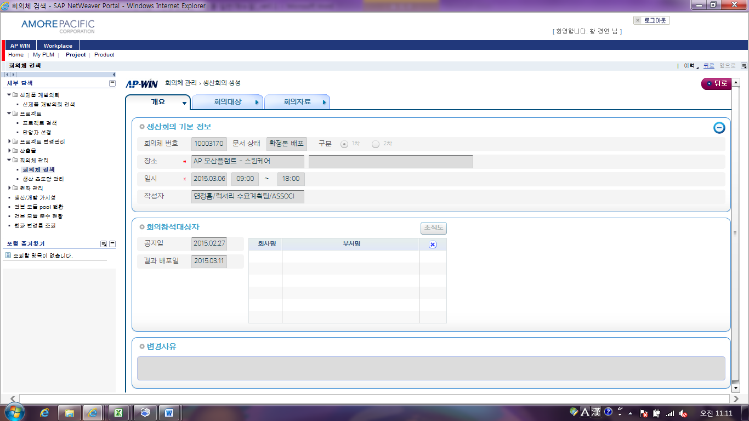
6
- Check the basic information on the meeting on the Summary tab.

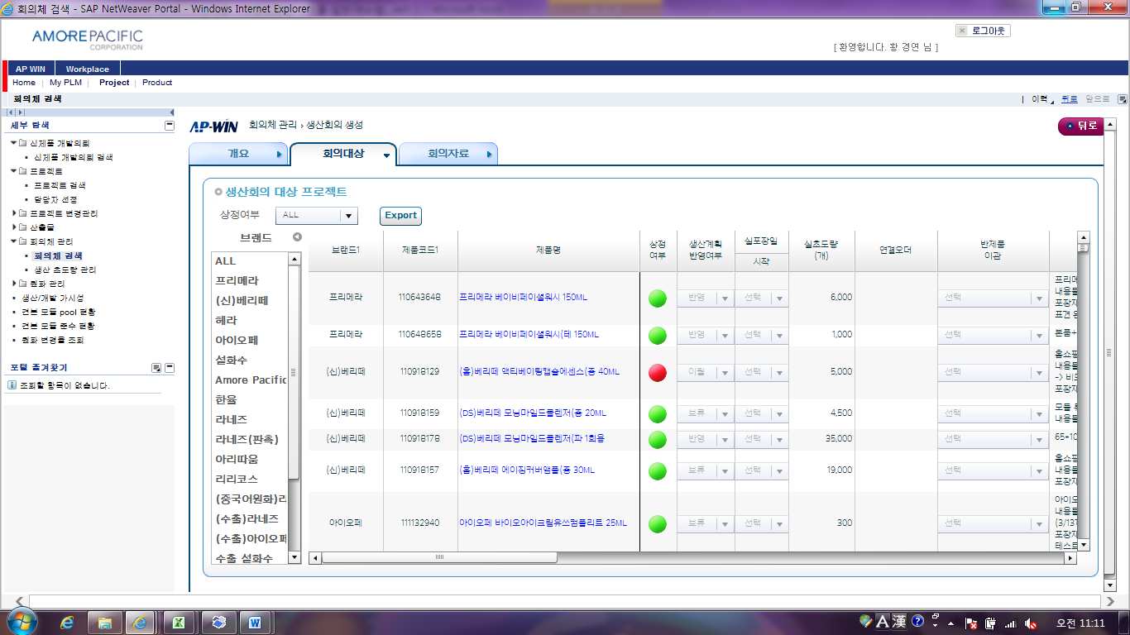
9
8
7
- Click the Meeting Required tab.
- Check the status for each product.
- When necessary drag to the right to check the additional information.

- Finished Product Initial Packaging Attendance (Manual)

  - Finished product initial packaging attendance
Description | Process of attending the packaging pilot or initial packaging of finished products to provide quality-related guidelines among production processes
Menu Path
System | Manual

- Inspection Specification Setting (Legacy)

  - Inspection specification creation
Description | Process of the QI PIC confirming the inspection specification to use when managing mass production quality based on the inspection specifications in the development stage.
Menu Path | GQMS-Master Data -Master Data Management -Inspection Specification Management
System | GQMS

    - Inspection specification creation
- Enter the G-QMS specification input screen.
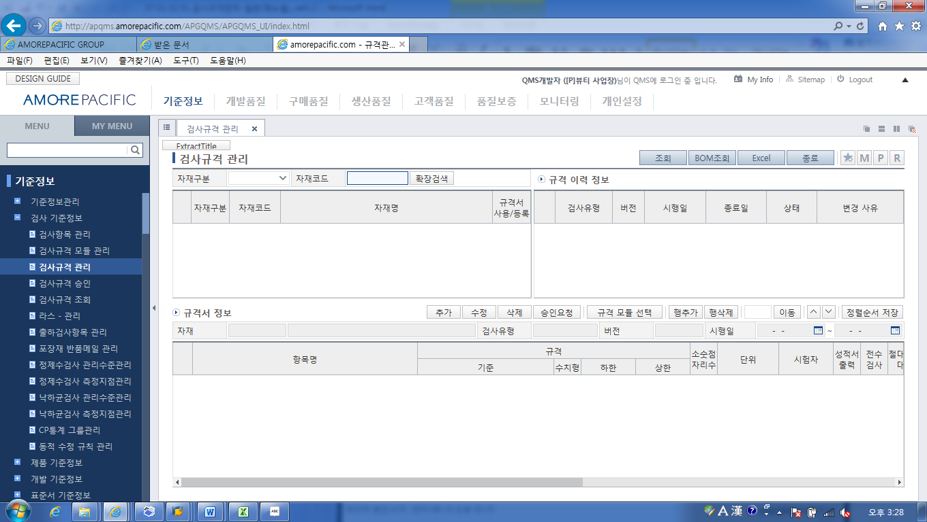
1
1
- Enter “Master Data – Inspection Master Data – Inspection Specification Management.”

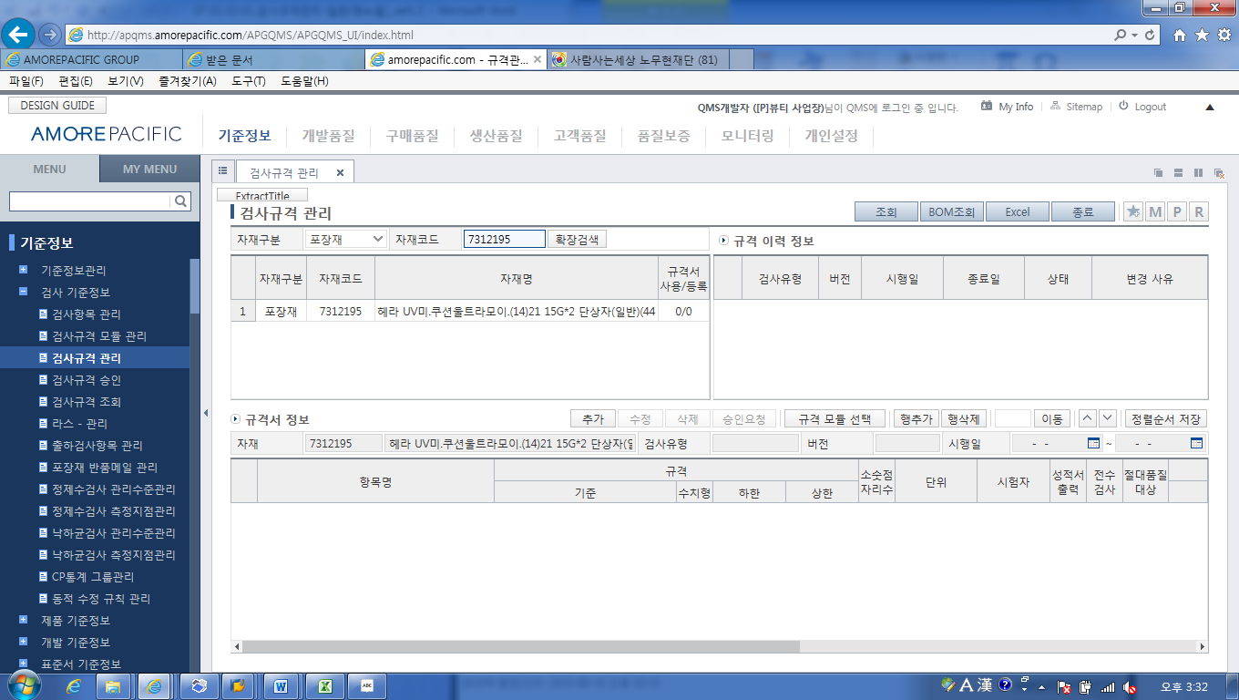
2
2
- Select the “Material Type” in “Material Classification” and enter the material code.

- There are the following three methods of entering specifications.
- Case of selecting and applying the specification module
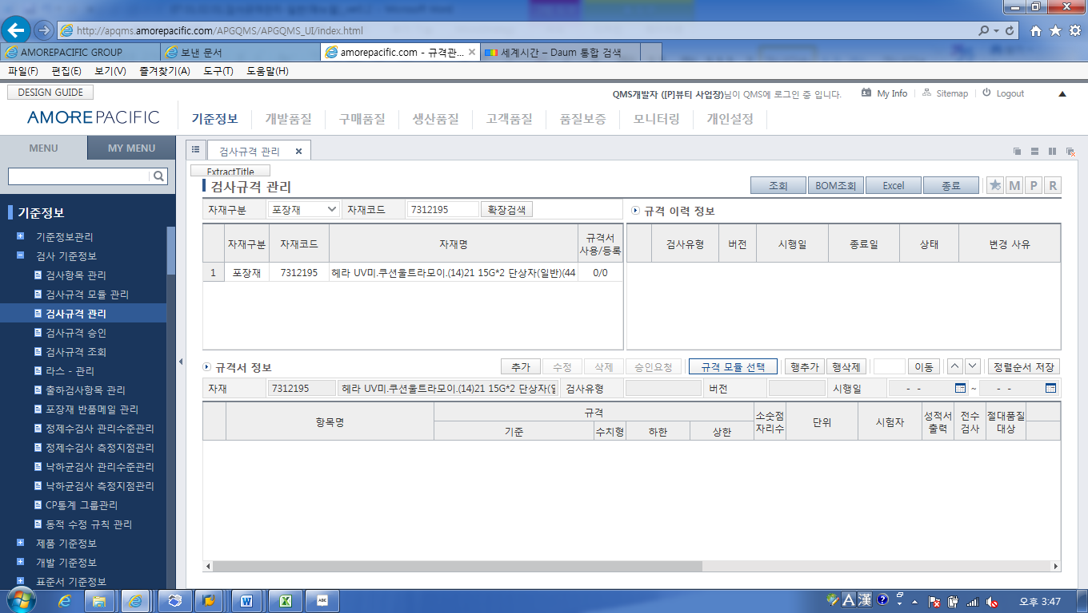
3
- Click the “Specification Module Select’ button. “

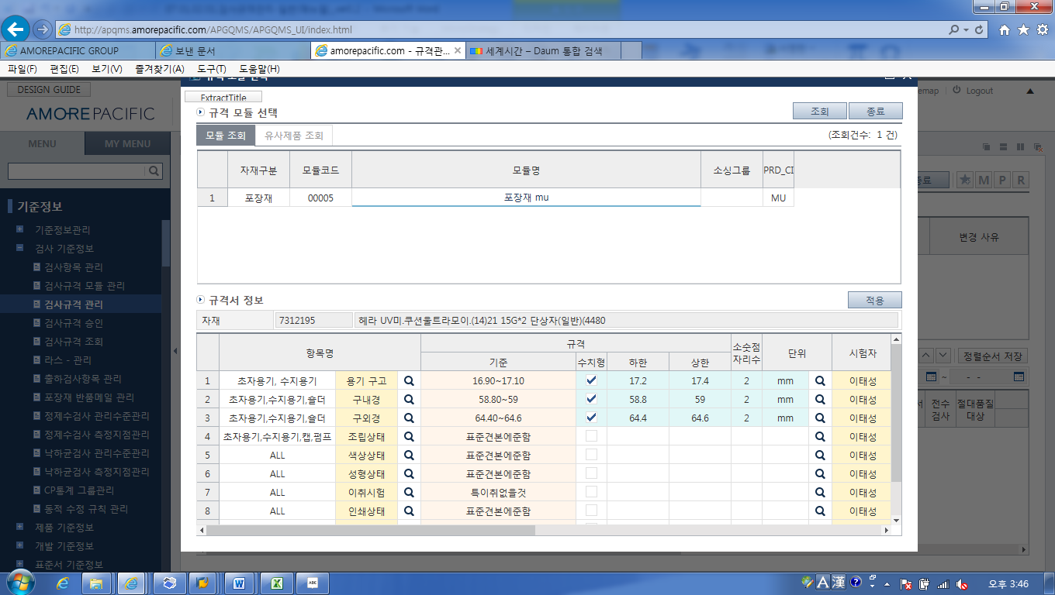
5
4
- Select the relevant module in the pop-up window.
- Click the “Apply” button.
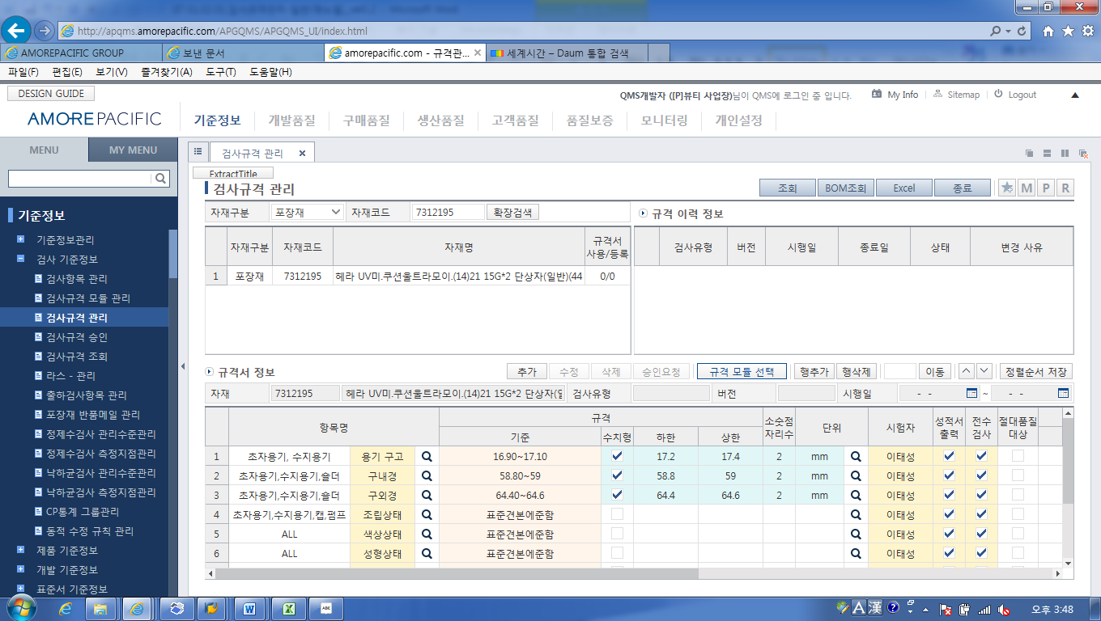
6
- Change and adjust the additional information then click on the “Add” button to confirm the specifications.

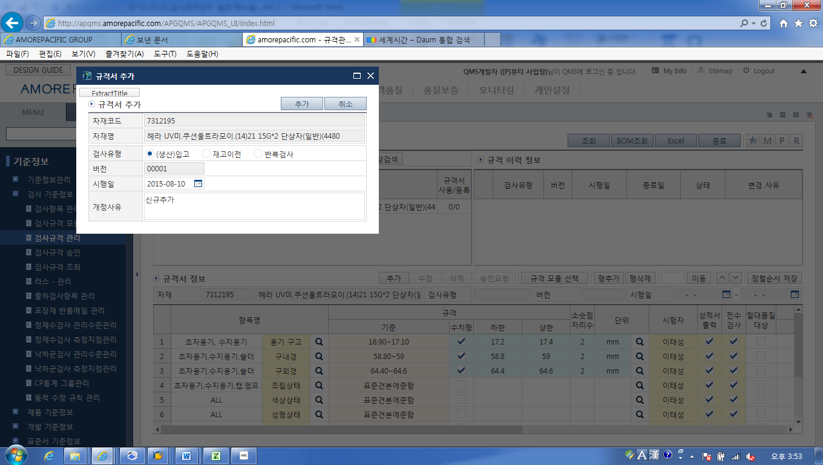
7
7
- Select “Inspection Type” to add the version and reason for revision then click on the “Add” button.

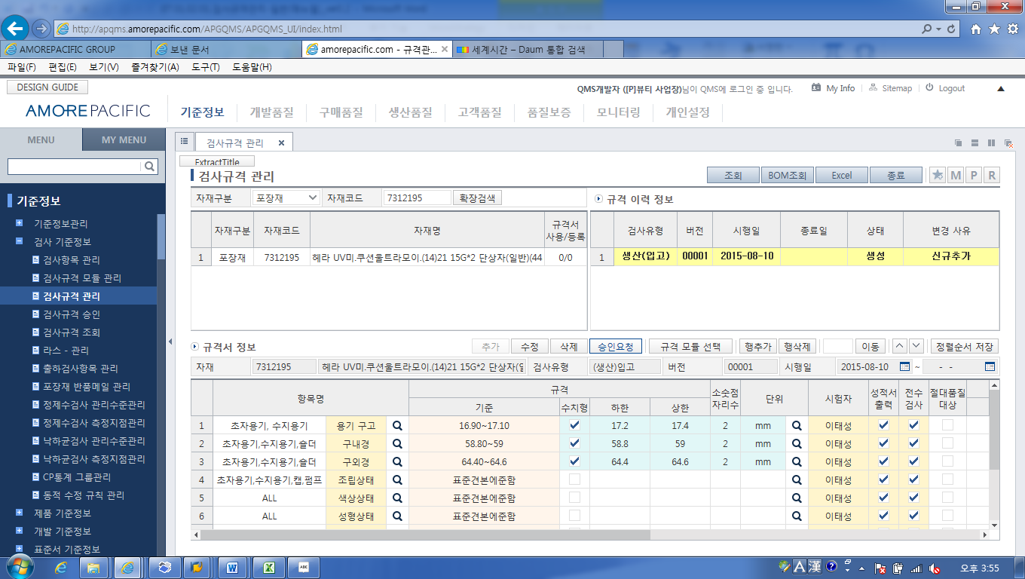
8
- As shown above, the new addition to the specifications are displayed in the “Specifications History Information.”

- Cases of selecting and applying similar products
3
- Click on the “Select Specifications Module” button.

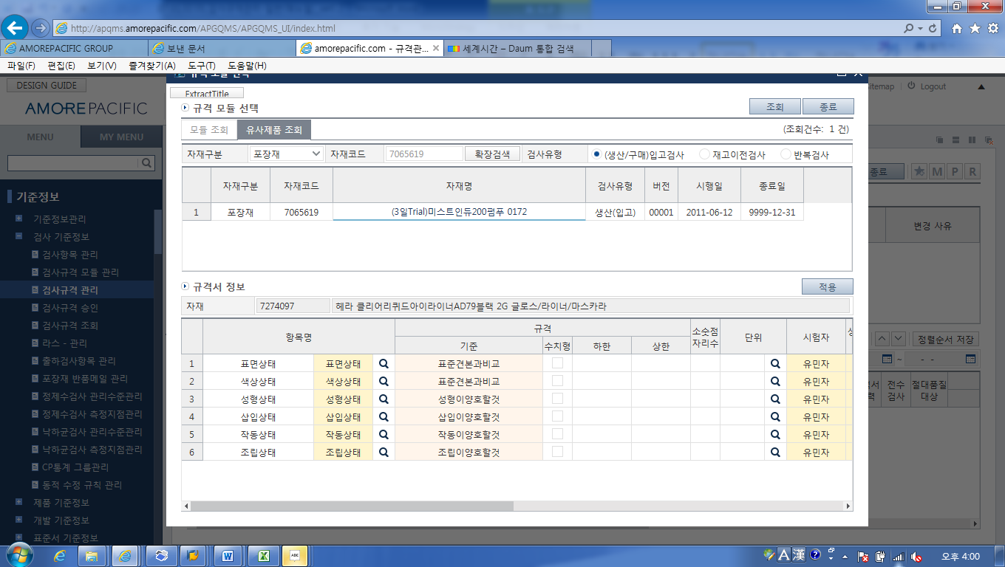
4
7
6
5
- Select “Display Similar Products.”
- Enter the “Materials Classification” and “Materials Code” of the material to copy.
- Double-click the selected material.
- Click “Apply.”

8
- Change and adjust the additional information then click the “Add” button to confirm the specification.

9
9
- Select “Inspection Type” to add the version and revision reason then click the “Add” button.

10
- As shown above the addition to specifications are confirmed in the “Specification History Information.”

- Case of Selecting and Applying Individual Inspection Items 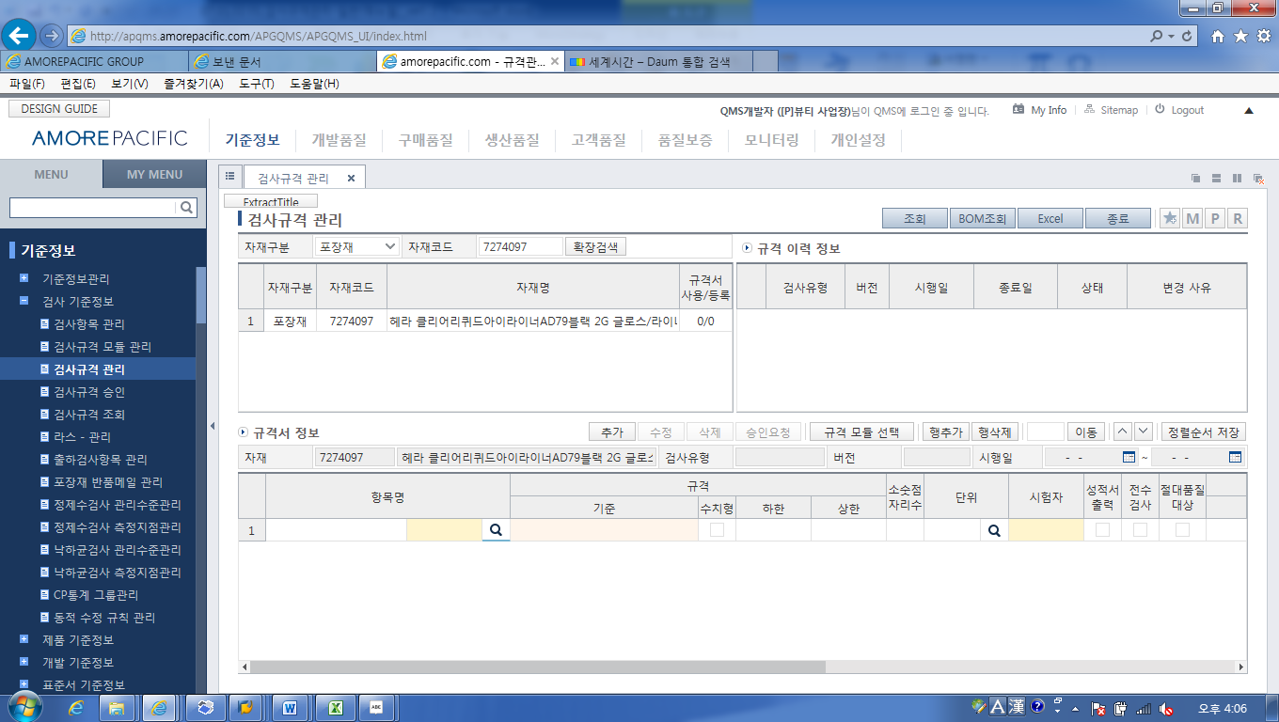
4
5
④ Click “Add Row“
⑤ Then click the magnifying glass icon beside the item name of the added row.

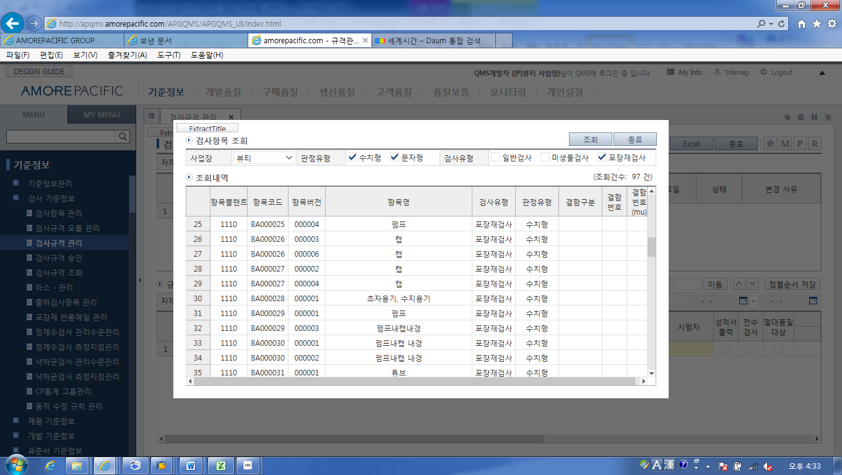
6
⑥ Check and select the items in the pop-up window then click “Display” to make a relevant inspection item list and double-click the items intended to input into the inspection item.

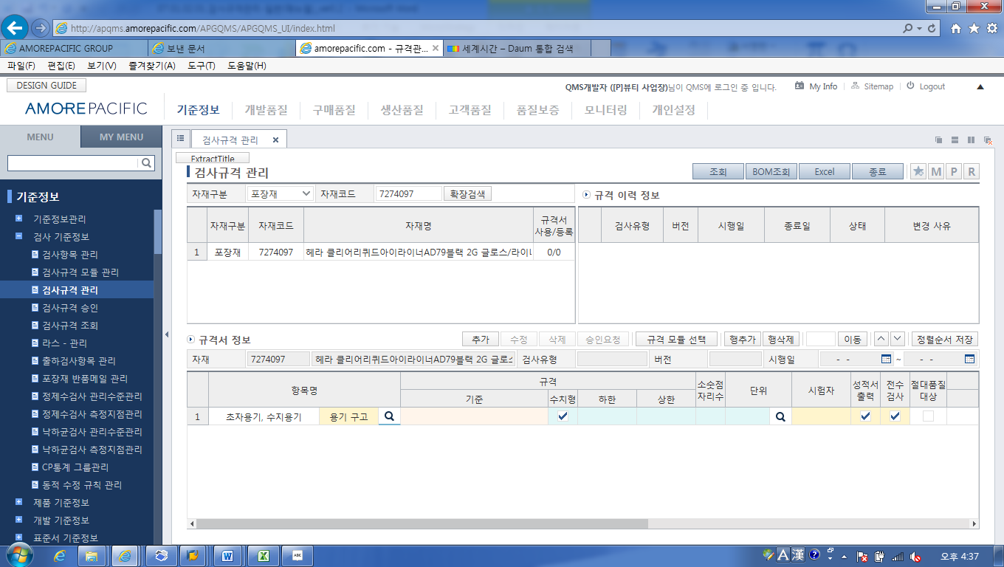
8
7
- Enter the other items. After repeating the same process
- Click the “Add” button.

9
9
- Select “Inspection Type’ to add the version and revision reason then click on the “Add button.

10
- As shown above the addition to the “Specification History Information” is checked.

- Inspection Execution (Manual)

  - Inspection execution
Description | Process of the QI PIC inspecting each inspection item in accordance with inspection standards defined currently and when necessary conducting additional inspections for prior inspection for risk.
Menu Path
System | Manual

- Results Entry (Legacy)

  - Results entry
Description | Process of the QI PIC recording the inspection execution results into GQMS
Menu Path | GQMS-Development Quality
System | GQMS

- Standard Item Settings (Manual)

  - Standard item settings
Description | Process of setting standard items using products which were ruled to be conforming after packaging pilot or after initial production. Set one each of products for self-inspection at the production staging area and one each for QA GR inspection.
Menu Path
System | Manual

- Entering Precautionary Items in Packaging (SAP)

  - Entering Precautionary items in packaging – ZPP10170
Description | When there are precautionary items needed in filling and packaging register precautionary items when printing out the pick list.
Menu Path | Quality Management -Development Quality - Pre-Quality Check for New Products
System | SAP

    - Entering in HAL3 (Contents) basis
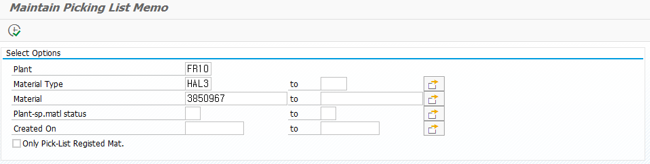
1
① Enter and open Plant, Material Type, Materials.
-. Plant and Material Type are essential items.
-. Plant-sp matl status
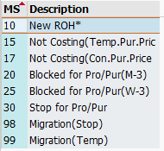

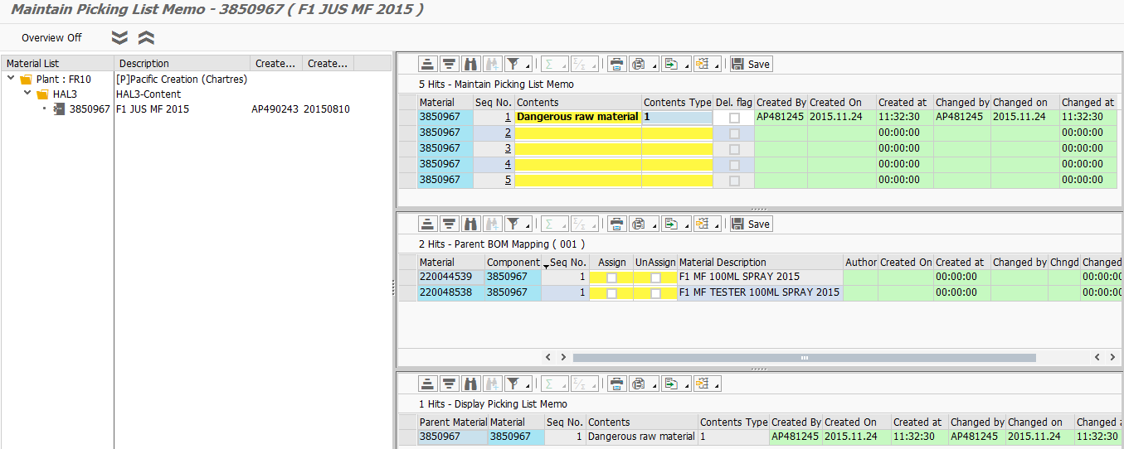
3
4
5
2
- Description by screen space
- Materials List: Details, creator, creation date
- Enter remarks section by material
- Parent BOM mapping
-. For contents, allow mapping of upper semi-finished/finished products
-. It is possible to map on all upper-level materials and onto only some upper-level materials
- Picking list memo display screen
-. Possible to display the memo information registered in the relevant material
8
9
6
7
적용함
적용함
- Enter the relevant materials and enter the details to register in the pick-list.
- Select the details type.
None selected: Registering this makes it impossible to apply this section.
1: When entering “Apply All Parent Materials” to the contents (HAL3) the relevant contents are registered into all parent materials.
When new parent products occur the relevant details are entered automatically.
Connect and use “Upper BOM Mapping” and “Un-used_Y/N.”
When the details are written in the contents and when intending to apply directly to the finished new products which occur later on, select the content type “1” and check the Un-use_Y/N. It is not applied to the checked parent materials, and automatically applied to new products thereafter.

2: “Apply Only to Relevant Materials” only selectively applies the relevant materials. There are no relevant items with HAL3. In the case of HAL1 or FER1 select only when applying to the relevant material.

3: “Apply Selectively to Parent Materials” may be applied selectively to the parent materials.
To select, check the “Apply” in the “Upper BOM mapping” box to apply only the relevant items.
When selecting content type “3” for new finished products which arise thereafter do not apply the relevant details. When you want to automatically apply to new products which occur later, select content type “1.”

- Mark as delete: Checking does not use the relevant details. This was made to use for managing history. Check the “Mark as Delete” and it is not displayed in the “Picking List Memo Display.”
- Save: Enter contents in ⑥⑦⑧ and select then click “Save.” The “Save” button works the same way as clicking the “Save” button on the upper part of the screen.
- When selecting “Enter Remarks section by Material” when selecting “3” for Content Type” and “Selectively Apply Parent Material,” check on the parent materials box to reflect the relevant contents.
11
12
10

- When selecting “Content type” as “1, Parent Materials All Apply,” for “Enter Remarks section by material,” check the parent materials that do not connect the relevant contents

Connecting the Content type 3- Apply; Content type 1 – Un-use_Y/N depends on whether they are applied to the parent materials which will occur as new products.
- Click the relevant details then save.

    - Enter on the basis of FER1/FER2 (Finished products)
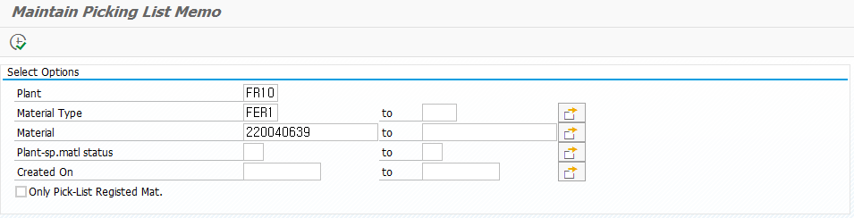
1
① Enter the Plant, Material Type, and Material then open.
-. Plant and material type are essential items.

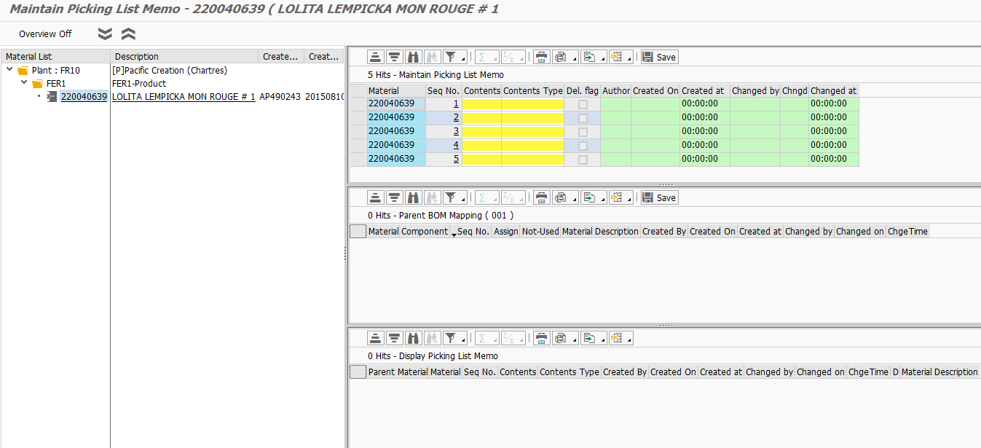
4
5
3
2
- Description by screen section
- Material List: Details, creator, creation day
- Enter Remarks section by material: Enter directly the contents to remark on in the Pick-list Remarks section
- Upper BOM mapping
-. For contents allow the upper semi-finished/finished products to be mapped
-. Mapping may be conducted for all or only for some parent materials
-. Finished products have no parent items and accordingly the relevant field is not activated
- Picking list memo display screen
-. It is possible to display the memo information registered in the relevant material
-. The relevant details are entered into the materials code in the “Materials” field

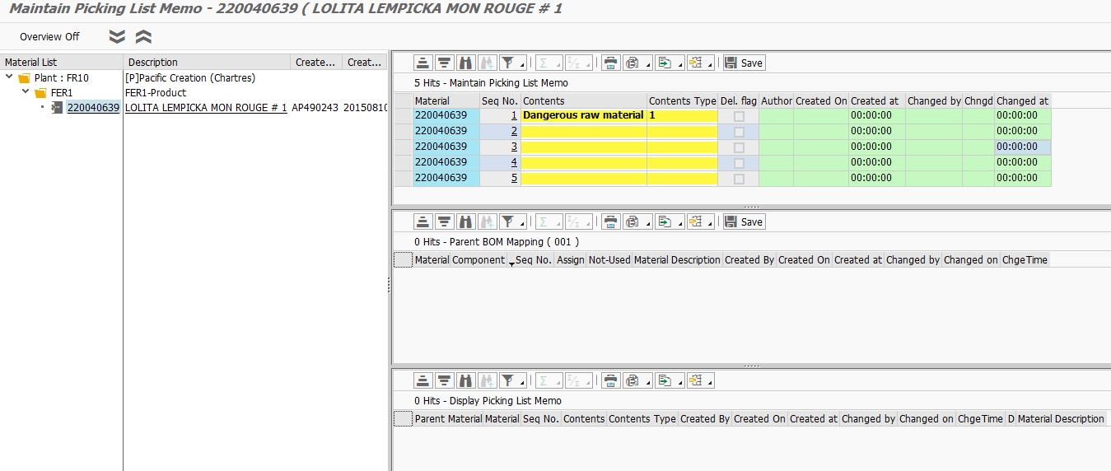
8
7
6
9
- Enter the relevant material and enter the details to register in the Pick-list.
- Select details type.
None selected: Registering this makes it impossible to apply this section.
1: “Apply all parent materials” When contents (HAL3) are entered, the relevant details are registered in all upper materials.
When there are new products in the parent materials the relevant details are entered automatically.
It is used in connection with “Parent BOM mapping” and “Un-use_Y/N.”
When you enter the details into the details section and you want to apply that directly to the finished new product made after that, choose detail type “1” and check on Un-use_Y/N. This does not apply to the checked parent material but are automatically applied to new products.
.
2: “Apply to Relevant Materials Only” selectively applies only to the relevant materials and for HAL3 there is nothing relevant and in the case of HAL1 or FER1 selection is for when applying only to the relevant material.

3: You can only apply some of the parent materials in “Upper-level Material Selective Application. “
To select, check on “Apply” in the ‘Parent BOM Mapping” box to apply only the relevant items.
When selecting content type “3” the finished new products arising thereafter do not apply the relevant contents. When intending to automatically apply to the new products arising thereafter you should choose content type “1.”

- Delete Flag: Checking this makes it unused. This was made in order to use in history management. Check the Delete Flag box and it is not displayed in the “Picking List Memo Display.”
- Save: Enter the contents in ⑥⑦⑧ and select then click “Save.” The “Save” button works the same way as clicking the “Save’ button on the upper part of the screen.

11
10
- Given there are no upper-level materials, the relevant sections are not activated
- The pick list details describing the relevant material are displayed. Up to a total of five items may be entered and displayed.

- BOM Quantity Adjustment (SAP)

  - BOM Quantity Adjustment – ZQM20050
Description | When the contents (HAL3) pilot is completed, register the content gravity into the Materials Master-Quality Management View then deliver this information to the BOM screen. The gravity information registered in the materials master is computed automatically with the standard quantity when new products using parent materials are made to provide the basic filling volume information to the BOM
Menu Path | Quality Management - Development Quality - Pre-Quality Check for New Products
System | SAP

    - Enter “Materials master inspection information maintenance”
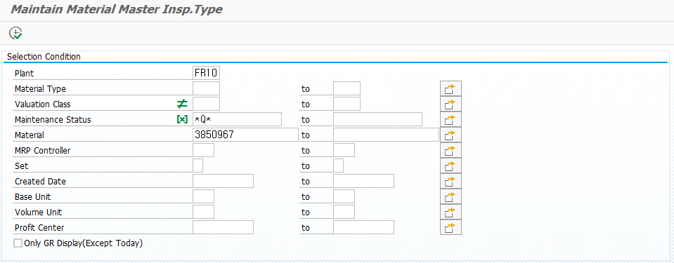
1
1
- Open the “Materials Master Information Maintenance (ZQM20050)” to enter “Plant” and “Materials” and click “Enter.”

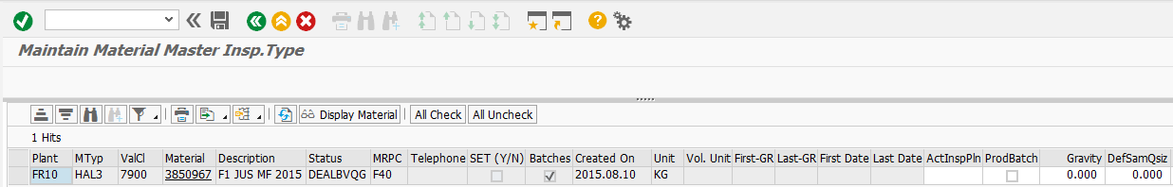
2
3
2
- Enter the values in the gravity fields for the relevant products and click the “Save” button to complete changes.
- Double-click the materials code in the materials field to move to the materials master.

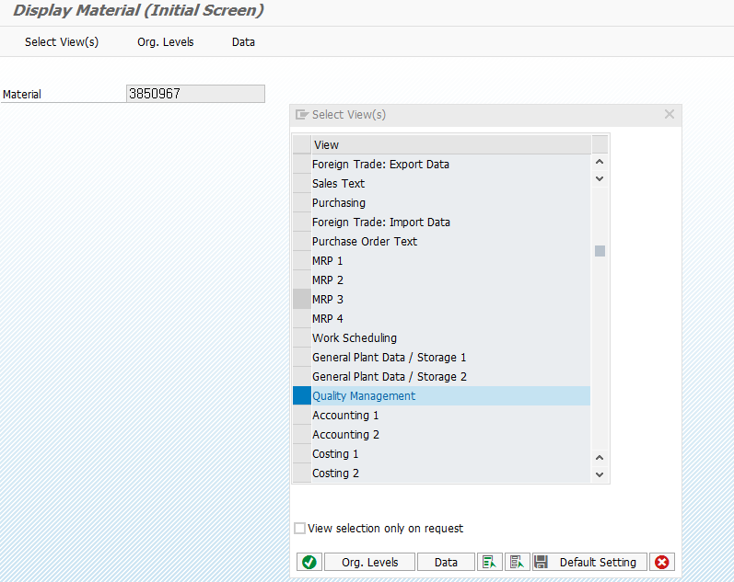
4
- Select quality management view and enter the materials master.

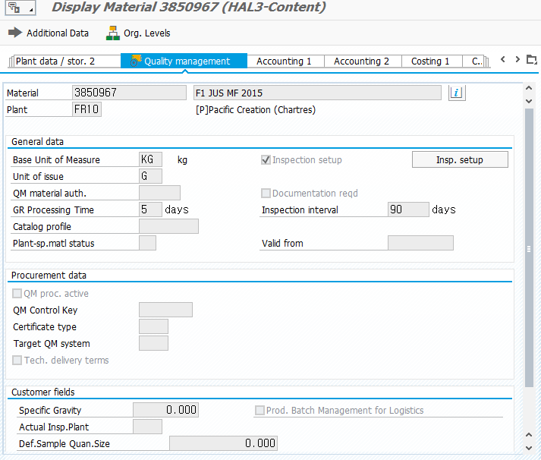
5
- When newly entering or changing the gravity value the gravity value of the materials master changes in the same way. When after changing values you need to check you can do that on two screens (MM03/ZQM20050).

  - Check Filling Quantity Entry and QA Check – ZPP10601
Description | Reflect the gravity value registered in the materials master  - To provide a value which is automatically computed via Marked Quantity*Weighting when new finished products are made  - Consider the quality and operate a filling quantity for QA confirmation
Menu Path | Quality Management - Development Quality - Pre-Quality Check for New Products
System | SAP

    - Display and QA check of contents
Open the display and QA check screen in the screen below.
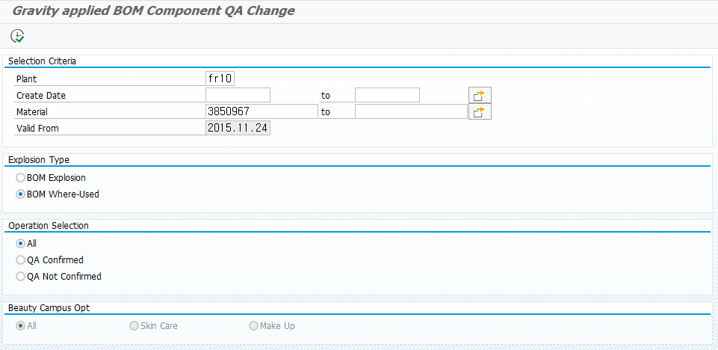
4
3
2
1
- Plant: For entering the relevant plant. It is an essential input field
Creation Date: Displays materials master creation day. It is an essential field.
Materials: For entering material code
First Effective Day
- Explosion Classification: For selection of the product or contents.
- Activity Selection: You can display by classifying between those confirmed and not confirmed by the QA.
When necessary the “QA Unconfirmed” list should be displayed periodically and confirmed.
- For Beauty Campus it is possible to select skin care and makeup.

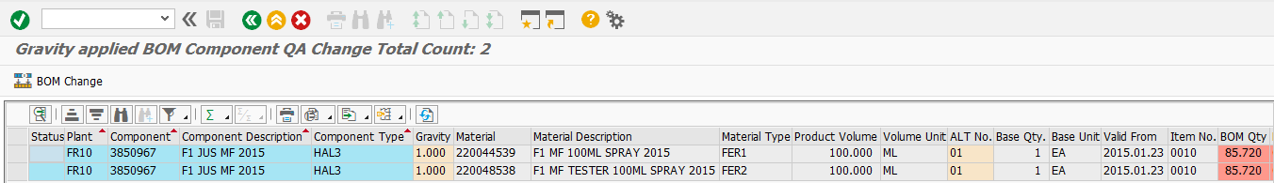
1
- The key fields are as shown below.
-. Gravity: Enter the gravity of the materials master (MM03/ZQM20050) of the contents. When finished new products arise, it carries over the relevant gravity value
-. Marked quantity: Refers to the legally marked quantity of the relevant product.
-. Quantity unit: The weighting is applied only when the units are ML.

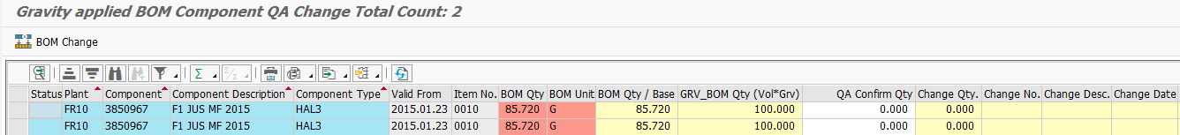
1
2
2
-. Component parts quantity: Quantity currently registered in BOM
-. BOM quantity/basic quantity
-. Marked volume*gravity: the first registered marked volume*gravity value
-. QA confirmed quantity: Consider the “Marked volume*gravity” to confirm the actual filling volume value.
Registration of the confirmed quantity and click “②QA confirmation (change BOM)” button to change the BOM in the changed value.
-. Changed number, changed date, details, flag, and message: It is possible to check the changed results after change.
② Enter values in the QA confirmed quality field and click on the “QA Confirmation (BOM change) button.

    - Check BOM change history
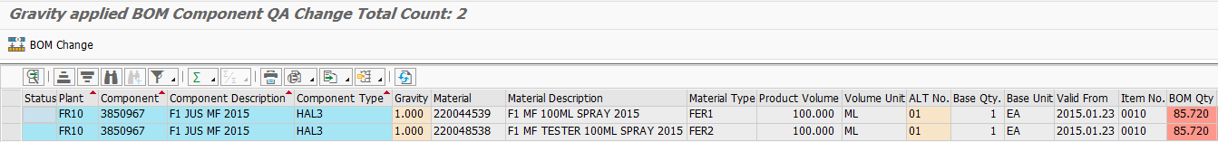
1
- When changing BOM quantity through QA check the change history. To do that, select the row of the product to first check then double-click the alternative BOM
.
3
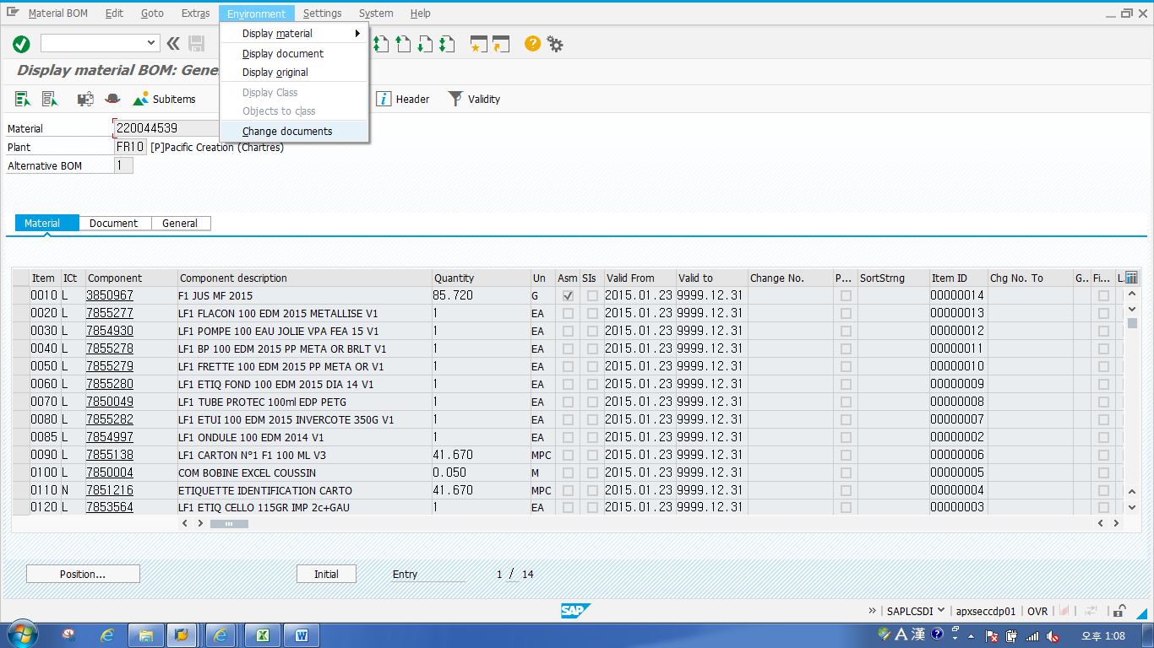
2
4
- Check the BOM change results.
- Click on “Environment.”
- Click on “Change Documents.”

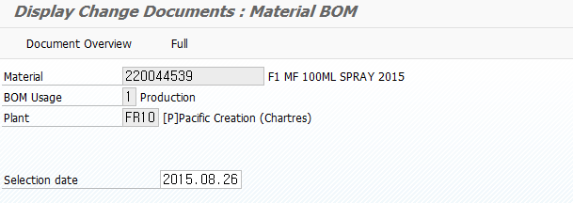
5
- Click “All.”

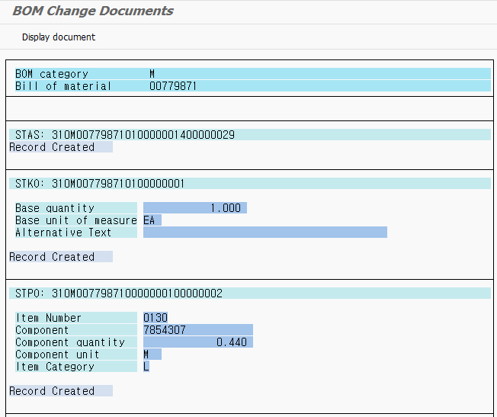
6
7
This allows check of the change history of the relevant material. To see details
- Put the cursor on “Record Creation”
- And click “Accounting Document Display.”

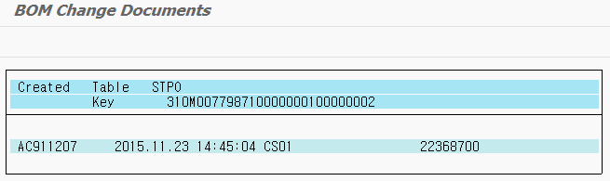
8
- It is possible to check the detailed history in the order of “Changing Person Employee Number, Change Date, Change Time, and Change T-Code.”

- Inspection Specifications Change (Legacy)

  - Inspection specification change
Description | Process of changing inspection specifications in GQMS when after experiencing a series of processes when inspection specifications need additional change
Menu Path | GQMS – Master Data – Inspection Specification Management
System | GQMS

    - Changing inspection specification
1
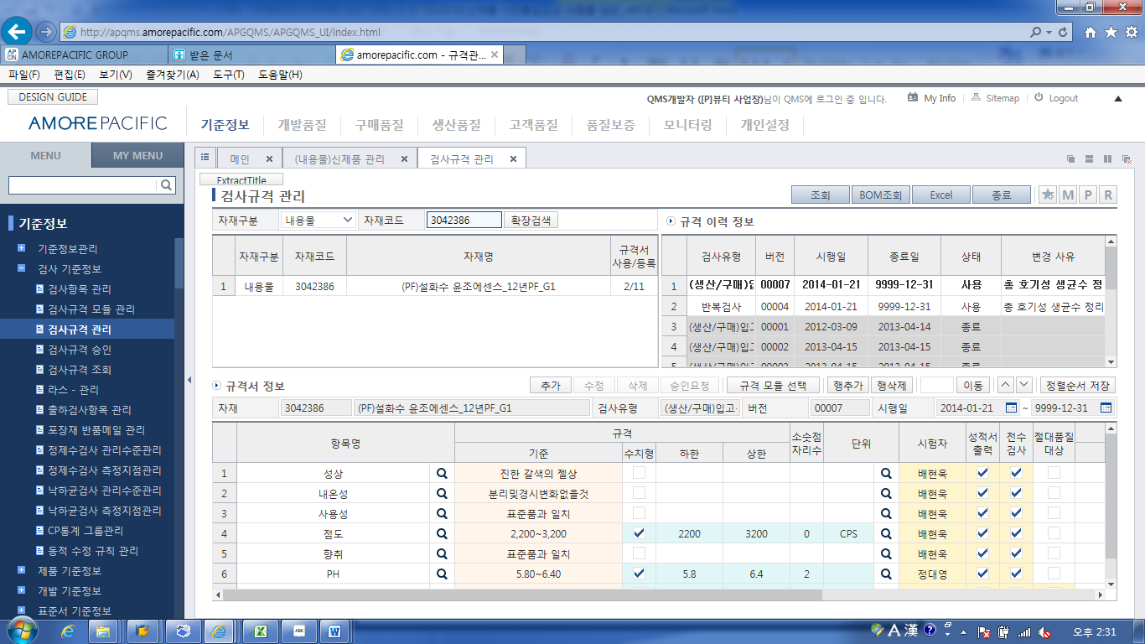
2
2
1
1
1
- Open “Master Data-Inspection Master Data-Inspection Specification Management” to enter the relevant items for which to confirm the inspection specifications.
- Check “Specification Information” then when necessary adjust the inspection specifications and click “Add.”

- Preparation of Product Specification Certificate (Legacy)

  - Preparation of Product Specification Certificate
Description | Process of QI PIC preparing a Product Specification Certificate for the items defined in the legal standards, other guidelines, and requesting approval
Menu Path | GQMS – Development Quality – Product Specification Certificate – (Legislation) New Registration
System | GQMS

    - Preparation of Product Specification Certificate
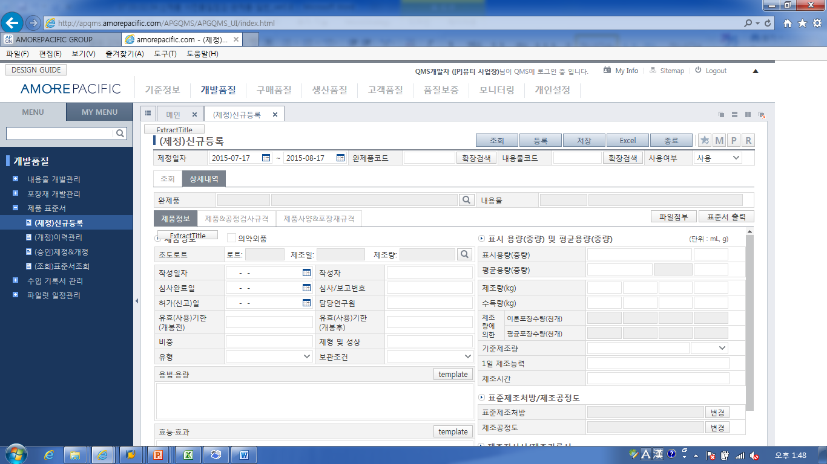
3
1
2
- Open GQMS “Development Quality.”
- Open “Product Specification Certificate – (Legislation) New Registration.”
- Search for “finished product code” to register and save the relevant details.

- Approval of Product Specification Certificate (Legacy)

  - Approval of Product Specification Certificate
Description | Process of reviewing the Product Specification Certificate by the quality department head and based on legal and internal standards decide whether it is suitable. If it is, the head issues approval.
Menu Path | GQMS – Development Quality – Product Specification Certificate – (Approve) Legislation & Revision
System | GQMS

    - Approval of Product Specification Certificate
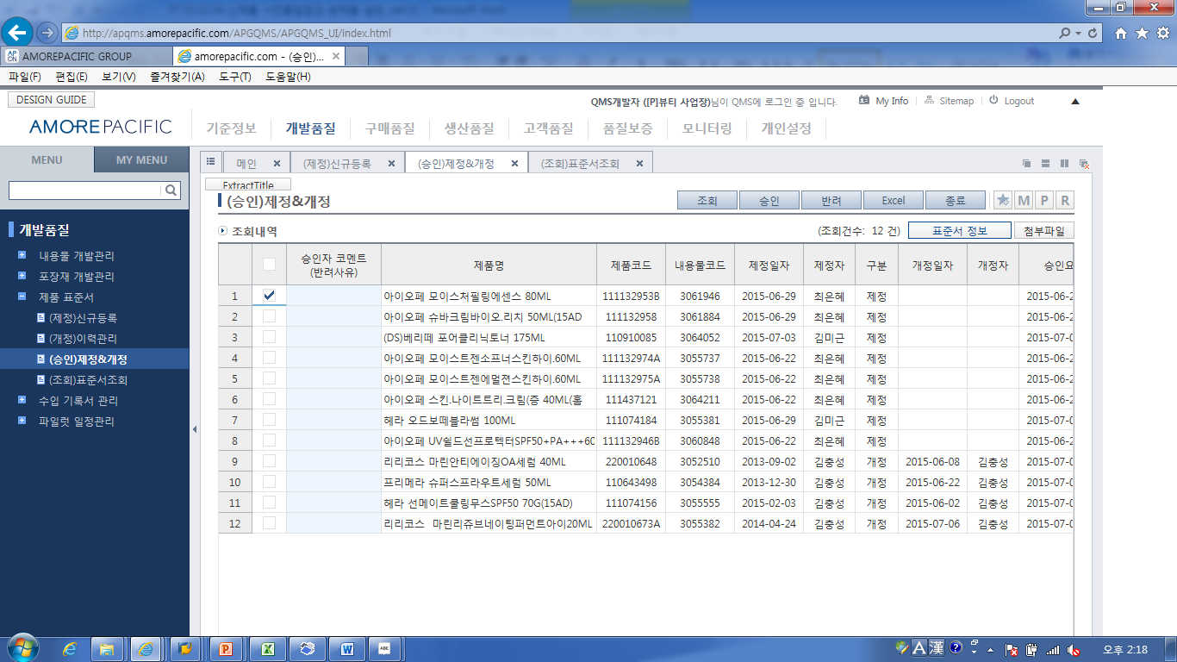
2
5
4
3
1
- Open GQMS – Development Quality-Product Specification Certificate-(Approval) Legislation&Revision.
- Click “Display.”
- Select the Specification Certificate to approve.
- When intending to check the information of the relevant specification certificate click the “Specification Certificate Information.”
- Check the specification information then click on “Approve or Reject.”
When “rejecting’ always enter “Approver Comment (Rejection Reason).”

