FI_Carry Forward Manual_ Asset fiscal year change (AJRW)
- T-Code/Function/Menu
Application | Menu/Func./Tcode | Descriptioin
SAP-FI | AJRW | Opens a new fiscal year for asset posting and Enables postings in the new fiscal year.
SAP-FI | AW01N | How to check after Asset fiscal year change
- Asset Change Procedure for new year
  - Enter company code
  - Enter new fiscal year
  - If it is a test, check the "Test run" as 'X'
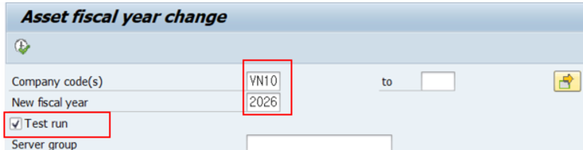

  - Delete the value of the "Test run" field, if it is a real run, Run in the background from the menu.
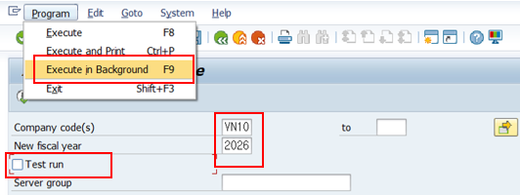

- Check Asset Fiscal Change in AW01N.
  - Enter “Company Code”
  - Enter “Asset Number”
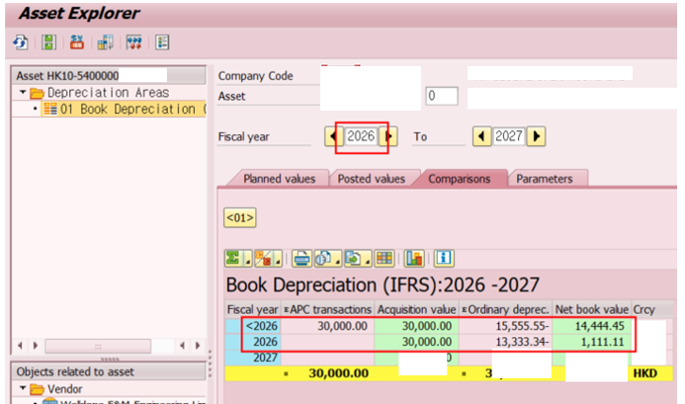
- After the change of the asset fiscal year, it will be displayed from the new year.
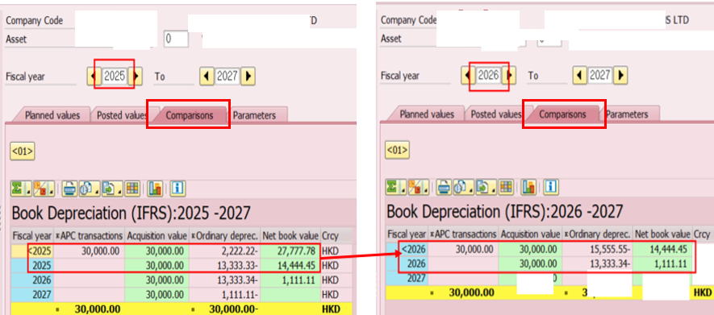
- In addition, when checking the “Comparisons” tab in AW01N, you can confirm that the 2025 year-end balance matches the 2026 beginning balance (cumulative balance). If they do not match, it means that additional postings were entered in the prior year after the carryforward process. In that case, simply rerun the carryforward process.

