SAP CO - Solution for SAP F4 Help Search Help Function Error
- T-Code/ Function / Menus
Application | Menu/Function/T-code Name | Description
SAP-CO | F4 Search help | Search help  Input value help
- Executives and execution status
  - Executives – Who wants to F4 input value help SAP
  - Execution status – Error while F4 Search help pop-up windows. Title : Internal error Table format , Message : “Cancel”
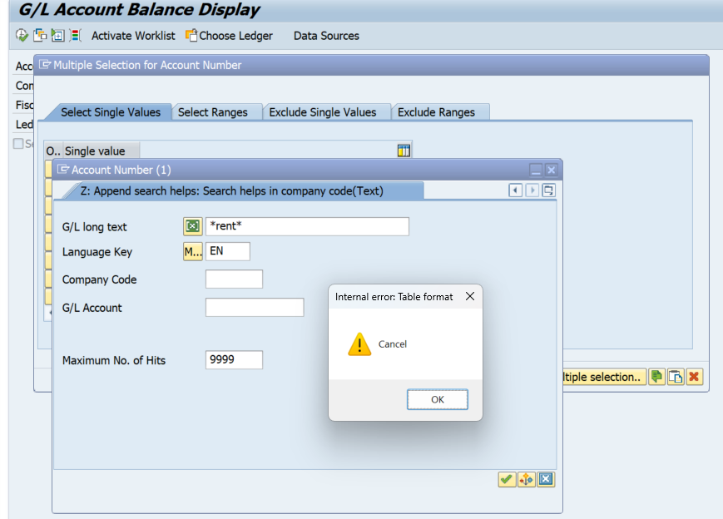
- The solution
  - SAP Top Menu Help > Settings > F4 Help > Display Control(amodal) > okay (-> However, please note that this method may be inconvenient for users.)
  - It is recommended to install SAP GUI version 770 or higher. To install SAP 770, please submit a request through IT Helpdesk > General Inquiry > SAP-BC, or call 1588-5870 for remote support installation.
