BW/BI - S_ZSD_702_Q0013 [Std] Sell-Thru Analysis by POS receipt
- T-Code/ Function/Menu
Application | Menu/Func./Tcode | Description
SAP BW | S_ZSD_702_Q0013 | [Std] Sell-Thru Analysis by POS receipt
- Executor & Inquiry Details
  - Executor: Analysis Office user
  - Inquiry Details: When user try to analyze POS sales & CRM status with BI report.
  - Inquiry Type:
    - What is difference between Consumer Price / Sell-thru amt?
    - How is customer status calculated at a monthly level?
    - How is customer status calculated at a yearly level?

- S_ZSD_702_Q0013 [Std] Sell-Thru Analysis by POS receipt Key Figures
  - Key Figures
Key Figures | Description
Sell-Thru Qty (Bfr. / Aft. Set Dsb.) | Sales quantity
Consumer Price (Bfr. / Aft. Set Dsb.) | Sales amount in consumer price
Sell-Thru Amt (Bfr. / Aft. Set Dsb.) | Actual sales amount after discount
Number of consumer | SAP BI system counts unique "CRM Customer" numbers at each reporting level.
Number of Bill | SAP BI system counts unique "Bill no." number at each reporting level.

  - Difference between “Bfr. Set Dsb.” / “Aft. Set Dsb.”
    - Before set disassembly, the performance is reported based on the actual items in POS system.
    - After set disassembly, the performance of set products is allocated and presented at the component level based on sales BOM in SAP.
    - There are 3 conditions for set disassembly
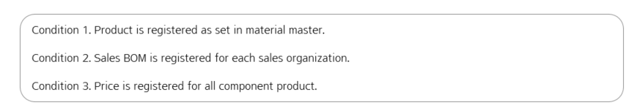
      - Set Disassembly Criteria
        - The material is registered as a set product in material master, or set disassembly indicator is checked. (T-Code: MM03)
        - Example ) 111380687 – AP BOTANICAL ESSENTIAL SET (20)
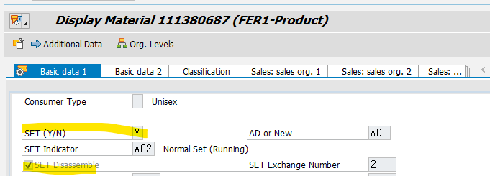

      - Quantity Disassembly criteria
        - Sales BOM is registered in the system with valid period. (T-Code: CS03). Sellable goods only considered for set disassembly.
        - Example ) Sales BOM for 111380687 material in HK20 Organization
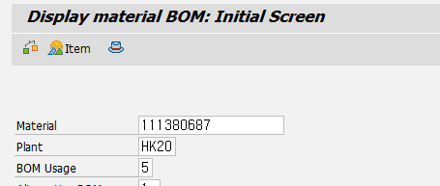
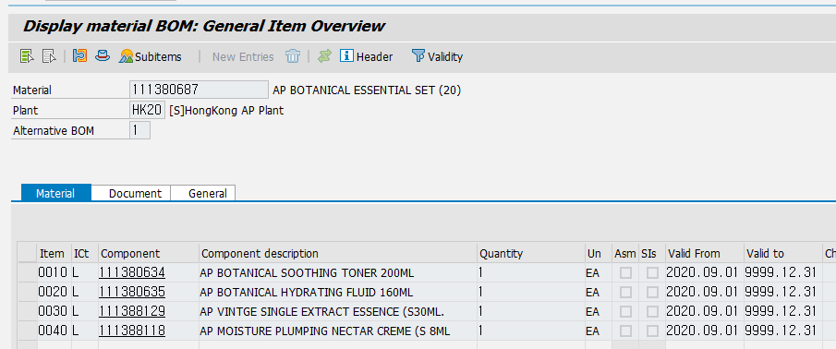
Bfr. Set Dsb. Sales Qty – 111380687 – 1 EA
Aft. Set Dsb. Sales Qty – 111380634 – 1 EA
111380635 – 1 EA
      - Amount Disassembly criteria
        - Pricing for the components must be maintained with a valid period. The allocation ratio is calculated by considering the price and quantity within the set (T-Code: VK13, Condition Type: ZP00)
        - Example ) Price for 111380634 material in HK20 Organization
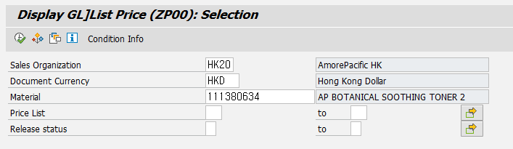
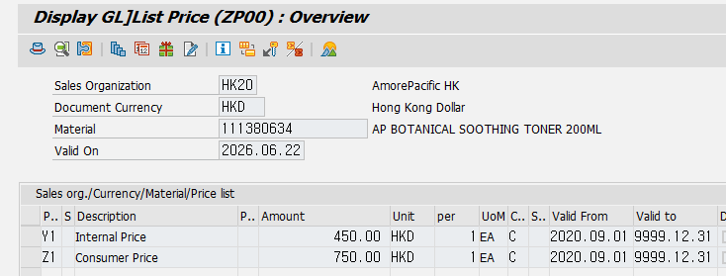
Price for 111380635 material in HK20 Organization
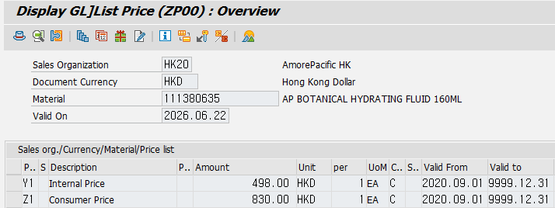
Set Allocation Ratio
111380634 = 1 EA * 750 HKD / ( 1 EA * 750 EA + 1 EA * 830 HKD ) = 47.5 %
111380635 = 1 EA * 830 HKD / ( 1 EA * 750 EA + 1 EA * 830 HKD ) = 52.5 %

  - Remarks for Number of consumer / Bill
    - Number of Consumer
      - This customer have sales result with 2 stores. so number of consumer is counted as 1 for each store, but it also counted as 1 in summary level.
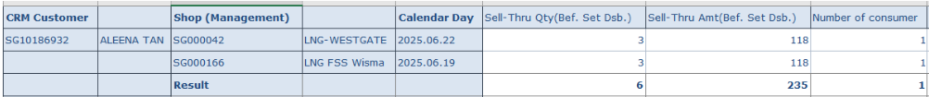
      - Visitors also have CRM Customer code, it also counted as 1. so if you want to exclude visitors, please exclude "Visitors" condition in (MTD) Customer Check.
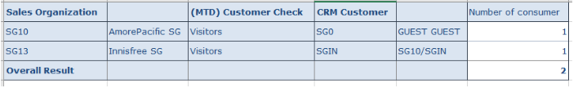
    - Number of Bill
      - This receipt have 9 different items. so number of bill is counted as 1 for each material, but it also counted as 1 in summary level.
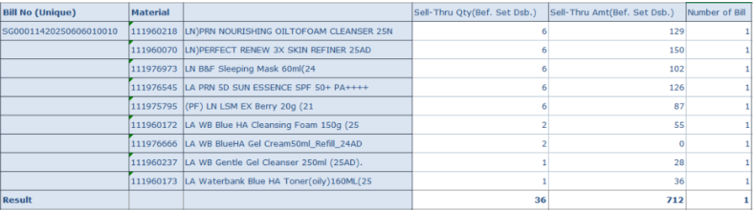

- S_ZSD_702_Q0013 [Std] Sell-Thru Analysis by POS receipt Characteristics
  - Material
Characteristic | Description
Material | Material code in recorded in Global POS system
Brand Group(N) | Brand Group in SAP Material master
Brand(N) | Brand in SAP Material master
Material Usage(N) | Material Usage in SAP material master (Sellable Goods, Sample, Promotional, .. )
Material Type(N) | Material Type in SAP material master (FER1 - Product, HAW1 - Trading goods, PCM1 - Promotional, SVC - Service, .. )
Rep. Product(N) | Representative product code in SAP material master
Prod.Type Lvl1(N) | 1 level product type in SAP material master (Beauty, Health, .. )
Prod.Type Lvl2(N) | 2 level product type in SAP material master (Skin Care, Makeup, .. )
Prod.Type Lvl3(N) | 3 level product type in SAP material master (Makeup Cleansing, Mask, .. )
Prod.Type Lvl4(N) | 4 level product type in SAP material master (Cleansing Oil, Wash-Off Mask, .. )
SET (Y/N)(N) | Set product indicator in SAP material master (Y, N)
Material before SET | When you analyze "Aft. SET Dsb." key figures, you can find original set product code information with this characteristic
Material Grade(N) | Material grade in SAP Material - Sales view master (New, Running, Discontinued, .. )
  - Shop
Characteristic | Description
Shop (Management) | Shop code managed in Global POS system
CRM Brand(N) | Brand information in Shop level
S/Sales District(N) | Sales District in Global POS shop master (JP]kanto, JP]kinki, .. )
S/Customer Categ(N) | Customer Category in SAP Customer - Sales view master (ID]Department, ID]Online Shopping, ..)
S/Sales Office(N) | Sales Office in SAP Customer - Sales view master ([SG]Sulwhasoo, [SG]Laneige, .. )
S/Distributor(N) | Distributor in SAP Customer - Sales view master (AS]Lazada, AS]Shopee, NA]Amazon, .. )
  - POS Sales
Characteristic | Description
Bill No (Unique) | Receipt number in Global POS system
First Sales Flag | If this receipt was generated in same date with member's first sales date in Global POS member master, "Y" or "N"
Sales/Return Flag | Sales type indicator (Sales, Return, Gift Sales, Gift Return, Sample Sales, Sample Return)
Discount Reason | A reason why discount is applied on this receipt
  - CRM Customer
Characteristic | Description
CRM Customer | Member code managed in Global POS system
Age(N) | Age of member. This is calculated based on birthday information in Global POS member master
POS Grade | Member grade at the time of purchase
(MTD)Customer Status | Member Status in that month  ** New: Purchase amount of this month > 0 & If member sales result was recorded for the first time.  ** Comeback: Purchase amount of this month > 0 & Last 12 months purchase amount <= 0  ** Retained: Purchase amount of this month > 0 & Last 12 months purchase amount > 0  ** Others: Purchase amount of this month <= 0. (Return / Gift / Sample .. )  ** Visitors: Not Registered.
(BY)(YTD)Customer Status | First entered (MTD) Customer Status during the Business Year  - If first entered MTD status is "Others", YTD status is also assigned as "Others" of that month,  But from next month, YTD status will be updated as MTD status of next month.

- Example of Customer Status
  - Case 1) If a member purchase for the first time in July 2024 & No valid sales result (amount <= 0) for Aug 2024 & Purchase amount > 0 for Sep 2024.
    - July 2024 - (MTD) Customer Status: New / (BY)(YTD) Customer Status: New
    - Aug 2024 - (MTD) Customer Status: Others / (BY)(YTD) Customer Status: New
    - Sep 2024 - (MTD) Customer Status: Retained / (BY)(YTD) Customer Status: New
  - Case 2) If a member doesn't have valid sales result for July 2024, and purchase amount > 0 for Aug 2024, Sep 2024.
    - July 2024 - (MTD) Customer Status: Others / (BY)(YTD) Customer Status: Others
    - Aug 2024 - (MTD) Customer Status: Comeback / (BY)(YTD) Customer Status: Comeback
    - Sep 2024 - (MTD) Customer Status: Retained / (BY)(YTD) Customer Status: Comeback

