S_ZSD_001_Q0058 [Std] Net Sales by Brand / Channel
- T-Code/ Function/Menu
Application | Menu/Func./Tcode | Description
SAP BW | S_ZSD_001_Q0058 | [Std] Net Sales by Brand / Channel
- Executor & Inquiry Details
  - Executor: Analysis Office user
  - Inquiry Details: When user try to analyze net sales with BI report.
  - Inquiry Type:
    - What does 'Net Sales' mean in the BI query S_ZSD_001_Q0058?
    - How is net sales quantity / amount calculated in the net sales report?
    - How is consumer price calculated in the net sales report?
    - What is definition of “Customer” in the net sales report?
    - What is definition of “Material before SET” in the net sales report?
- S_ZSD_001_Q0058 [Std] Net Sales by Brand / Channel Key Figures
  - Key Figures
Key Figures | Description
Bfr. Set Dsb. / Aft. Set Dsb_Net Sales Qty | Sales Qty + Return Qty
ㄴ Bfr. Set Dsb. / Aft. Set Dsb_Sales Qty | Billing Quantity by sales type in SAP (Standard Order, Direct Order, Handover Order, Adjust Order, …)
ㄴ Bfr. Set Dsb. / Aft. Set Dsb_Return Qty | Billing Quantity by return type ins SAP (Returns, Direct Returns, Handover Returns, Adjust Returns, …)
Bfr. Set Dsb. / Aft. Set Dsb_Sales-Return Amt (Exc. VAT) | Sales Amt (Product Amount) + Return (Product Amount)
ㄴ Bfr. Set Dsb. / Aft. Set Dsb_Sales Amt (Product Amount) | Billing Amount by sales type in SAP - Exclude VAT (Standard Order, Direct Order, Handover Order, Adjust Order, …)
ㄴ Bfr. Set Dsb. / Aft. Set Dsb_Return (Product Amount) | Billing Amount by return type ins SAP -Exclude VAT (Returns, Direct Returns, Handover Returns, Adjust Returns, …)
Bfr. Set Dsb. / Aft. Set Dsb_Total sales | Billing Amount by sales + return type in SAP – Include VAT
Bfr. Set Dsb. / Aft. Set Dsb_Consumer Price | Net Sales Qty * Consumer Price (Z1)
Bfr. Set Dsb. / Aft. Set Dsb_Net sales | Same with net sales amount in Profit & Loss report. (Calculated by product sales & retail margin)  Before 2022.07– Old P&L (Standard Report – HQ AP: S_ZCO_402_Q0066 / Others: S_ZCO_402_Q0006)  From 2022.07– New P&L (Standard Report - S_ZCO_408_Q0001)
  - Difference between “Bfr. Set Dsb.” / “Aft. Set Dsb.”
    - Before set disassembly, the performance is reported based on the actual billed material in SAP
    - After set disassembly, the performance of set products is allocated and presented at the component level based on sales BOM in SAP.
    - There are 3 conditions for set disassembly
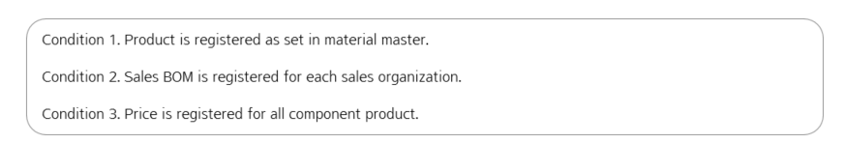
      - Set Disassembly Criteria
        - The material is registered as a set product in material master, or set disassembly indicator is checked. (T-Code: MM03)
        - Example ) 111380687 – AP BOTANICAL ESSENTIAL SET (20)
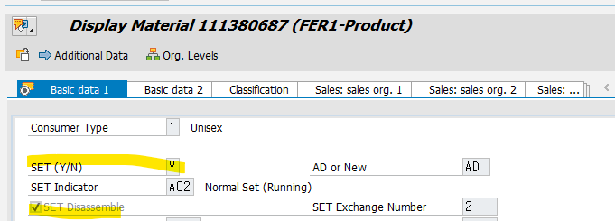
      - Quantity Disassembly criteria
        - Sales BOM is registered in the system with valid period. (T-Code: CS03). Sellable goods only considered for set disassembly.
        - Example ) Sales BOM for 111380687 material in HK20 Organization
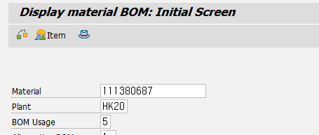
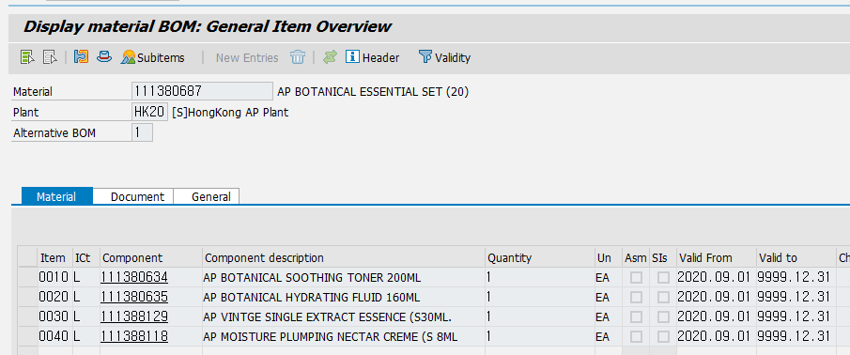
Bfr. Set Dsb. Sales Qty – 111380687 – 1 EA
Aft. Set Dsb. Sales Qty – 111380634 – 1 EA
111380635 – 1 EA
      - Amount Disassembly criteria
        - Pricing for the components must be maintained with a valid period. The allocation ratio is calculated by considering the price and quantity within the set (T-Code: VK13, Condition Type: ZP00)
        - Example ) Price for 111380634 material in HK20 Organization
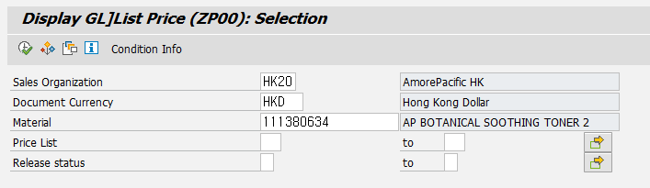
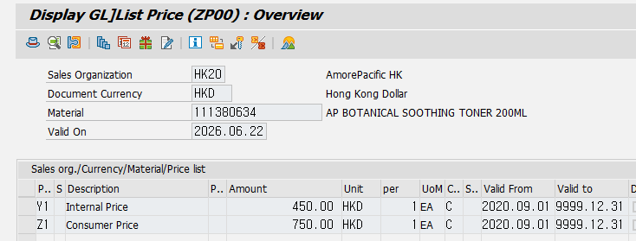
Price for 111380635 material in HK20 Organization
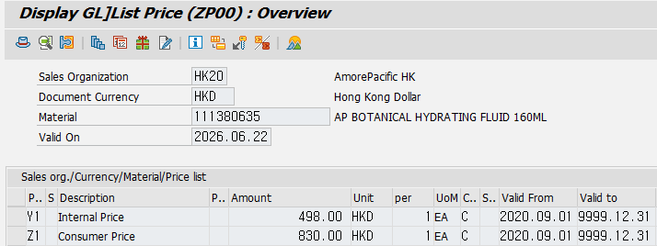
Set Allocation Ratio
111380634 = 1 EA * 750 HKD / ( 1 EA * 750 EA + 1 EA * 830 HKD ) = 47.5 %
111380635 = 1 EA * 830 HKD / ( 1 EA * 750 EA + 1 EA * 830 HKD ) = 52.5 %

- S_ZSD_001_Q0058 [Std] Net Sales by Brand / Channel Characteristics
  - Material
Characteristic | Description
Material | Material code managed in SAP system
Brand Group(N) | Brand Group in SAP Material master
Brand(N) | Brand in SAP Material master
Material Usage(N) | Material Usage in SAP material master (Sellable Goods, Sample, Promotional, .. )
Material Type(N) | Material Type in SAP material master (FER1 - Product, HAW1 - Trading goods, PCM1 - Promotional, SVC - Service, .. )
Rep. Product(N) | Representative product code in SAP material master
Prod.Type Lvl1(N) | 1 level product type in SAP material master (Beauty, Health, .. )
Prod.Type Lvl2(N) | 2 level product type in SAP material master (Skin Care, Makeup, .. )
Prod.Type Lvl3(N) | 3 level product type in SAP material master (Makeup Cleansing, Mask, .. )
Prod.Type Lvl4(N) | 4 level product type in SAP material master (Cleansing Oil, Wash-Off Mask, .. )
AD or New (N) | AD / New / SPOT information in SAP material master
SET (Y/N) (N) | Set product indicator in SAP material master (Y, N)
SET Ind(N) | Set product type in SAP material master (Single Product Set, Normal Set, ... )
Material before SET | When you analyze "Aft. SET Dsb." key figures, you can find original set product code information with this characteristic
Material Grade(N) | Material grade in SAP Material - Sales view master (New, Running, Discontinued, .. )
Product Operator(N) | Product operator in SAP Material - Sales view master
1st sale date(N)_mat | First sales date in SAP Material - Sales view master
  - Customer
Characteristic | Description
Customer | Shop code managed in SAP system
Customer Type(N) | Customer type in SAP Customer master (Online, Offline)
Shop Condition(N) | Customer status in SAP Customer master (General, Stopped, Business Closed, .. )
Sales Type(N) | Sales type in SAP Customer master (Direct Purchase, Consignment Stock, Export, ...)
Partner Company(N)) | Partner company code in SAP Customer master, If customer is for internal transaction with affiliate company, it shows the affiliate company code
Sub Sales Channel(N) | Sub Sales Channel in SAP Customer - Sales view master (SG]AmorePacific, SG]Innisfree, .. )
Sales Office(N) | Sales Office in SAP Customer - Sales view master ([SG]Sulwhasoo, [SG]Laneige, .. )
Customer Category(N) | Customer Category in SAP Customer - Sales view master (ID]Department, ID]Online Shopping, ..)
Customer group(N) | Customer group in SAP Customer - Sales view master (B2B]Agency, B2C]Road Shop, B2C]Online mall, .. )
Distributor(N) | Distributor in SAP Customer - Sales view master (AS]Lazada, AS]Shopee, NA]Amazon, .. )
1st sale date(N)_cust | First sales date in SAP Customer - Sales view master

  - Others
Characteristic | Description
Company Code | Company code information (CN10, SG10, ..)
Sales Organization | Sales organization information (CN10, CN12, CN13, ... )
Country(N) | Country of Company code
Sales doc. type | Sales order type of billing quantity & amount (Standard Order, Direct Order, .. )
Reason for order | Sales order reason of billing quantity & amount (SA]General, SA]Promotion Product Sales, .. )

