BW/BI - Analysis Office – How to resolve the issue when the Analysis tab does not load automatically
- T-Code/Function/Menu
Application | Menu/Func./T-CODE | Description
SAP BW | Analysis Office | Analysis Office
- Executor & Inquiry Details
  - Executor: Analysis Office User
  - Inquiry Details: Analysis tab is not loaded to excel application.
  - Inquiry Types:
    - There is no analysis tab on excel.
    - I have to add analysis tab manually every time when excel opened.
    - How can I add analysis tab?
    - ff Please let me know how to resolve the issue where the Analysis tab is not visible after restarting Excel, even though it was loaded before.
    - I am unable to view the BW report in Excel.
- Troubleshooting steps : How to load analysis tab automatically
  - Go to Excel > File > Options.
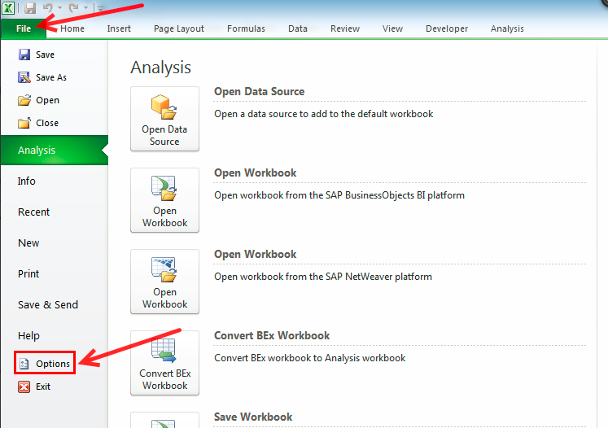

  - Go to [Add-Ins] > Change manage option as [COM Add-Ins] > Go
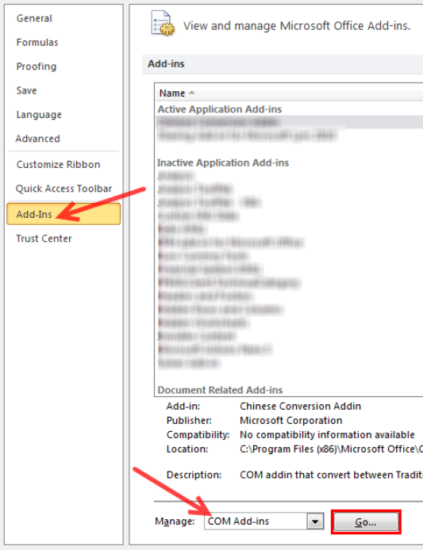

  - Check whether Load Behavior status is “Load at Startup” or not.
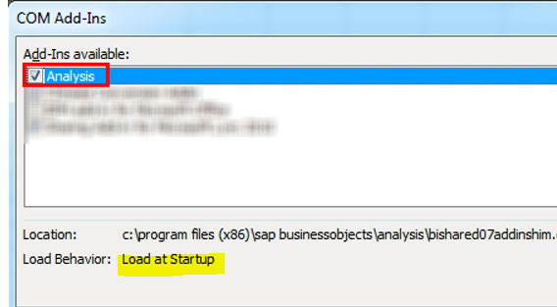
  - If this Load Behavior status is in “Loaded” or “Unloaded”, add-ins cannot be loaded automatically.
  - In this case, quit all excel files in process.

  - Search [regedit] at windows menu.
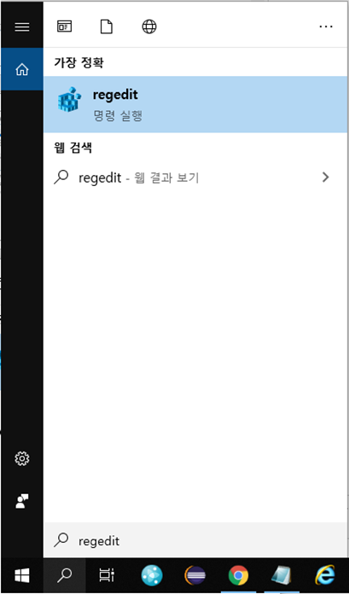

  - Go to [HKEY_CURRENT_USER\Software\Microsoft\Office\Excel\Addins\SapExcelAddIn] directory.
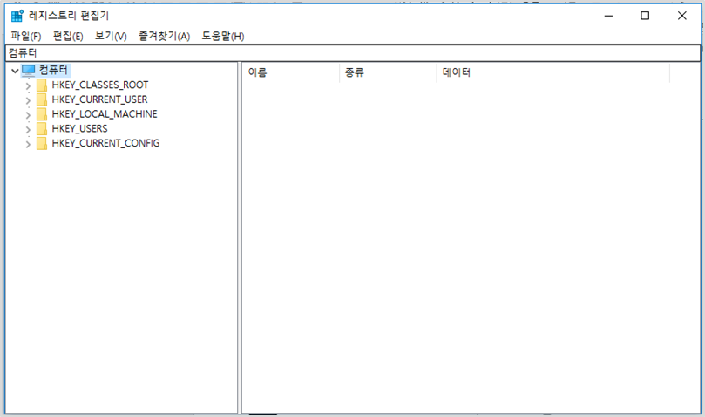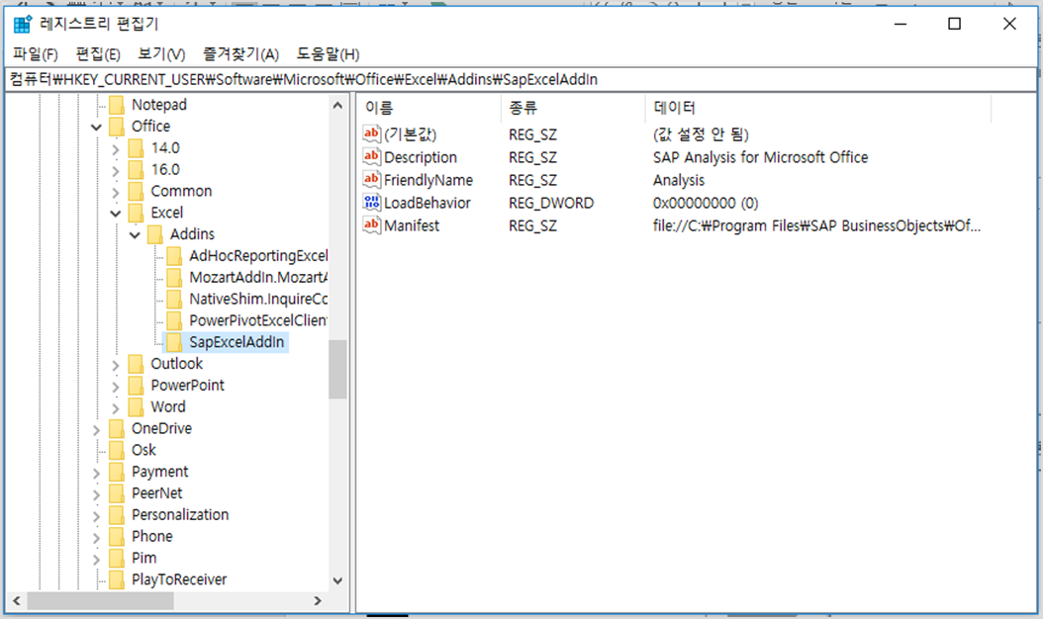

  - Double Click [LoadBehavor] and Change its value as 3.
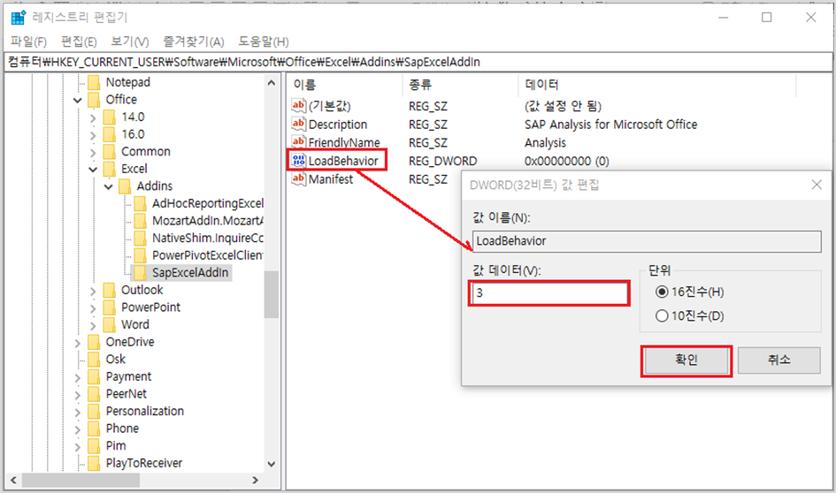
  - Restart Excel application, and check analysis tab is loaded or not.