BW/BI-Analysis Office-Logon balancing error 88: Cannot connect to message server
- T-CODE / Function / Menu
Application | Menu/Func./T-CODE | Description
SAP-BW | Analysis Office | Analysis Office

- Executor & Inquiry Details
  - Executor: Analysis Office User
  - Inquiry Details: User get ‘Logon balancing error 88: Cannot connect to message server’ error when try to log-on the service.
  - Error Message: ‘Logon balancing error 88: Cannot connect to message server’
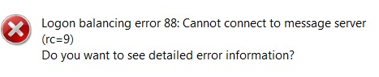
- Causes
  - Network connection error

- How to check network connections
  - Try server connection with SAP Logon application also. If you get same error when you try to open SAP server, this needs to be checked with related system operators.
System Checks Priority
1) Intranet network status in user PC
2) Intranet network status in user’s region
3) SAP network issue.
  - If you can access server in SAP logon application, only get errors on analysis office, please contact ITO SAP administrator for support.

