BW/BI – Analysis Office - No data shown on excel sheet
- T-Code/ Function/Menu
Application | Menu/Func./Tcode | Description
SAP-BW | Analysis Office | BW A-Office reporting tool
- Executor & Inquiry Details
  - Executor: A user who is unable to view rows and columns in Analysis Office.
  - Inquiry Details: When user insert BI report, no data extracted on excel sheet.
  - Inquiry Type:
    - BI report does not appear. It is empty.
    - There is no data shown even though I have signed in.
    - Missing Column / Rows in analysis.
- Error Situation: When user insert BI report in excel sheet, there is no data extracted and Rows and columns are not visible in design panel.
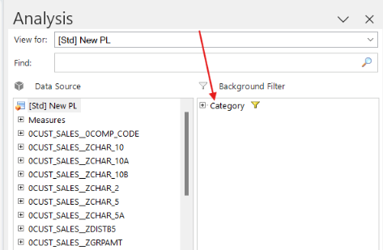
- How to resolve
  - Please try again with "Insert Data Source -> Select Data Source for Analysis" menu.
  - " Insert Data Source -> Select Data Source for Defining Formulas" is not used for report analysis.
