BW/BI-How to reset SAP BI password
- T-CODE / Function / Menu
Application | T-CODE / Function / Menu | Description
AP-ON | SAP/BI Password Reset | Password Reset Menu for SAP account

- How to reset SAP BI password

2.1. AP-ON > Profile Image > Select [SAP/BI Password Reset] menu.
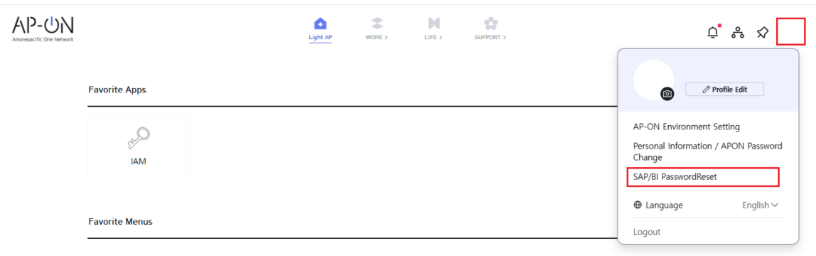

2.2. Select BWP(BI/BW) option as target system, Enter your AP-ON password and then Click [Reset Request] button.
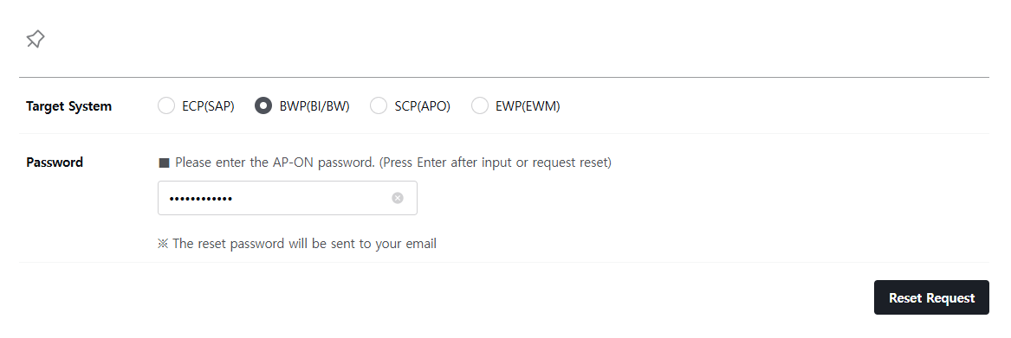

2.3. You can receive initialized SAP BI password with AP-ON mail.
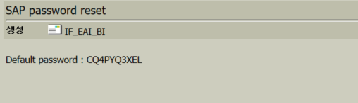
- How to log on analysis office with initialized password.

3.1. Go to Excel > Analysis > Insert Data Source > Select Data Source for Analysis > Choose BWP server on the list.

3.2. Enter log-on information. Client: 100 / User: ID / Password: Initialized password / Language: EN or ZH or KO. Then system requires you to change it into new one. You can access the service after password change.
