MM_How to cancel a goods receipt after it has been posted(MBST)
- T-Code/Function/Menu
Applications | Menu/Function/T-Code Name | explanation
SAP-MM | MBST | Cancel GR
- Scenarios
  - Situation
    - A user who wants to cancel a good receipt hat was mistakenly posted(Transaction MIGO), even though the actual materials of a Stock Transport Order (STO) or Purchase Order (PO) have not yet arrived at the site.
  - Inquiry Scenarios
    - I accidentally posted a goods receipt (MIGO) and want to cancel it. How can I cancel the good receipt(GR)?
    - If the current posting month is not closed and there is sufficient available stock, can we proceed with the cancellation using MBST?
- Cause
  - Due to human error, a goods receipt(MIGO) was posted before the physical receipt.
- Solution
  - First, to find the material document number for cancellation, run transaction code ZSD70140, enter the required selection criteria, and then display the list.
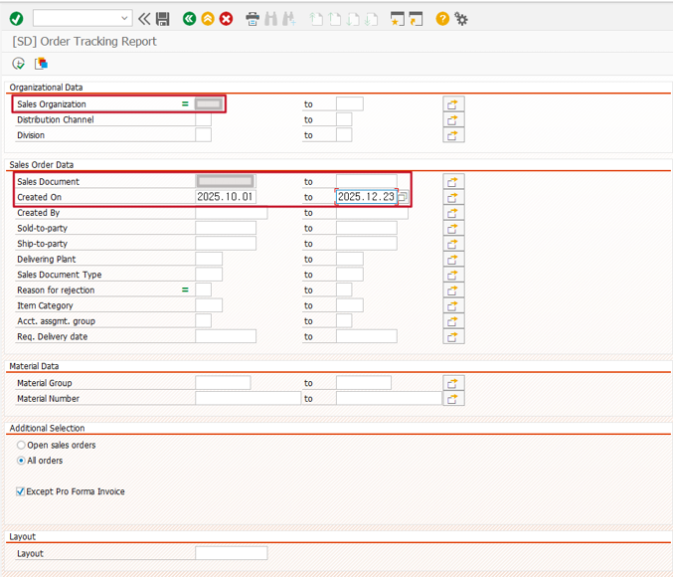
  - After display the list, you can check the goods receipt material document number.
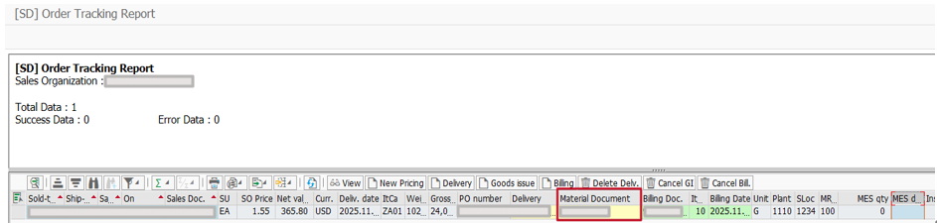
  - Using the identified goods receipt material document, execute transaction MBST, enter the material document number and posting date, verify the processing details, and then click the Save button to complete the cancellation.
