WM-[For Thailand Only]How to use transferring stock between storage locations of Thai
- T-Code/Function/Menu
Applications | Menu/Function/T-Code Name | Description
SAP-WM | ZWM85110 | STOCK Transfer
SAP-WM | ZWM80460 | STOCK Transfer Monitor
- Situation
  - Users who want to move inventory between storage locations in Thailand
  - Inquiry Type
    - "I want to move inventory between storage locations"
    - "I want to confirm the transferring stock from WMS."
    - "I want to check the results of the inventory movement between storage locations."

Transferring stock between storage locations and WMS Interface
  - Perform stock transfer between storage locations using transaction code ZWM85110.
    - Input the plant and FROM/TO storage location, then press Enter -> input the product code and transfer quantity, and click 'Stock Transfer Posting' at the top of the screen.
    - Automatically generated documents are canceled when a WMS reception error occurs.
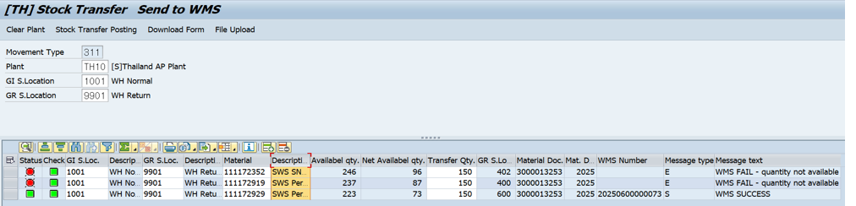
  - You can use transaction code ZWM80460 to check (monitor) the results of inventory movements.
    - Enter the I/F date and Plant, select the Status, and then execute.
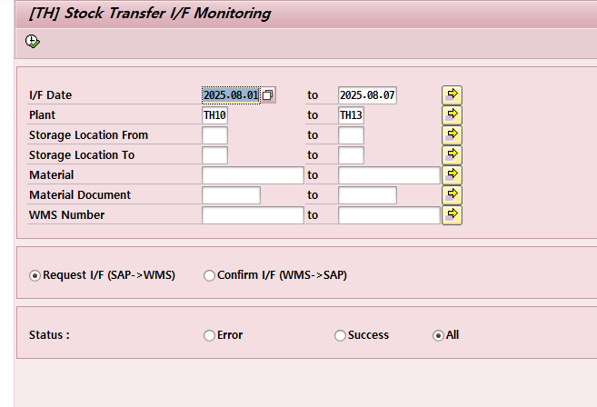
    - You can check the processing results on the query result screen. The first material document is an inventory transfer material document, and the second material document was automatically canceled due to a WMS interface error
