WM-[For Thailand Only] How to Use the Logistics Outbound delivery (GI) Process of the Thai
- T-Code/Function/Menu
Applications | Menu/Function/T-Code Name | Description
SAP-SD | ZSD77000 | Confirm outbound DN
SAP-WM | ZWM80180 | GI request Send
SAP-WM | ZWM80200 | Confirm picking and Good Issue
- Situation
  - Users who want to check how to use the logistics shipping process of the Thai subsidiary
  - Inquiry Type
    - "I want to send the outbound delivery to the Thai subsidiary WMS."
    - "I want to confirm the shipment confirmation process from the Thai subsidiary WMS."
    - "I want to check the documents that need to confirm the logistics shipment of the Thai subsidiary."

Logistics Outbound(GI) and WMS Interface Method
  - For the logistics shipment request, go to transaction code ZSD7000. Input the sales organization, shipping point/receipt point, and condition values and query them.
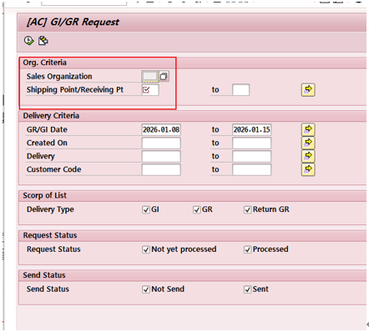
  - On the inquiry screen, Select All and click Request GI/GR to perform the shipment request.
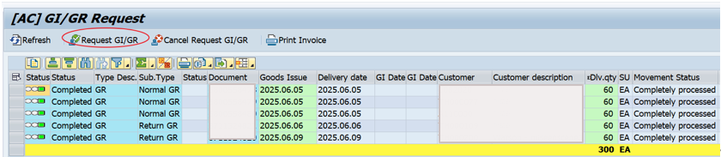
  - To send the shipment request to WMS, go to the transaction code ZWM80180, input the sales organization, shipping point/receipt point, and then query it.
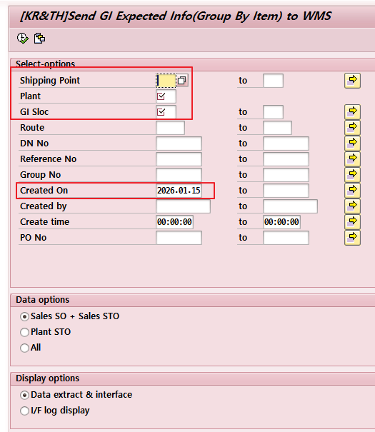
    - Select All on the inquiry result screen – click Send in the upper left corner to send it.
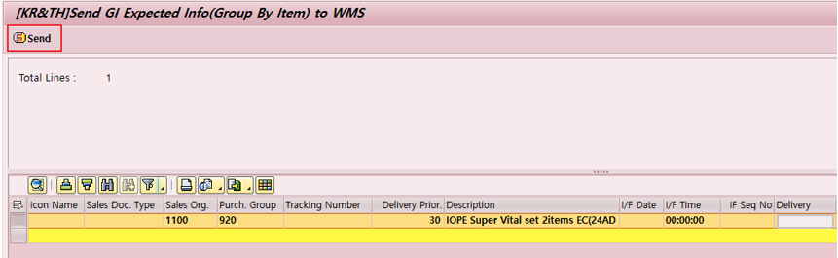
  - To confirm the shipment quantity picking, go to the ZWM80200, enter the plant, the shipment storage location, and the DN generation date, and then view the data.
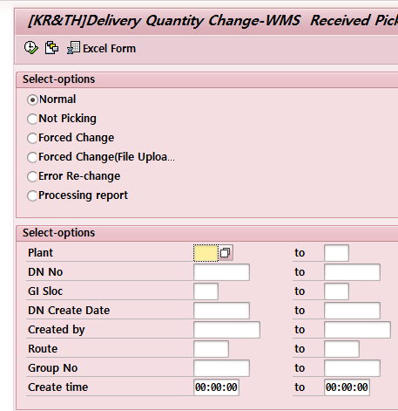
    - On the search results screen, select all -save, click "Save" in the top center to confirm picking.
