FI_Carry Forward Manual_Special Purpose Ledger Balance carryforward (GVTR)
- T-Code/Function/Menu
Application | Menu/Func./Tcode | Descriptioin
SAP-FI | GVTR | The balance of the Receivable's adjustment account is carried over to the next fiscal year
SAP-FI | FD10N | How to check after Carry forward of Special Purpose Ledger Balance.
- Carry Forward Procedure for Special Purpose Ledger
  - Enter ‘Z1’([FI-AR]Customer/Recon.Acct SL) for the value of the Ledger field.
  - Enter company code
  - Enter new fiscal year
  - If it is a test, check the "Test run" as 'X'
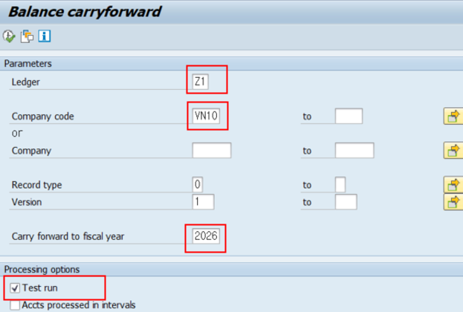

  - Delete the value of the "Test run" field, if it is a real run
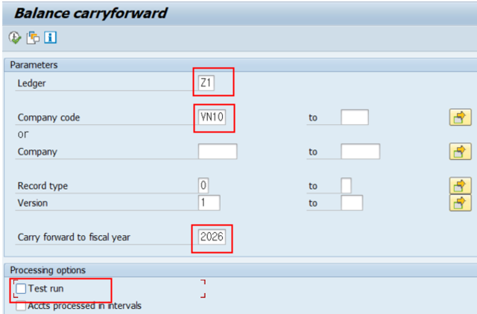

- Check the AR (Customer) Reconciliation Account Balance Carryforward in the Special general ledger view of FD10N.”.
  - Enter “Customer Code”
  - Enter “Company Code”
  - Enter “Fiscal Year”
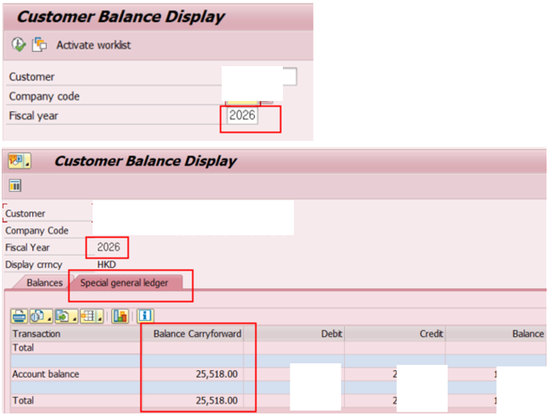
- When you view customer that use Special G/L, you can see the carryforward balance, which is the balance brought forward from the previous fiscal year into the current fiscal year

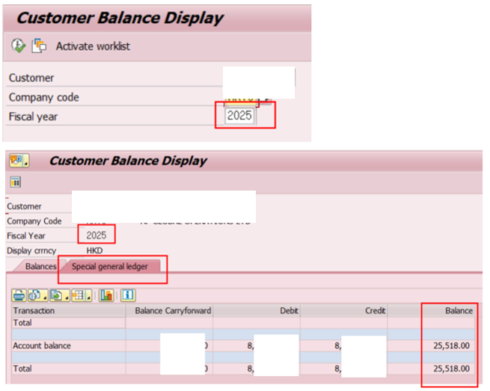
- When you check the Special general ledger for the customer you inquired, you can verify that the year-end balance of 2025 matches the beginning balance (cumulative balance) of 2026. If there are any customer for which the balances do not match, it indicates that additional postings were entered in the prior year after the carryforward process. In such cases, simply rerun the carryforward process.

