FI_Carry Forward Manual_Balance Carryforward to Accrual Engine (ACACCARRYFORWARD)
- T-Code/Function/Menu
Application | Menu/Func./Tcode | Descriptioin
SAP-FI | ACACCARRYFORWARD | The balance of the Accrual Engine is carried over to the next fiscal year
SAP-FI | ACACPSITEMS | How to check after Accrual Carry forward
- Carry Forward Procedure for Accrual Engine
  - Enter company code
  - Enter new fiscal year
  - If it is a test, check the "Test run" as 'X'
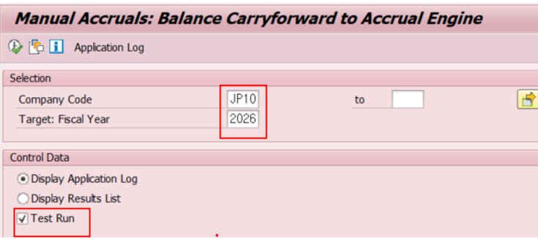
  - Delete the value of the "Test run" field, if it is a real run
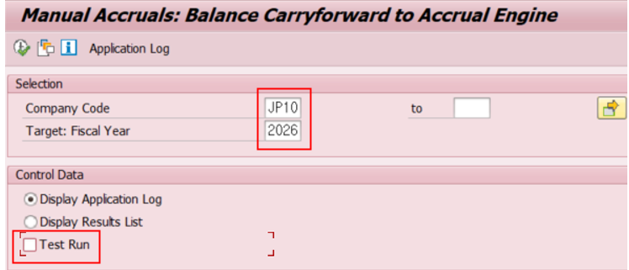
- Check Accrual balance Carry Forward in ACACPSITEMS.
  - Choose “Simulate Only”
  - Enter “Company Code”
  - Enter “Fiscal Year”
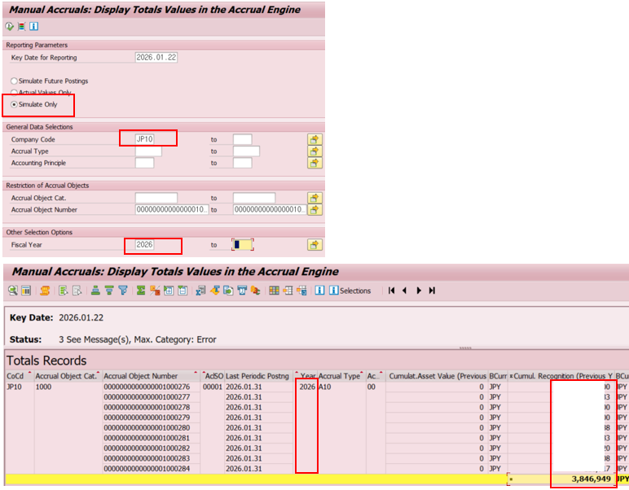
- After the Carry forward of Accrual Engine, the new year will be displayed as normal as above. If ACACCARRYFORWARD is not executed, it will not be displayed.
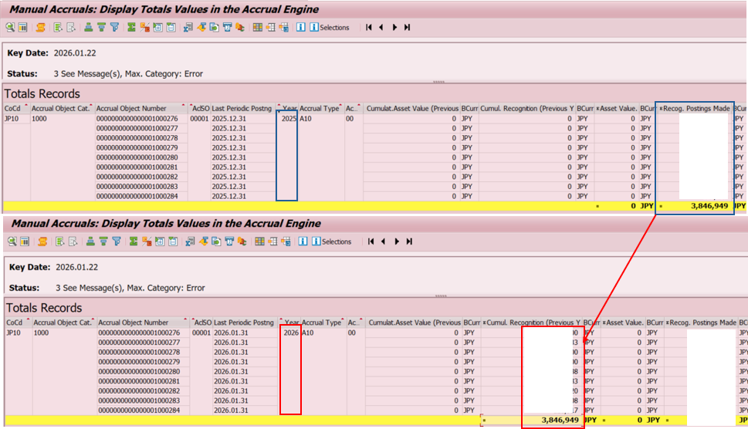
- After the Carry forward of Accrual Engine, 2025 year-end balance matches 2026 base balance (cumulative balance)

