How to handle Auto. Payment errors in F110 : error message - Item is blocked for payment.
- T-Code/ Function/Menu
Application | Menu/Func./Tcode | Description
SAP-TR | F110 | Explain how to take action against errors that occur when executing F110 (Auto.Payment).
- How to handle error message - Item is blocked for payment.
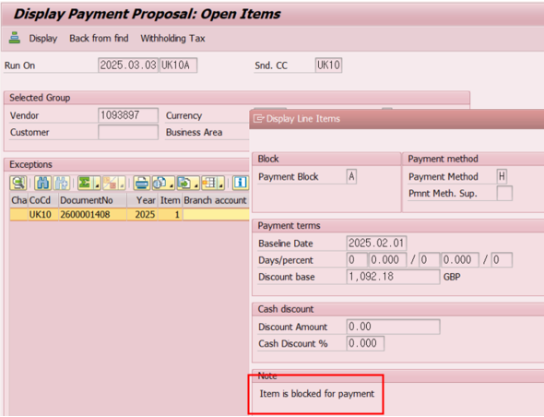
  - Error Message : Item is blocked for payment.

  - Cause of error : An error occurred because the 2600001408 documents was blocked for payment.
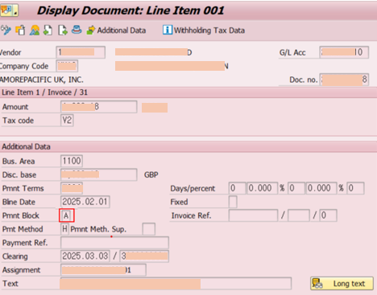
  - Resolution : Release the 2600001408 documents of payment block, and run F110 again.

