How to handle FI documents creation Error Message - Available amount is exceeded by 760.00 ( GBP ) Address(FIN3010/521702010)
- T-Code/ Function/Menu
Application | Menu/Func./Tcode | Description
SAP-FI | KE52  F-51 | Explain how to take action against errors that occur during FI documents generation.
- How to handle Error Message - Available amount is exceeded by 760.00 ( GBP ) Address(FIN3010/521702010)
  - Error Message : Available amount is exceeded by 760.00 ( GBP ) Address(FIN3010/521702010)
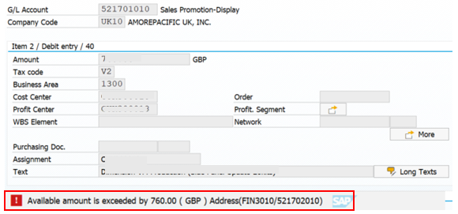
  - Cause of Error : Quarterly control is set in the 521701010 commitment item, which is an error caused by a lack of budget in the commitment item.
  - Resolution : Ask the budget manager to increase the budget.

