SAP FI - How to handle Asset Depreciation errors in AFAB.
- T-Code/Function/Menu
Application | Menu/Func./Tcode | Description
SAP-FI | AFAB | Explain how to take action against cost center errors when executing depreciation.
- Error Message : Cost Center VN00/VB5130 blocked against direct posting on 2025.02.28
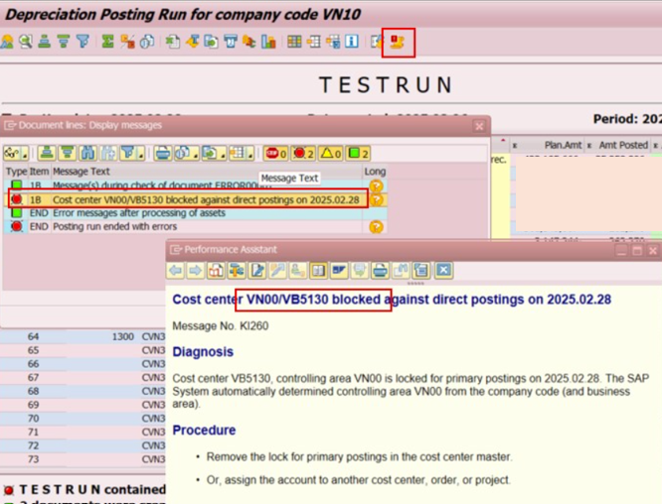
- Cause of error : It is an error issued because the cost center VB5130 is locked, so the document cannot be created to the cost center..
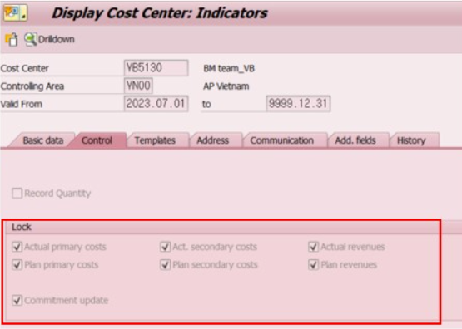
- Resolution : Unlock the cost center VB5130 in KS02 (Cost center Change), and Re-execute depreciation in AFAB.
