SAP TR - How to handle Auto. Payment errors in F110 : error message - Payment order has not been generated.
- T-Code/ Function/Menu
Application | Menu/Func./Tcode | Description
SAP-TR | F110 | Explain how to take action against errors that occur when executing F110 (Auto.Payment).
- Error Message : Payment order has not been generated.
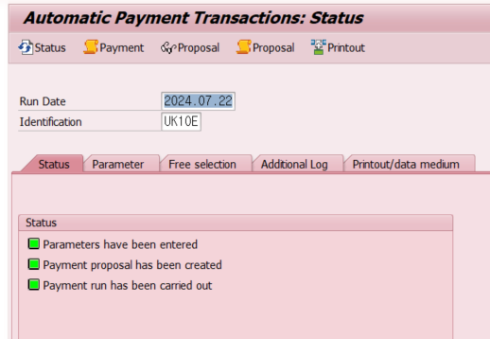
- Cause of error : The "Business Area" field is required, but the business area field is omitted.
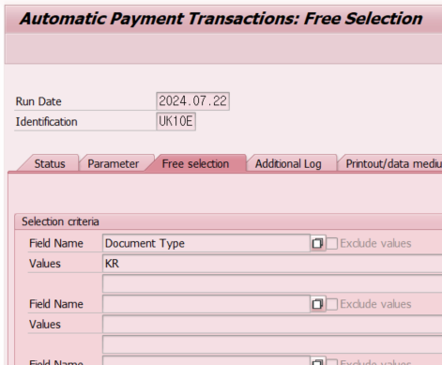
- Resolution : Click the "Free selection" tab and enter Business area.
