Error Occurs When Attaching files to Add Supporting Documents in SAP ZFI02600
- T-Code/ Function/Menu
Application | Menu/Func./Tcode | Description
SAP-FI | ZFI02600 – [FI] Voucher Approval Request Program > Attach | Attaching menu used to add supporting documents when submitting voucher approvals created directly in SAP.
- Types of Error Messages
  - Error Message : Windows cannot find ‘C:\WNS Files \GIANT\SlipXCMD.exe’. Make sure you typed the name correctly.
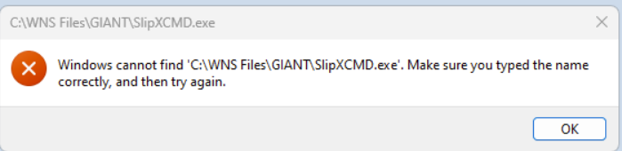
  - The supporting document solution file does not exist. Please download and run again.
  - Download failed! Please try again.
- Cause of Error
  - In cases of PC reinstallation or new PCs, the SCAN supporting document runtime program is not installed, so the electronic supporting document program must be installed.
- Resolution
  - Access the URL below and download the electronic supporting document installation file directly, unzip it, and run it to use the program.
https://slipscan.amorepacific.com/officewdm_v01/install/install.html
  - If the electronic supporting document program has already been installed but the supporting document window still does not appear, manually run the following .exe files (order does not matter):
    - C:\WNS Files\GAINT\SetupWNS.exe
    - C:\WNS Files\GAINT\AutoUpdate.exe
    - C:\WNS Files\GAINT\SlipXCMD.exe

  - If scanning and uploading the electronic supporting document works, but the middle section of the screen does not display the list of document types, you need to manually run the .exe files to update:
    - C:\WNS Files\GAINT\SetupWNS.exe
    - C:\WNS Files\GAINT\AutoUpdate.exe
    - C:\WNS Files\GAINT\SlipXCMD.exe
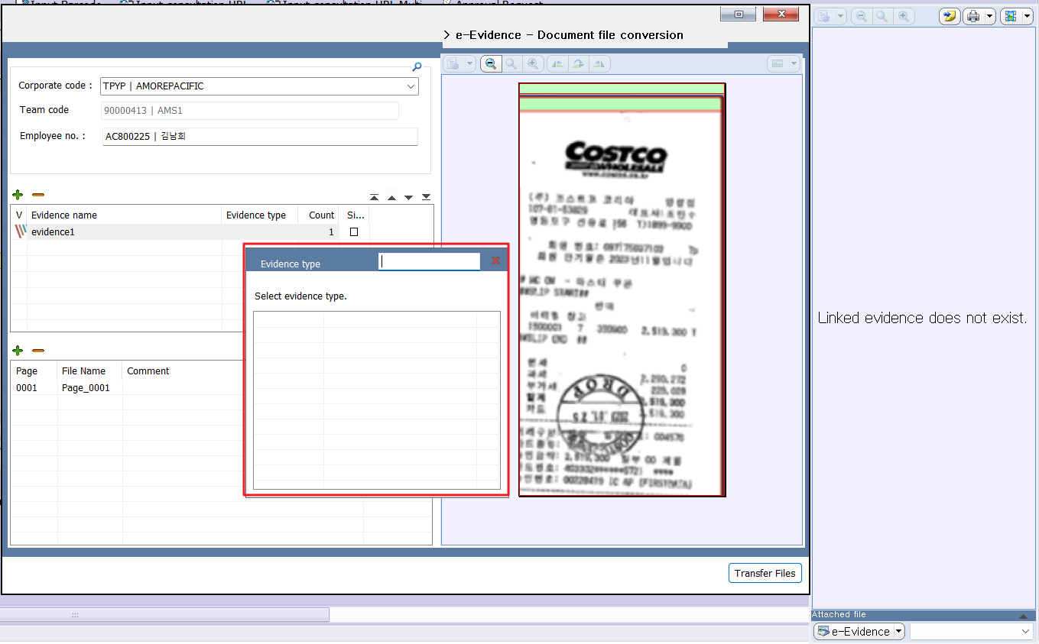
picture 1 : Abnormal screen — Document type selection list not visible (red box)><Abnormal screen — Document type selection list not visible (red box)

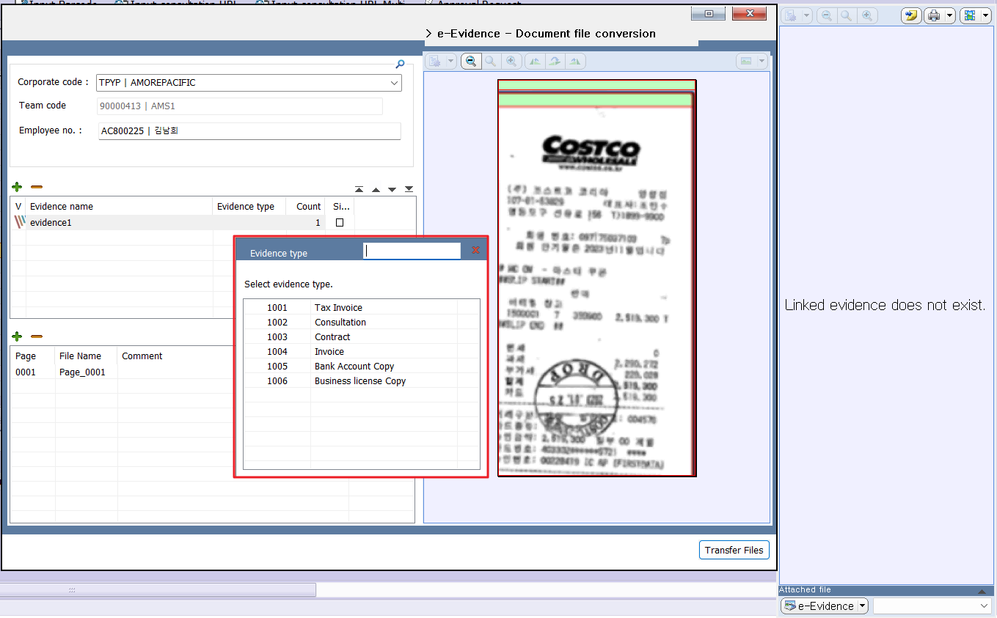
picture 2 Normal screen — Document type selection list is displayed (red box)

  - In case of the electronic supporting document screen does not run even after installation
Please register an inquiry with the IT Helpdesk as a general request under Service/Application SAP‑FI regarding the electronic supporting document error.

