How to change an Approver of FI doc. in ZFI02620
- T-Code/Function/Menu
Application | Menu/Func./Tcode | Description
SAP-FI | ZFI02620 | 1. This manual explains the procedures for changing the first and second approvers of FI documents due to organizational changes.  2. Approval lines can be set and modified according to the amount.
- How to change an Approver
  - The first approver is registered automatically. It gets the organization information (Team manager) from HR Interface. However, if you need to change the 1st approver manually, Send the Data modification Ticket to ITO . (IT-Helpdesk>Data modification>SAP-FI)
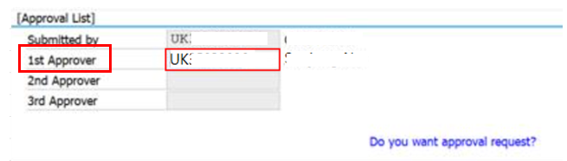
  - The second approver is registered in ZFI02620. Select the “Assign Approval Role to Organization” option to create ZZ1, the role of the secondary approver.
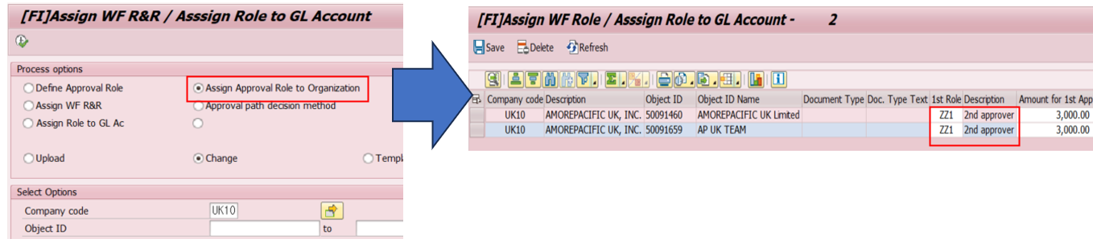
  - Then, Select the “Assign WF R&R” option to register the second approver.
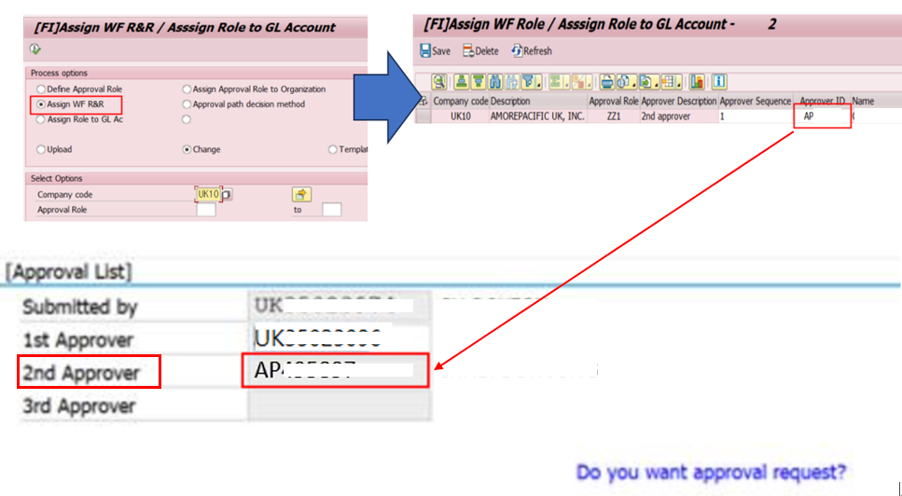
- How to make the approval line through amount.
  - If it is more than 3,000 GBP, assign to second approver, In case of 100,000,000 GBP or more, assign to third approver.
  - Select the “Assign Approval Role to Organization” option to create second approver(ZZ1) and 와 third approver(ZZ9) and amount.
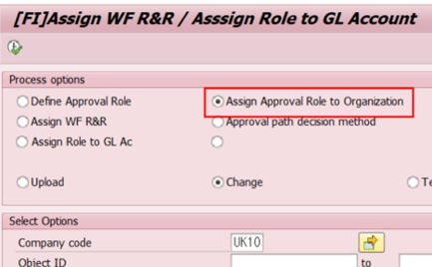
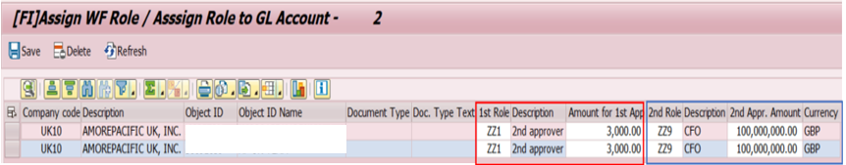

  - Then, Select the “Assign WF R&R” option to register the second and third approver.
