How to reverse a Foreign Currency Evaluation doc. in FAGL_FCV
- T-Code/ Function/Menu
Application | Menu/Func./Tcode | Description
SAP-FI | FAGL_FCV | Explain how to reverse the foreign currency valuation document in FAGL_FCV.
- Valuation Reset
  - Select the “Reset Valuation” option field and input ‘01’ of “Reason for Reset(Balances)” field.
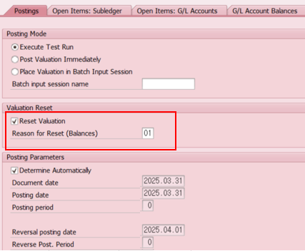
  - In order to reverse the same date, Reason for Reset is entered as ‘01’.
