SAP_Solution for SAP F4 Help Search Help Function Error
- T-Code/ Function / Menus
Application | Menu/Function/T-code Name | Description
SAP-CO | F4 Search help | Search help  Input value help
- Executives and execution status
  - Executives – Who wants to F4 input value help SAP
  - Execution status – Error while F4 Search help pop-up windows. Title : Internal error Table format , Message : “Cancel”
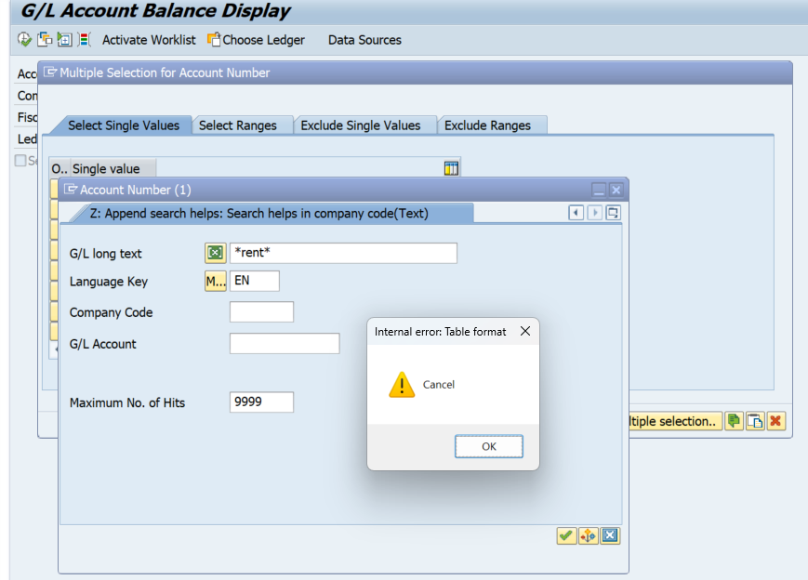
- The solution
  - After logging into SAP, go to the top menu on the Home screen → Help > Settings > F4 Help tab.
  - Select the search option as Control (amodal) and then save.
  - Completely exit SAP and log in again.
  - If the issue persists even after changing the search option, or if it is inconvenient to use, reinstall SAP GUI 770 or install the latest SAP GUI 750 patch 14(Patch 14-Full Installation). Please submit a request via IT Helpdesk > General Inquiry > SAP-BC, and remote support installation will be provided.
