How to manage profit center group for CO Allocation Cycle receiver
- T-Code/ Function / Menus
Application | Menu/Function/T-code Name | Description
SAP-CO | KCH1 | Menu for Creating a profit center group
SAP-CO | KCH2 | Menu for Change a profit center group
SAP-CO | KCH3 | Menu for Display a profit center group
- Person in Charge and Execution status
  - Person in Charge – Profit and Loss Manager for Each Corporation
  - Execution status – This is used when a separate profit center group needs to be maintained for allocation cycle receivers, instead of using the standard profit center hierarchy.

- Inquiry Types
  - Inquiry on how to create or change a profit center group used as a receiver in an allocation cycle
  - “In the new allocation cycle, I would like to exclude specific brand profit centers from the allocation..”
  - I would like to change the receiver group in the overhead allocation cycle. Specifically, I would like to know how to set the receivers by excluding specific customers from the profit center group.

4.The solution
  - T-CODE : KCH1 – Create Profit Center Group

4.1.1 Enter the Controlling Area in the Set Controlling Area pop-up window
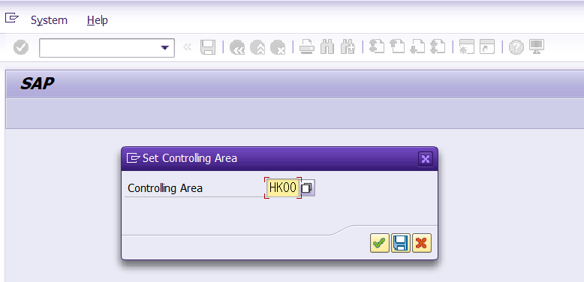
    - Enter the new Profit Center Group to create and press Enter
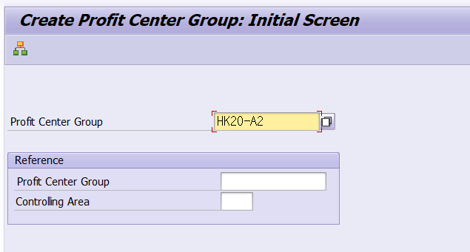
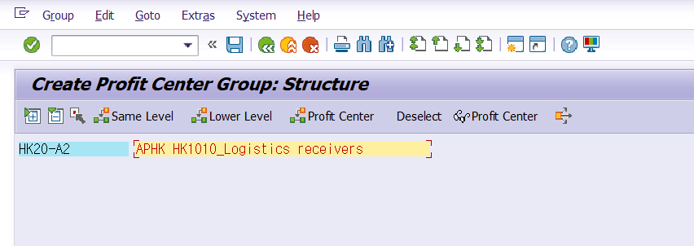
Description of the icons at the top of the screen
- Same Level : Used when adding a folder at the same level as the currently selected level.
- Lower level : Used to add folders at the lower level of the currently selected level.
- Profit Center : Used when adding a profit center under a profit center group.
- Select : Profit center group or profit center select
  - Delete: A function to delete incorrectly created profit and loss center groups without leaving any behind.
(Cannot delete if the profit center group is being used by another group)
  - Remove: Removes the item from the Profit Center group, but keeps the Profit Center group and the Profit Center itself intact
(A feature used when you want to include it in a different profit center group or use it separately)
    - To add a lower level to a profit center group, click the profit center group and then select the 'Lower Level' icon.
Enter the profit center group code and profit center group name to be added below.
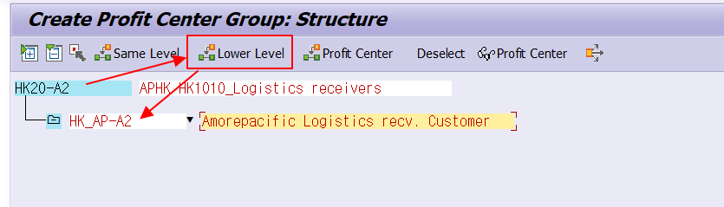
    - To add a same level to a profit center group, click the profit center group and then select the 'Same Level' icon.
Enter the profit center group code and profit center group name to be added below.
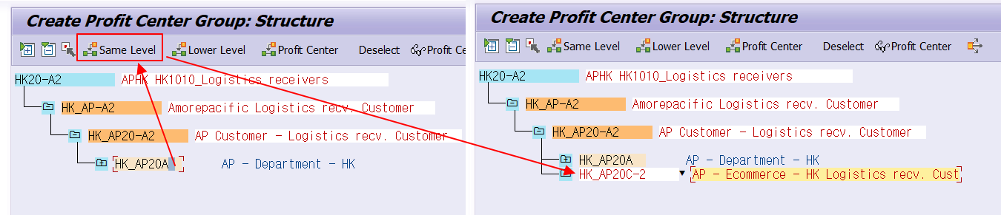
    - To add a profit center under a group, click the profit center group, then select the 'Profit Center' icon at the top. Enter the profit center to be added in the blank space displayed below the group.
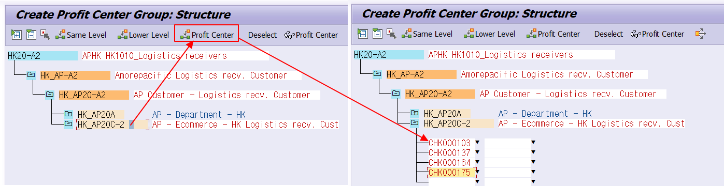
    - To exclude a lower profit center group from the profit center group currently being edited: Click the profit center group to be excluded, then click the third icon, 'Select'.
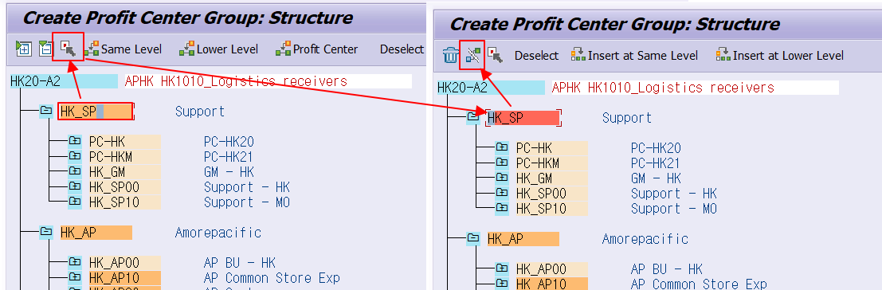
Remove: Removes the item from the Profit Center group, but keeps the Profit Center group and the Profit Center itself intact
If you click Yes in the pop-up window to choose whether to save changes
In the pop-up window asking whether to delete or remove the incorrectly created group, select Delete or Remove.
Description of deletion and removal options
Delete: A function to delete incorrectly created profit and loss center groups without leaving any behind.
(Cannot delete if the profit/loss center group is being used by another group)
Remove: A function that removes an incorrectly created profit center group from the profit center group currently being modified, but leaves the incorrectly created profit center group itself intact.
(A feature used when you want to include it in a different profit and loss center group or use it separately)

    - Proceed with steps 4.1.3 through 4.1.6 to create the desired group shape.
    - After configuring the profit center group to the desired structure, execute the ‘Save’ icon located at the top.

- Reference Information
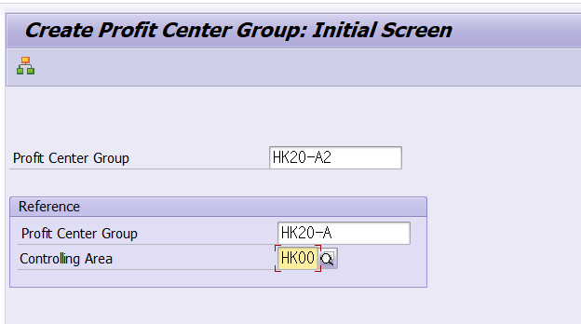
If there is a profit center group to reference, such as adding or removing some profit centers from a specific profit center group, enter the specific profit center group in the reference profit center group field and press Enter.
Values are automatically applied based on the hierarchy registered in the reference Profit Center group. Enter a new name in the Profit Center Name field and press Enter.
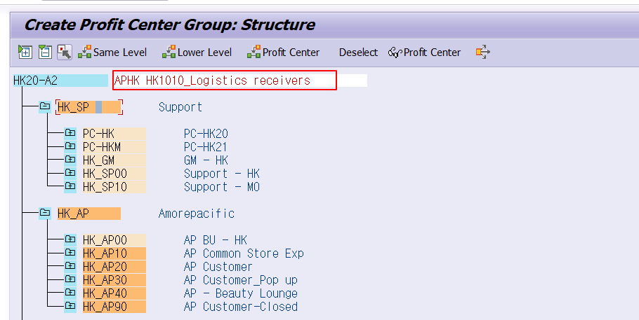

In T-CODE: KEU2, update the cycle receiver profit center group to the revised group and then save the changes
