PA40 – How to Assign a Concurrent Position (Concurrent Appointment)
- T‑Code / Function / Menu
Application | Menu / Function / T‑Code | Description
SAP-HR | PA40 | Concurrent Position Assignment (Change)
- Scenarios
  - Use this when an employee needs to hold another position in addition to their current position (concurrent appointment).
  - Inquiry Types
    - “A concurrent appointment was issued, but only one place is visible.”
    - “An employee with a concurrent appointment is not appearing in the concurrent position in PPOSE—please check.”
    - “I want to issue a concurrent appointment.”

How to Use
  - Navigate to the Personnel Action (Concurrent)
- Execute Transaction Code PA40.
- Enter Personnel Number and Start Date(From) for the action.
- Select Action Type “Concurrent position”.
- Click Execute.
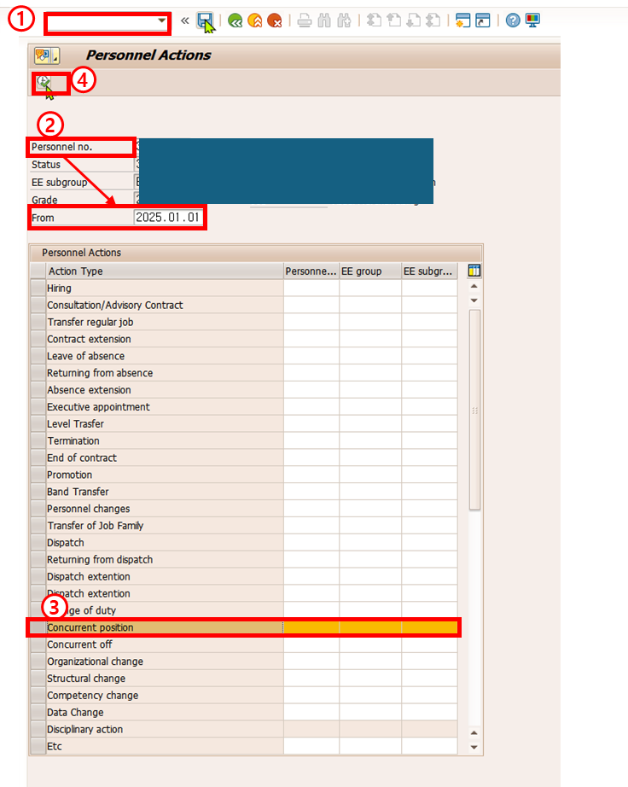
  - Create the Concurrent Appointment
- In the Reason for Action field, open Value Help (F4).
- In the value help for Reason for Action, select the applicable reason (sample uses 10).
- Click Save to move to the organizational assignment screen.
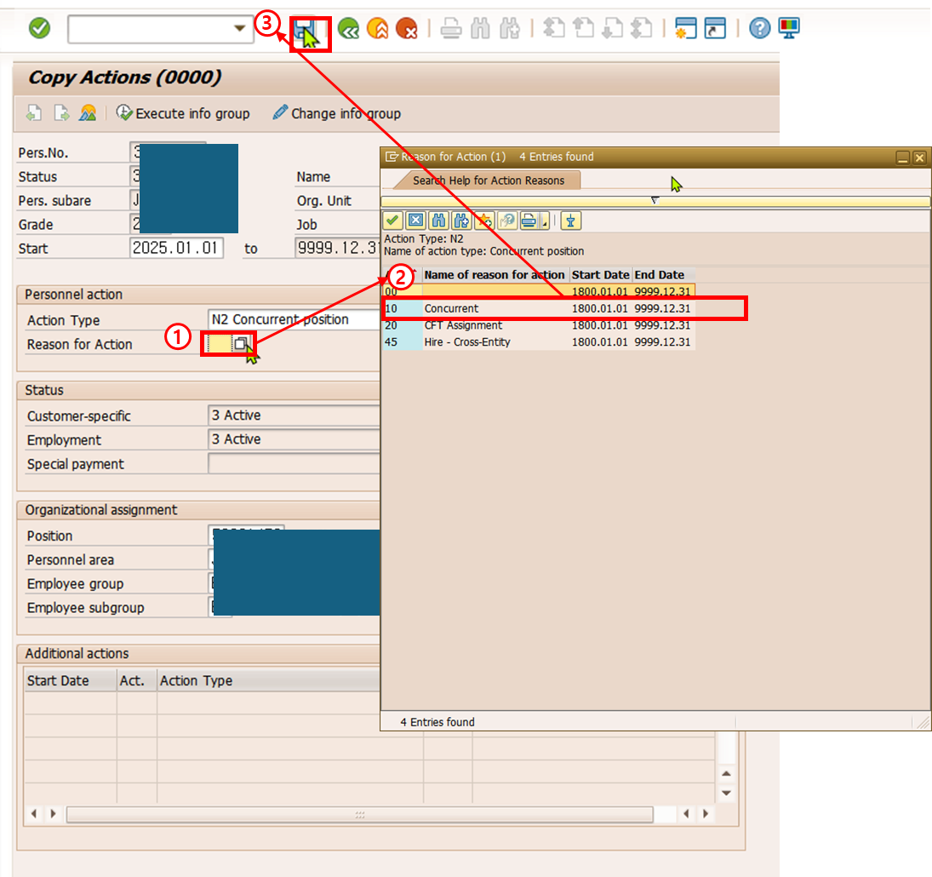

  - Click Assignment within the Organizational Plan box.
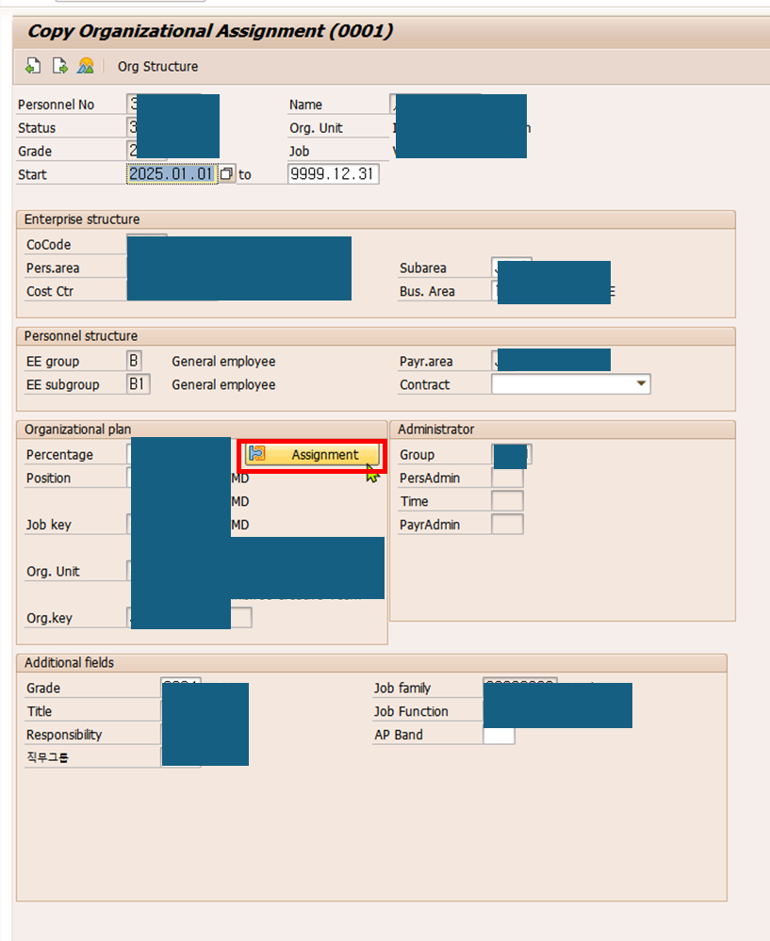

  - Enter Positions
- Enter both the Primary Position and the Concurrent Position. For each position field, open Value Help (F4) to select a position.
- In the Staff Assignment Along Organizational Structure window, search for and select the Position ID to be assigned.
- Click OK (Confirm) to close the Choose Position window.
- Enter the Percentage allocation for each position (total must be 100), and the End Date (typically 31.12.9999).
- Click Continue to close the position assignment popup.
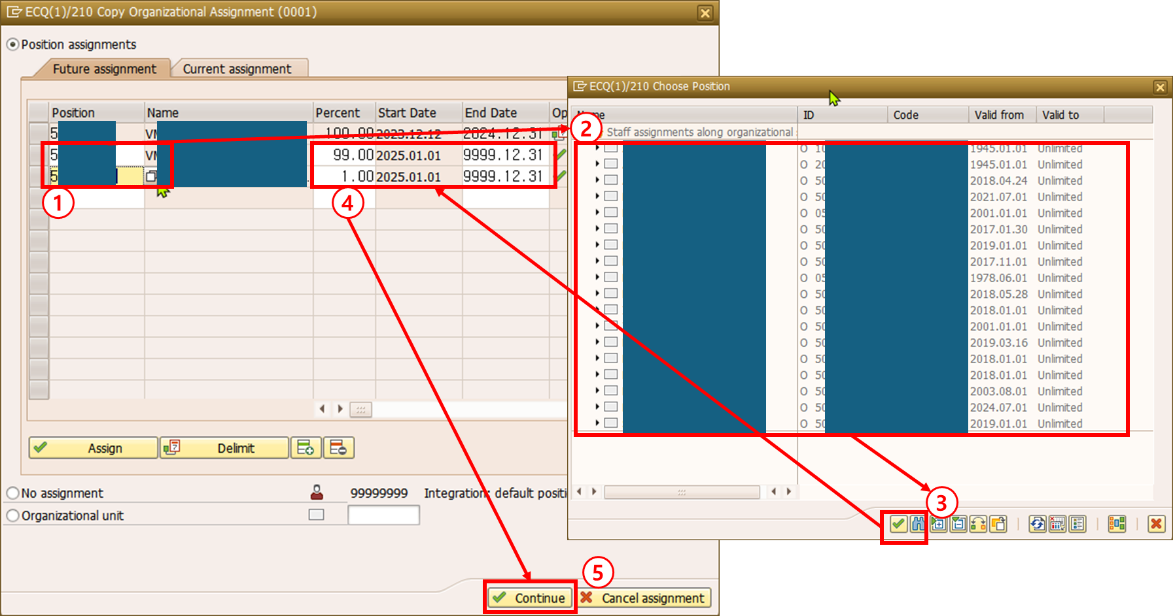

  - Click Save to complete.
