HR – How to Upload Employee Master English Name Using LSMW

T-Code/Function/Menu
Application | Menu/Function/T-Code | Description
SAP-HR | LSMW | Customer Upload
- Situation
  - Updating English Names in the China Employee Master

This LSMW object (PA30_0002) was created based on a request from the China HR team.
[Requirements]
- Applicable only for company codes in China (CN10, CN20, CN30)
- pdate English names in Personnel Infotype (0002)
- Effective start date for changes: 2025.05.01

  - Inquiry Types
    - “Please update the English name field in the China Personnel Master with an effective date of 2025.05.01.”
    - “Please upload the English names for new hires in China with an effective date of 2025.05.01.”

How to Use

Create Upload File (Text File .txt) – (employee number, Name)
1) In Excel, enter the employee number in column A and the English name in column B.
2) Go to File > Save As, select a folder, and save the file
File Name:EN_NAME
File Type: Text (Tab Delimited)

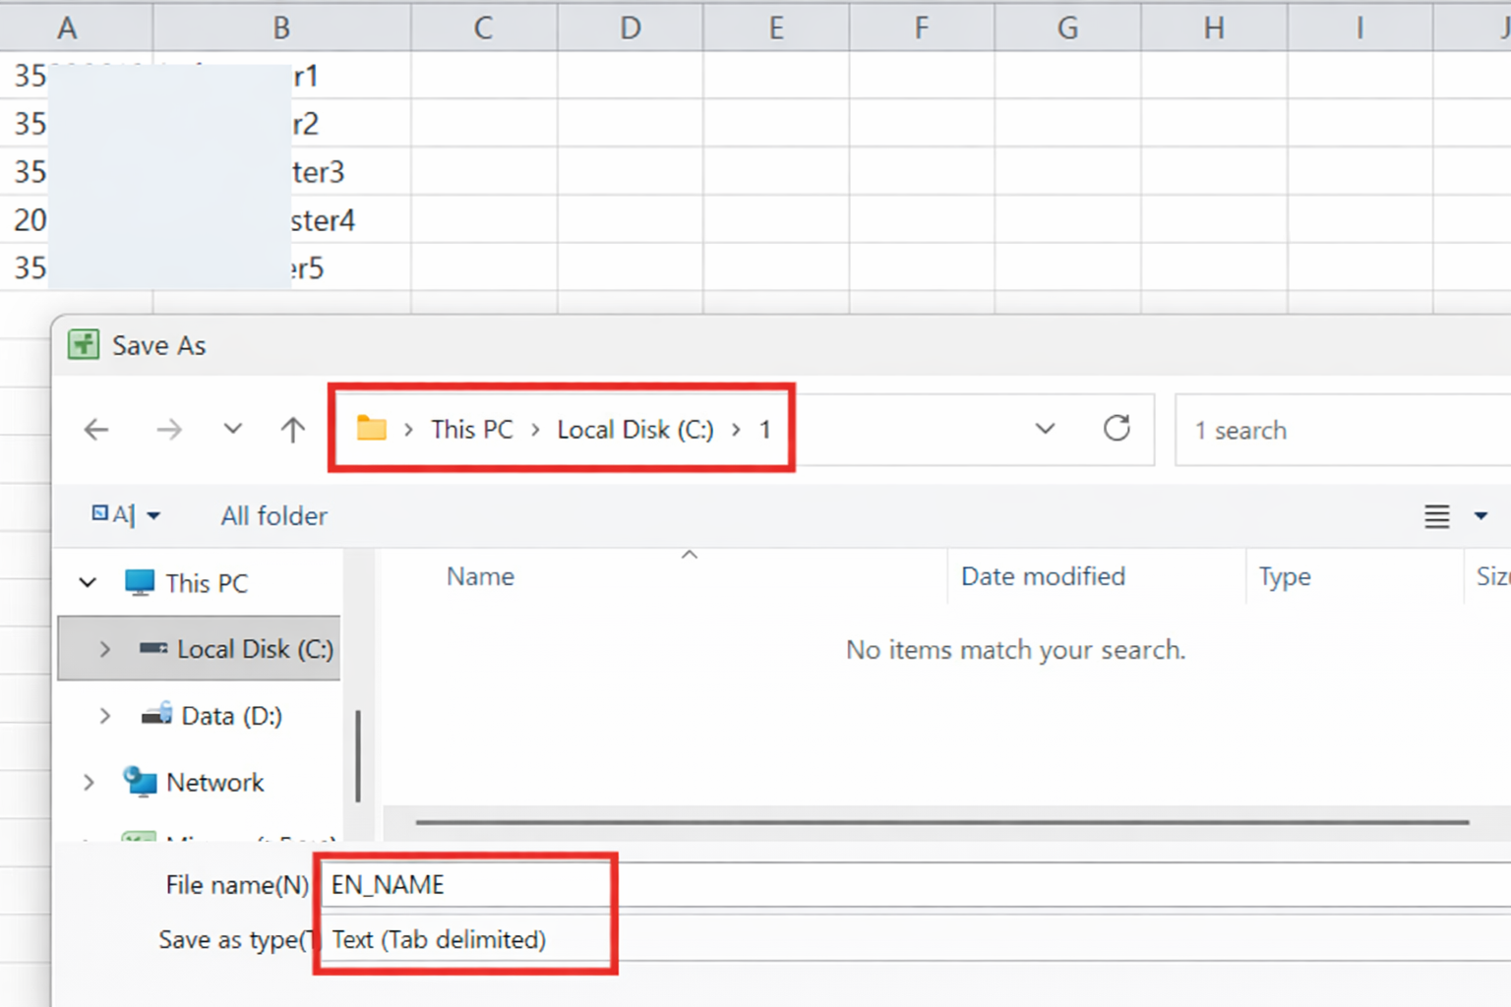

  - Run Transaction Code LSMW
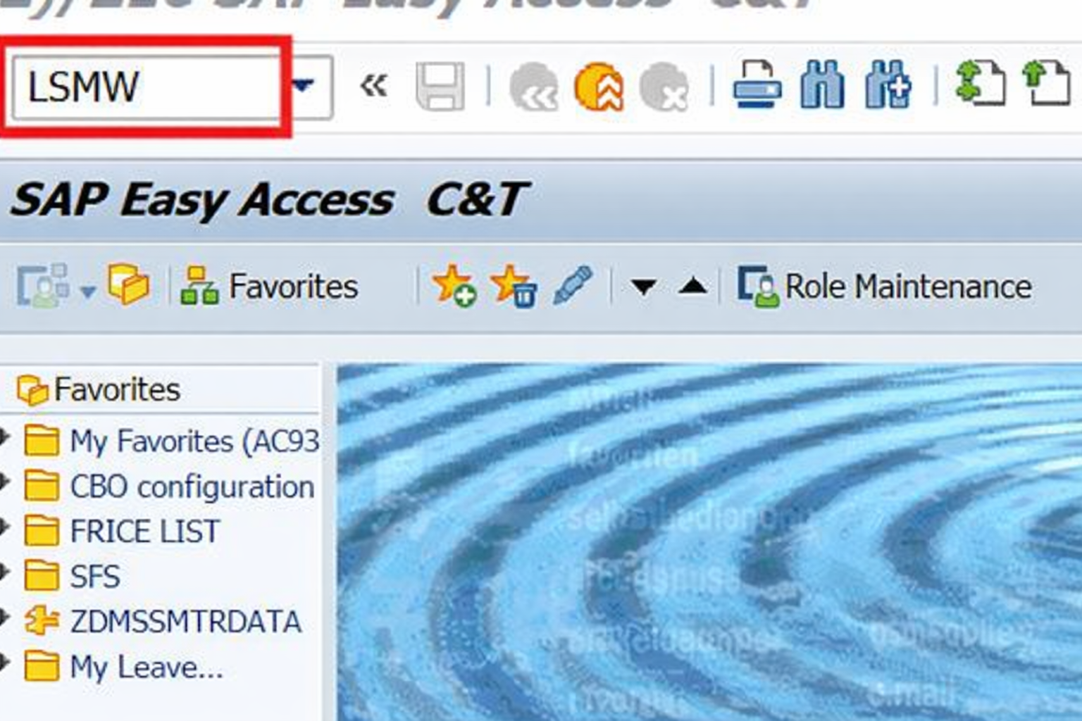

  - Enter Required Selection Parameters① and Execute②
-Project: ZHR
-Subproject: Maintain HR Master Data
-Object : PA30_0002D(English name update(China))
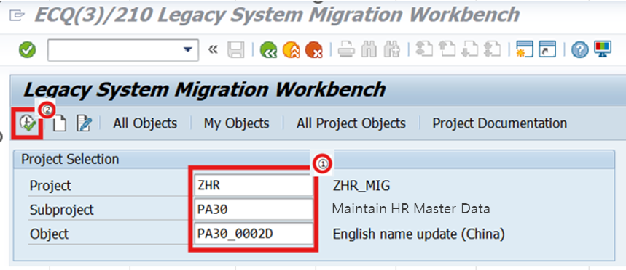

  - Select “Specify Files” and Execute
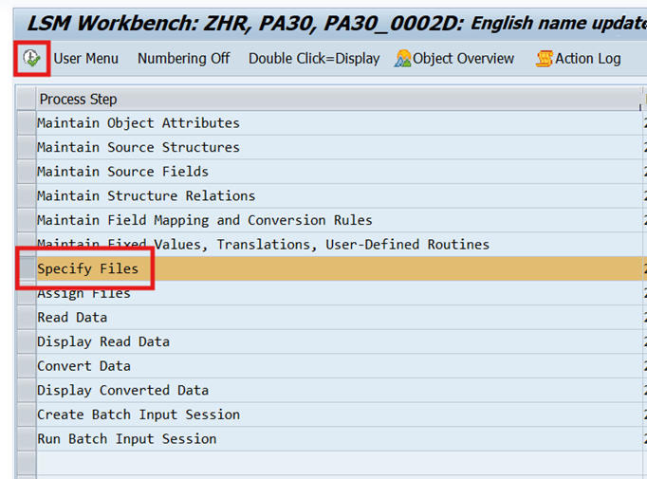

Here, choose the legacy data file located on your PC.
- When entering the screen(Specify Files), the previously used directory/file may appear — be sure to select the current upload file.

    - Switch to Change Mode : Click Display ↔ Change
    - Double-click the Directory and File Line
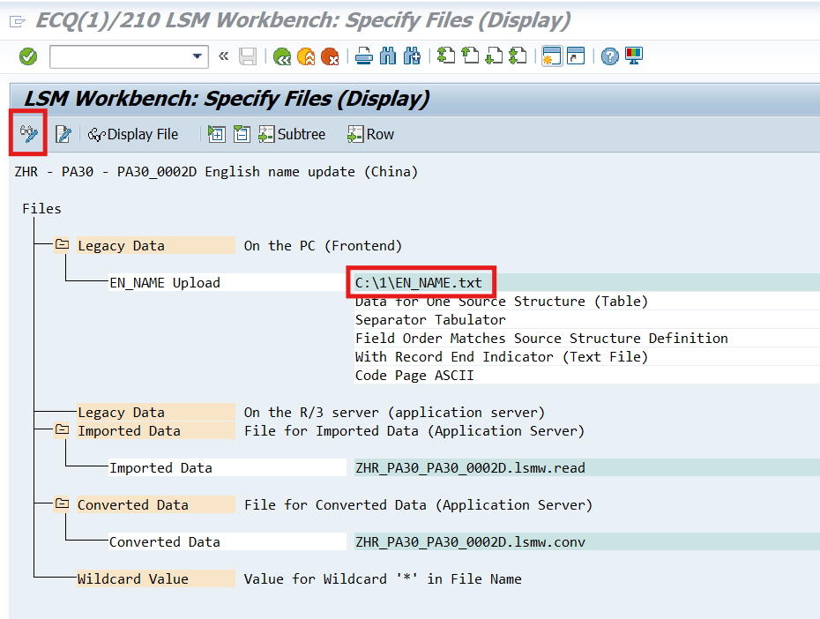

    - Upload the File
- Click the File input field and browse for the upload file.
- Select the upload text file created in Step 3.1 (example: EN_NAME)
- Assign a name for the uploaded file (used later in the process).
(Example: EN_NAME Upload)
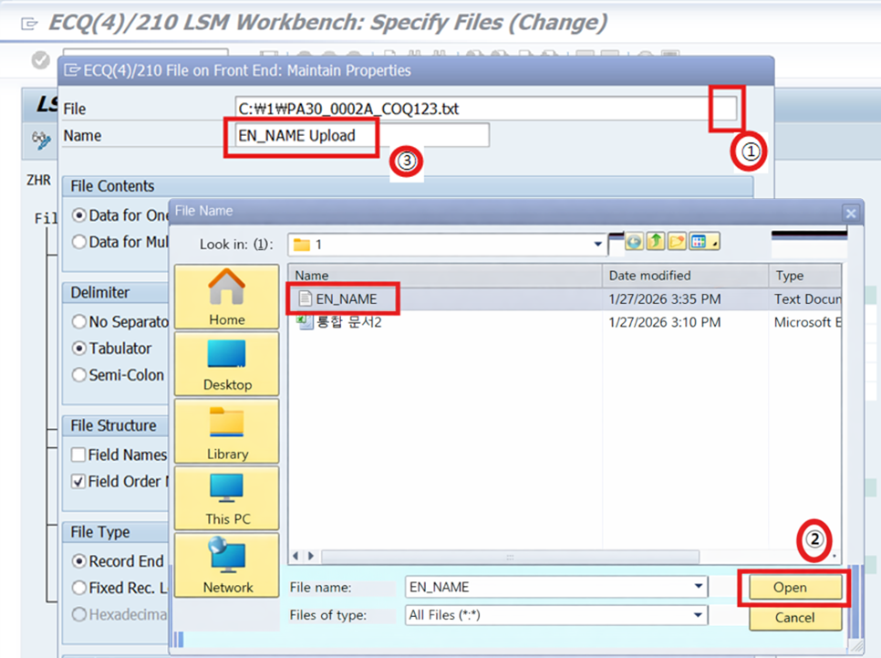

    - Confirm the Upload File and Name and click the Check button
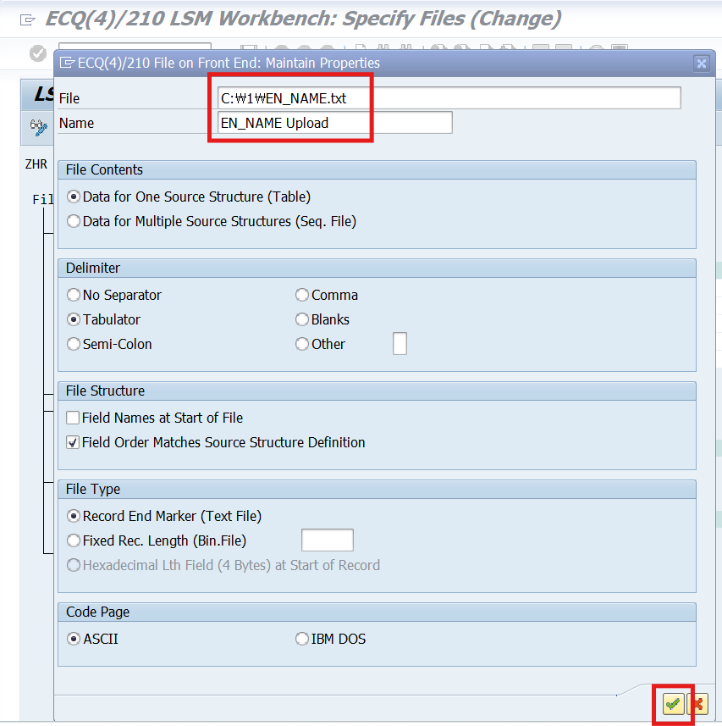

    - Verify the Uploaded File and Name, Then Click Save

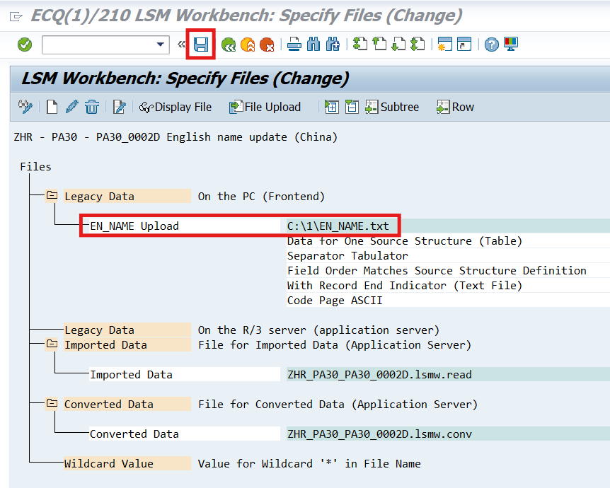

  - Select “Assign Files” and Execute(Or double-click Assign Files directly.), Verify the directory and upload file mapping.
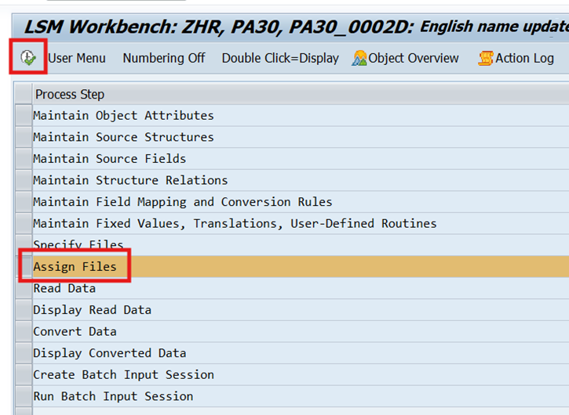
  - Confirm Directory and File Assignment①, Then Click Back②. This returns you to the LSM Workbench main screen.
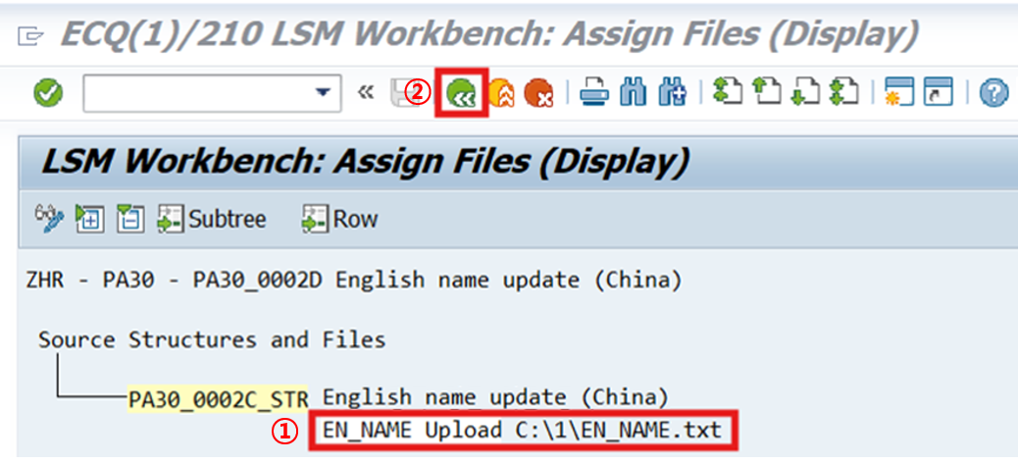
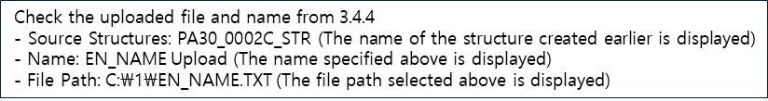

  - Select “Read Data” and Execute
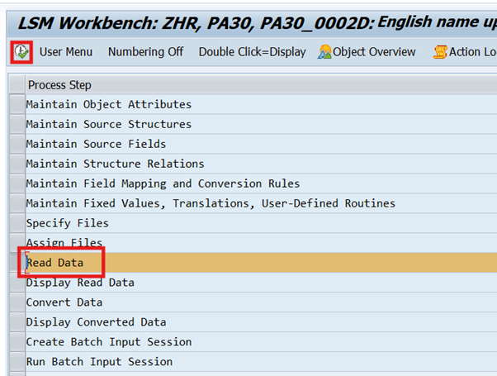
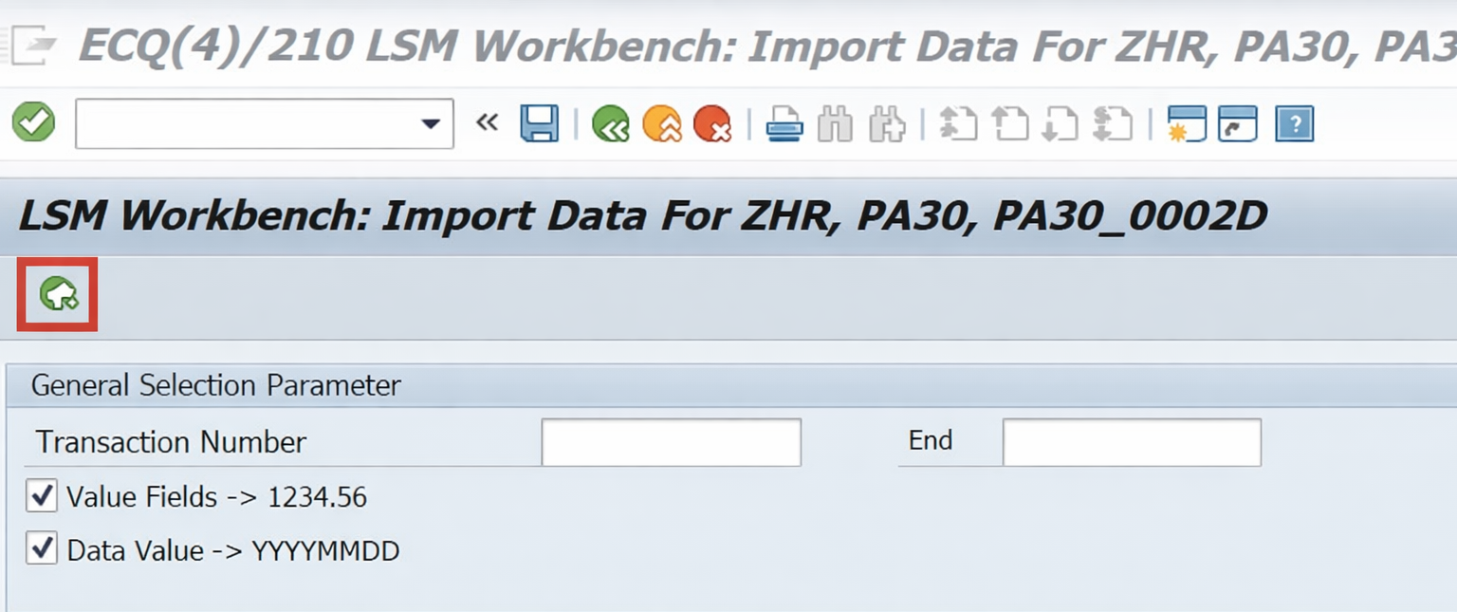

    - Grant Read Authorization -Click “Allow” to save “Reminder My Decision.”
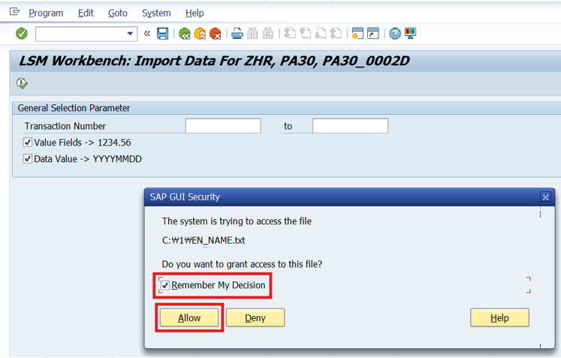

    - Check Import Information (Read Data Details)
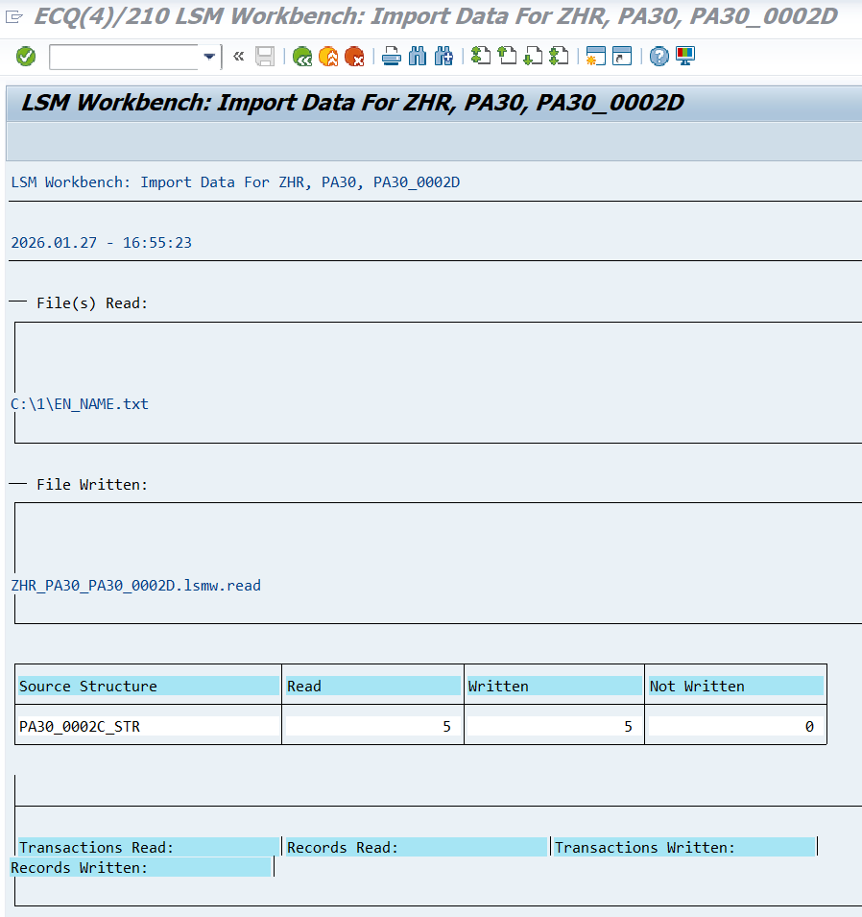

    - Click Back Twice to Return to the Workbench

  - Select “Display Read Data” and Execute – Enter Line Range
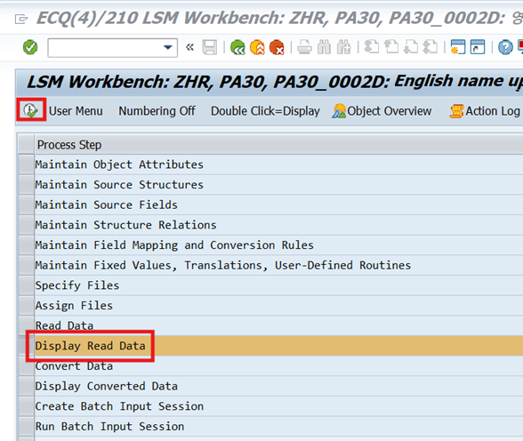

    - Enter From Line / To Line and Press Check
(Default range: 1 – 10,000)
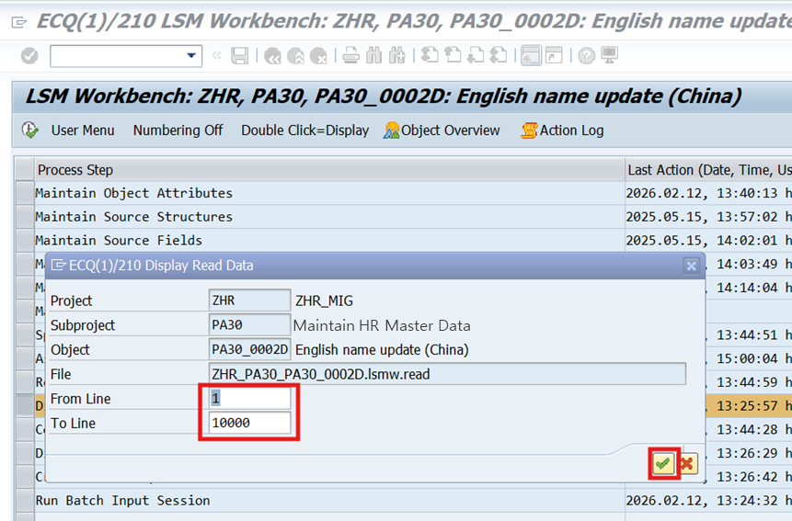

    - After confirming the data to be imported, press the Back button to return to the LSM Workbench screen.
=> 5 records created in the upload file will be displayed.
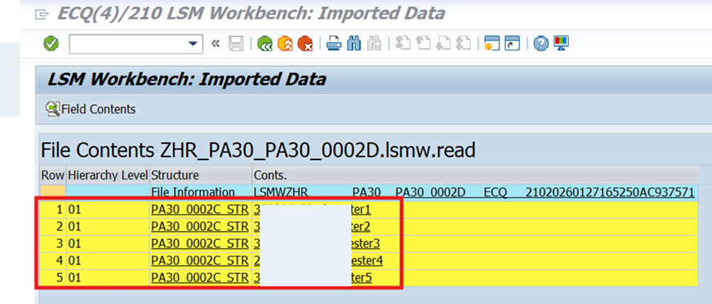

  - Select “Convert Data” and Execute
(The employee number and name will be converted into the required format.)

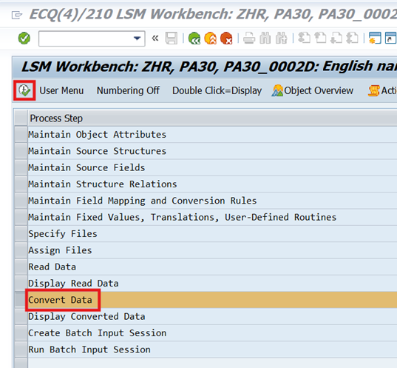

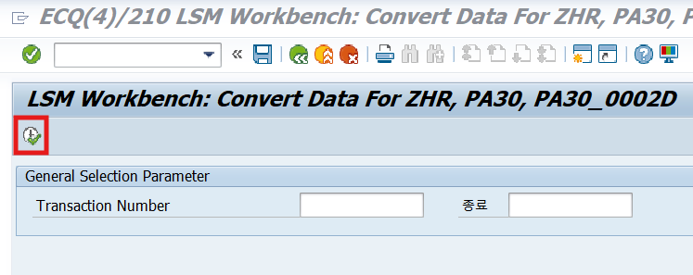
Transaction Number field remains blank — the system will auto-convert as many records as uploaded.

    - After checking the Convert Data, click the Back-Back button and move to the LSM Workbench screen
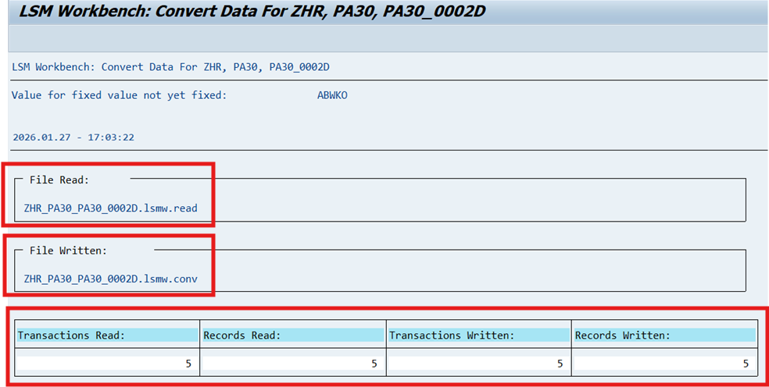

  - Display Converted Data – Enter Line Range
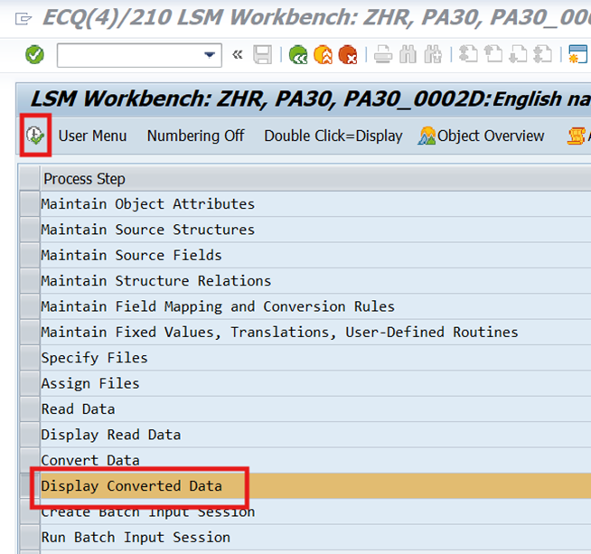

    - Input From Line, To Line ① And Click Check button②
(Default Range: 1 - 10000)
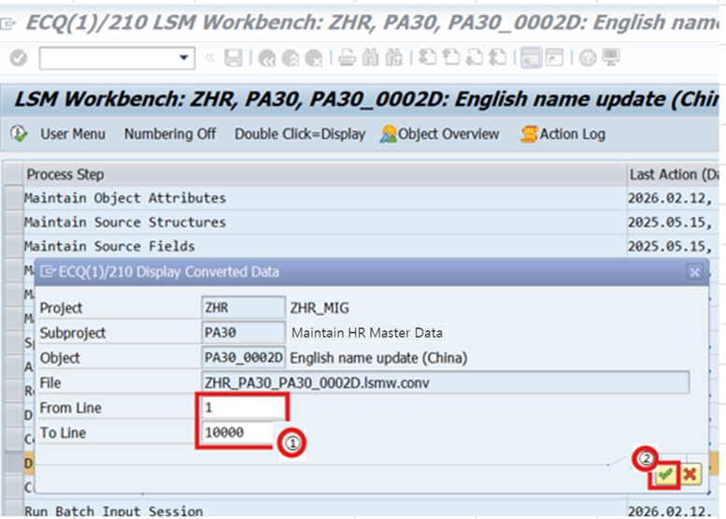

Confirm the Converted Record ③, Click Back Button④
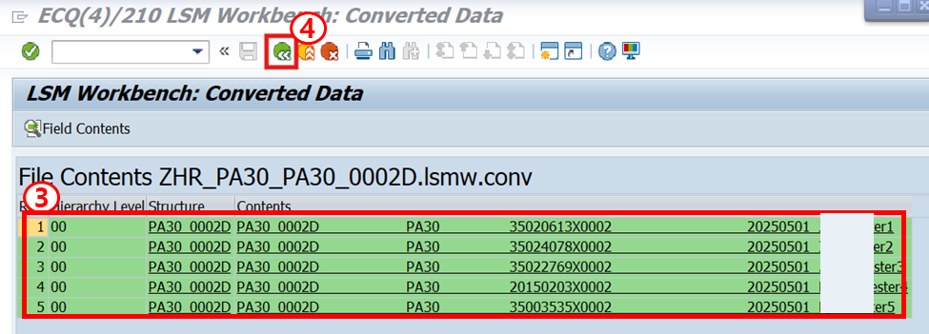

  - Select Create Batch Input Session ①, Then Click Execute ②
(Pop-up confirmation of the number of records to be uploaded)
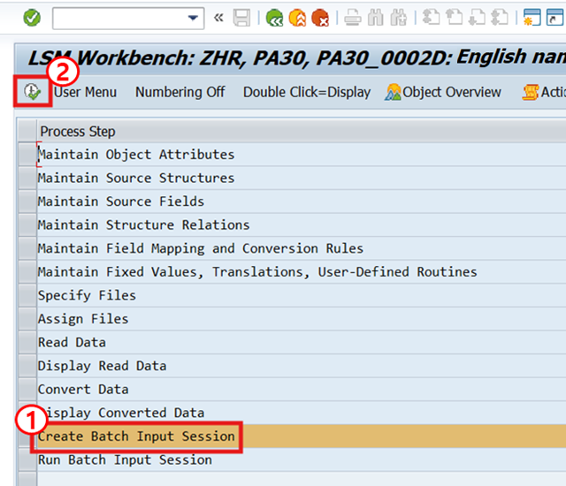
The name, folder, and creator of the file to be uploaded are automatically entered and displayed on the input screen ①. Clicking the Run button② prepares the batch upload.
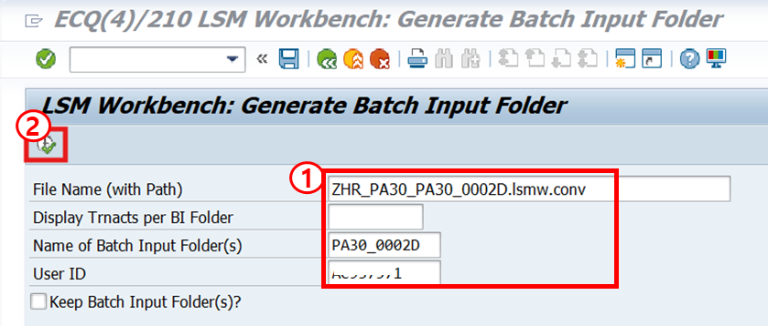
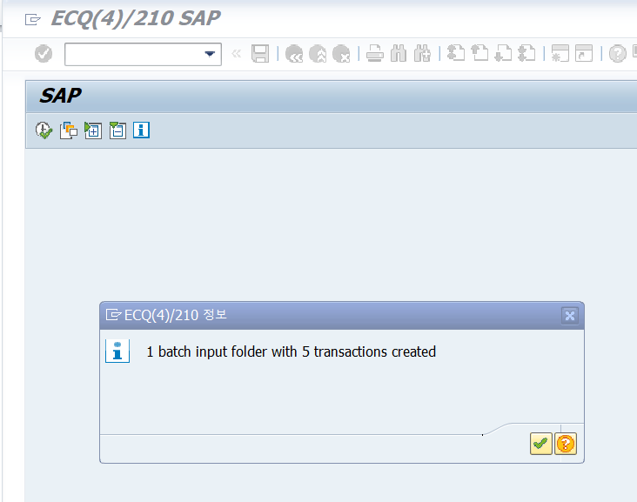

  - Select Run Batch Input Session① and click the Run button ②
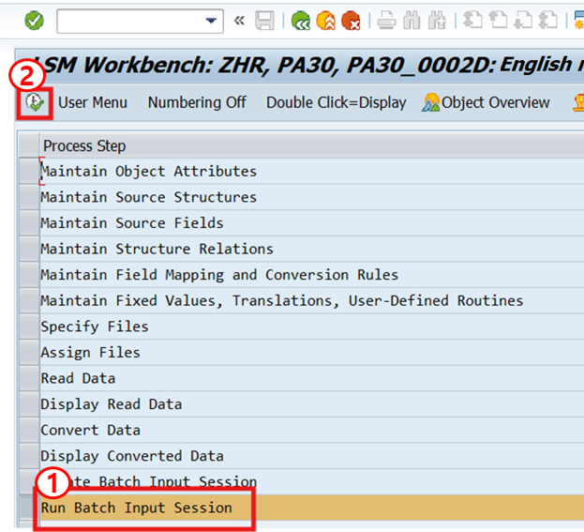

  - Select the Session → Click Process
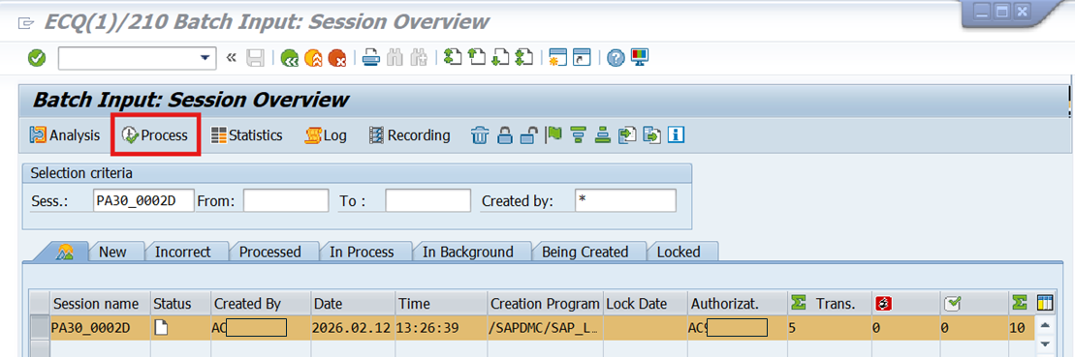

    - Enter the batch execution values ​​and click the Process button
Processing Mode: Display errors only
Additional Functions: Check “Dynpro Standard Size”
Click Process.
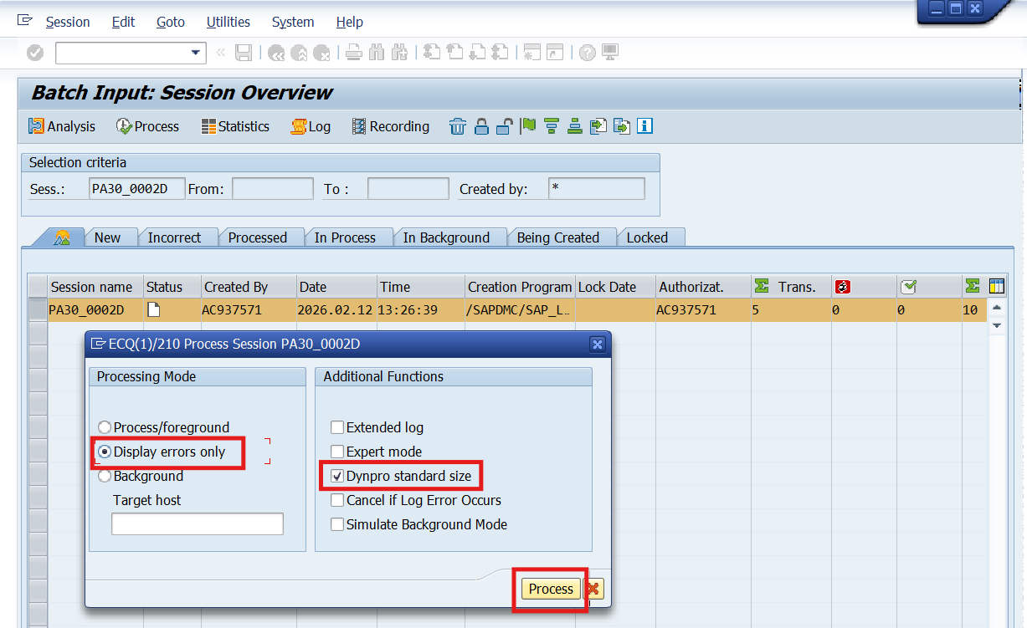

  - Batch Input Completed (Complete Record Change)
When the completion popup appears, click Exit Batch Input.
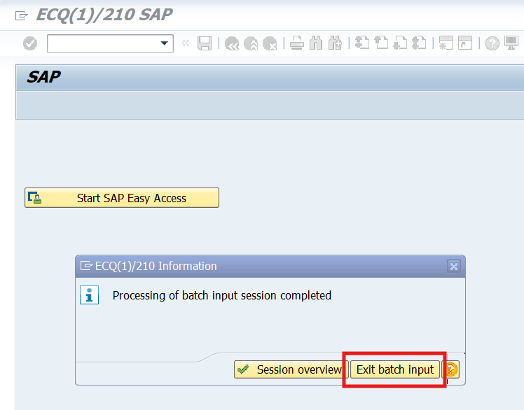
  - Confirm the updated English name of the Personal Information Info Type (0002) of the Personnel Master (PA20)
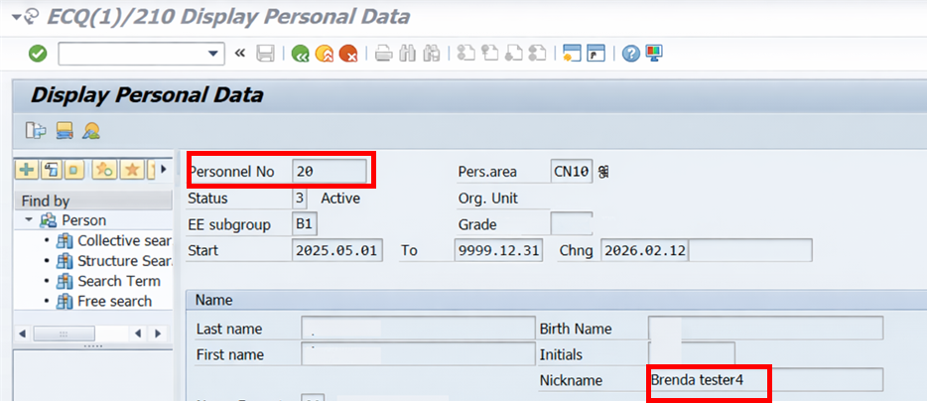

    - Verify Uploaded Data via Table (SE11 – PA0002)
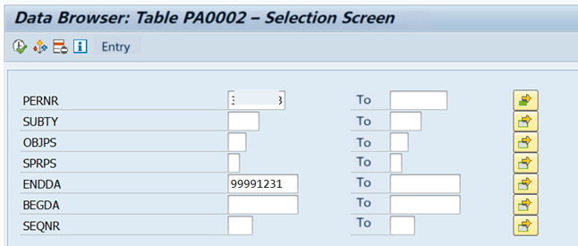

[Upload Verification]
Personnel Master (PA20) → Personal Data (0002) → Confirm modified English Name fields.
