SAP Sales and Distribution – How to solve Error Deficit of SL Unrestr. prev. 1 EA : 110641115 1190 LA06.
- T-Code/Function/Menu
Applications | Menu/Function/T-Code Name | explanation
SAP-SD | ZSD22110 | Sales order Aggregation
SAP-SD | ZSD22160 | Store Available G/I Stock
- Executives and execution status
  - Executives – A person who reprocesses sales document to close sales amount
  - execution status – The following error message occurs when reprocessing a sales order. Error message “Deficit of SL Unrestr. prev. 1 EA : 110641115 1190 LA06’.
When processing sales transaction, if there is a shortage of inventory, the error message "Deficit of SL Unrestr. prev. 1 EA : 110641115 1190 LA06’." will occur, which means that the order cannot be confirmed due to insufficient inventory during sales processing.
The sales order cannot be confirmed, and the error 'Deficit of SL Unrestr. prev.' occurs.
- The solution
  - Check the stock quantity on the transaction code ZSD22160
  - Enter the sales organization, plant, storage location and material code, then click display to check the available stock.
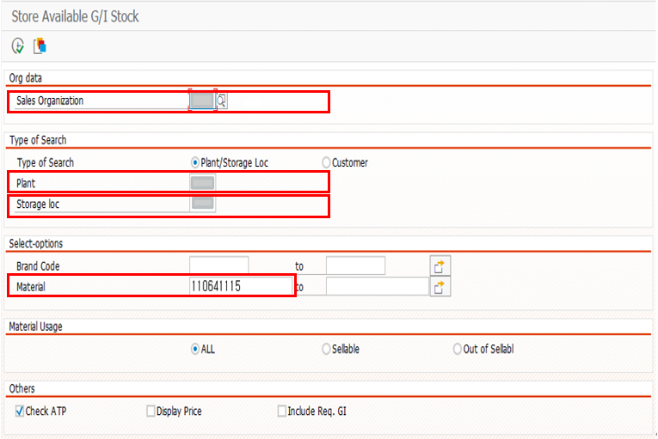
  - Check the Unrestr. field and see if available inventory is insufficient.
If the stock quantity is insufficient, you need to increase the inventory through the Physical inventory process and perform the order reprocessing task.
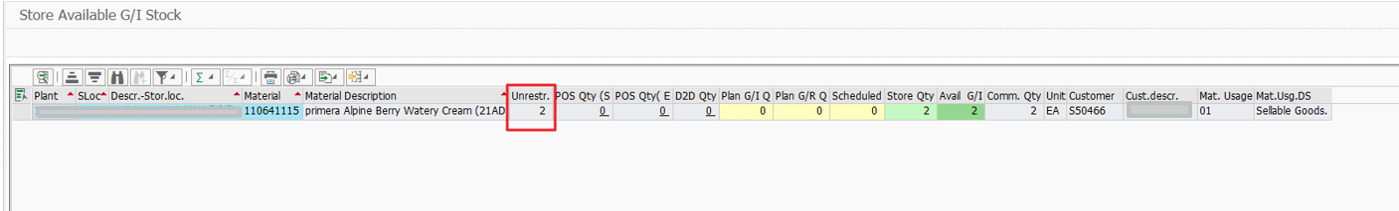
  - Physical inventory process is carried out using transaction code ZSD21100, and thorough review is required before proceeding with the physical inventory process.

