BW/BI - Analysis Office – How to resolve the “Customization does not have the permissions” error
- T-Code/Function/Menu
Application | Menu/Func./T-CODE | Description
SAP BW | Analysis Office | Analysis Office
- Executor & Inquiry Details
  - Executor: Analysis Office User
  - Inquiry Details: User get ‘Customization does not have the permission’ when try to open analysis application
  - Inquiry Type:
    - Analysis Office does not open with ‘Customization does not have the permissions required to create an application domain’ message.
    - BW Report does not open with ‘Customization does not have the permissions required to create an application domain’ message.
- Error Message: ‘Customization does not have the permissions required to create an application domain’
- How to re-install the application without permission problem.
  - Go to [Control Panel] > [Program and Features].
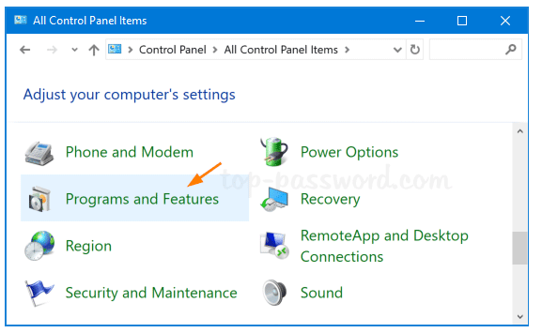

  - Uninstall ‘SAP BusinessObjects Analysis, edition for Microsoft Office’.
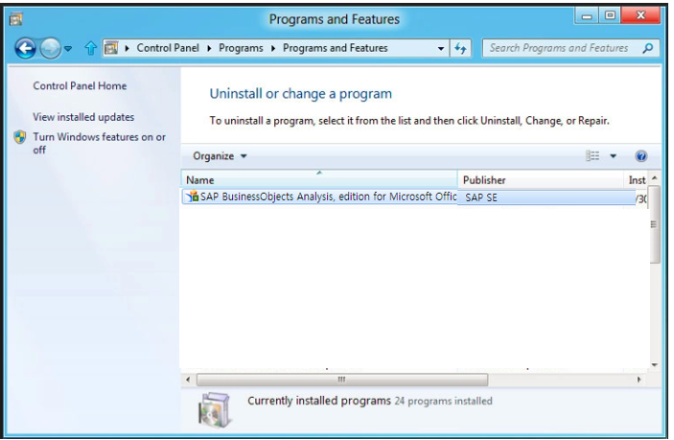
  - Go to [Control Panel] > [Internet options].
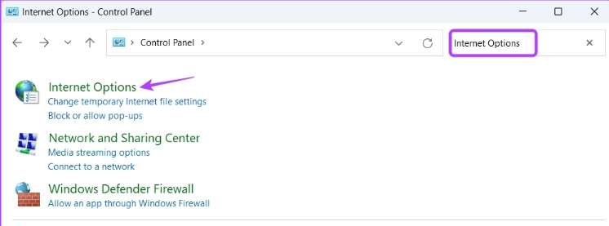

  - Go to [Security] > [Trusted Sites] > [Sites]
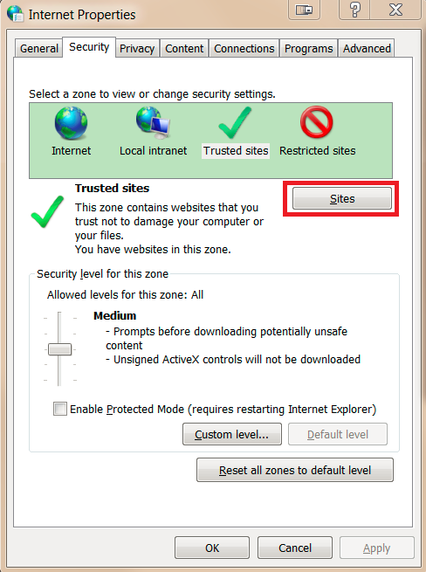

  - Un-check ‘Require server verification (https:) for all sites in this zone’ option and Enter ‘*.amorepacific.com’ website domain and Add it.
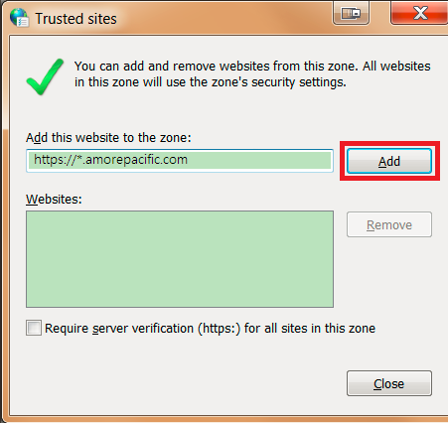
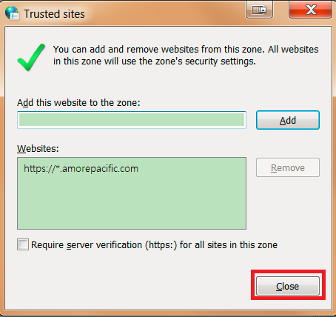
  - Quit all current internet browser.
  - Open Internet browser again, and Go to [AP-ON] > [Work] > [AP-ON Store] > Search ‘Process Portal’
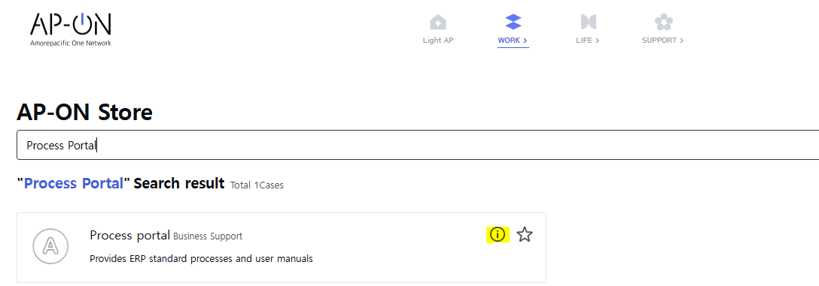
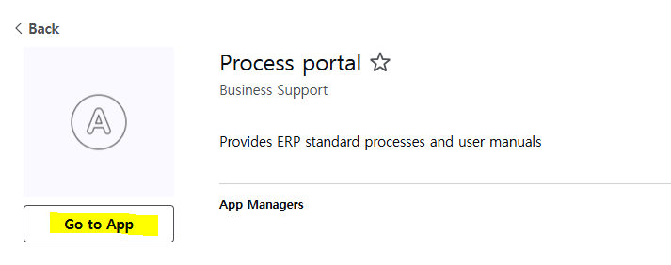
  - Go to [Solution] > [BI Solution Manual] and Download analysis office installer.
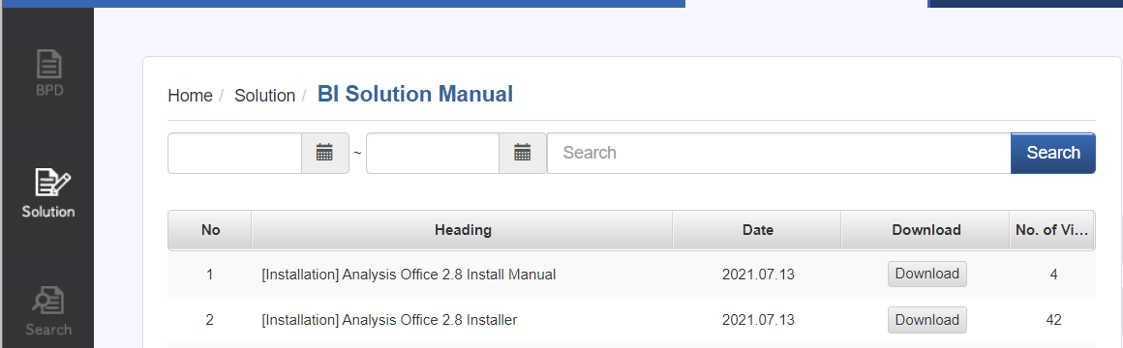

  - Execute ‘SetupAll.exe’ after extract all files from downloaded installer.
  - Click ‘Next’.
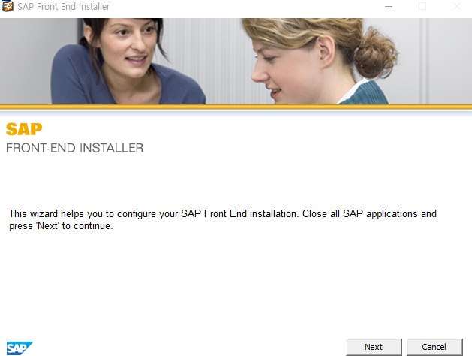
  - Expand ‘Analysis for Microsoft Office’ option, and Select ‘Add In is always active’, ‘Analysis plugin’ options.
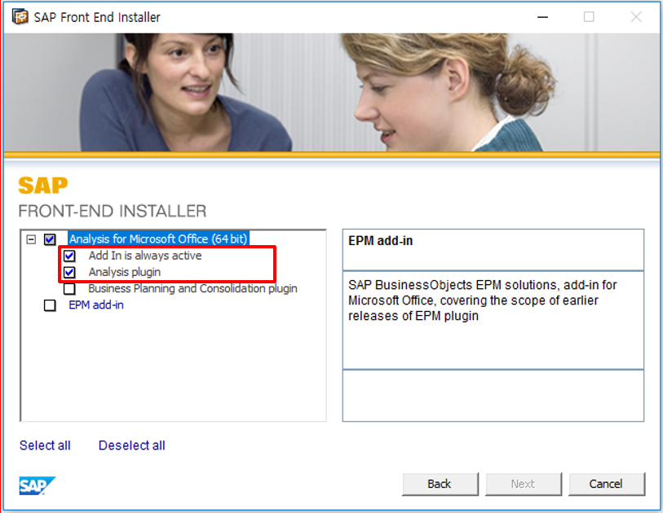
  - Installation will be done. 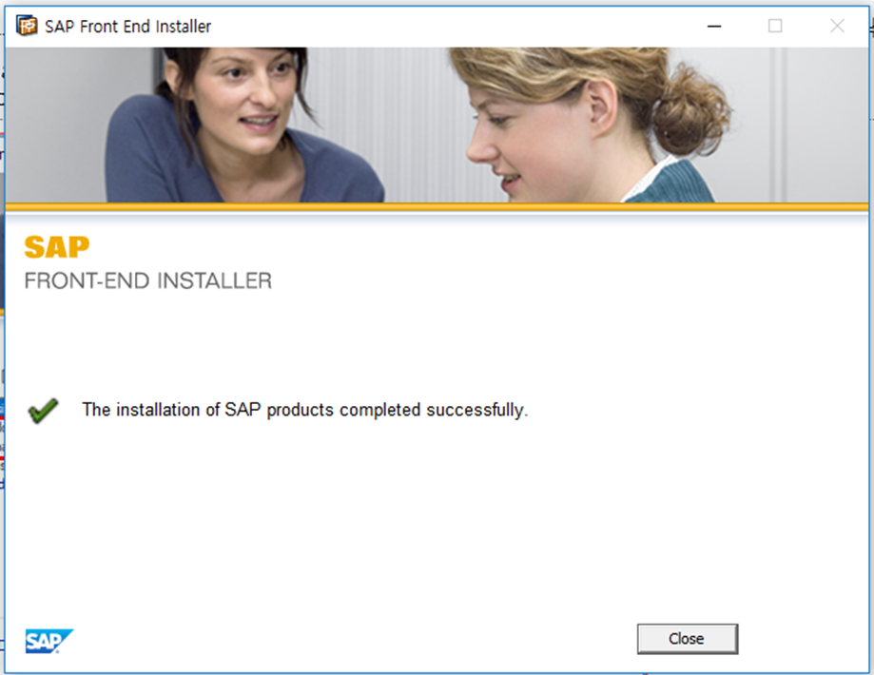
  - Search & Execute ‘Analysis for Microsoft Excel’ at windows menu.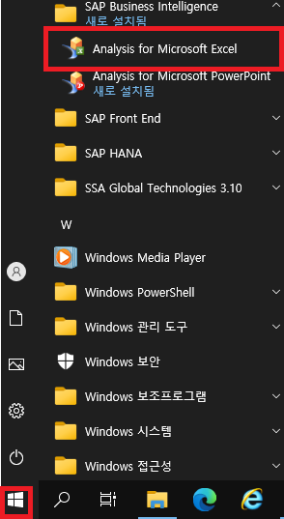
  - Analysis add-ins will be loaded properly.