BW/BI- Analysis Office - How to resolve the ‘service sapmsBWP unknown’ error in Analysis Office”

- T-Code/ Function / Menu
Application | Menu/Func./T-CODE | Description
SAP BW | Analysis Office | Analysis Office
- Executor & Inquiry Details
  - Executor : Analysis Office User
  - Inquiry Details: User get ‘service sapmsBWP unknown’ error when try to log-on analysis office.
  - Inquiry Type:
    - I can’t log-on analysis office with ‘service sapmsBWP unknown’ error
    - While using BW/BI Analysis Office, the error ‘service sapmsBWP unknown’ occurred. Could you tell me how to resolve this issue?”
    - I encountered the ‘service sapmsBWP unknown’ error while using the BW report. Please let me know how to resolve it.”
- Error Message : “service 'sapmsBWP' unknown”
- How to register SAP service configuration
  - Notepad > Right Click > Run as Administrator
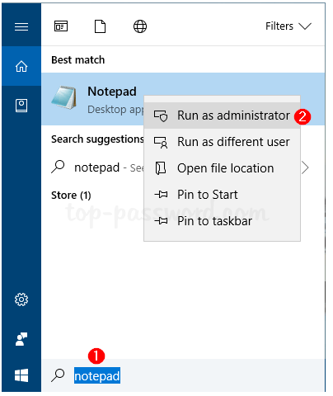
  - File > Open > Go to C:\windows\System32\drivers\etc and Open ‘services’ file.
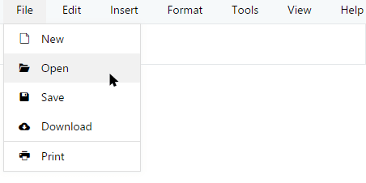
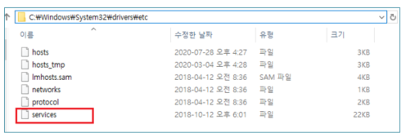
  - Add below lines to end of the file and save.
# GIANT ERP
sapmsECP 3601/tcp
sapmsBWP 3601/tcp
sapmsSCP 3601/tcp
sapmsEWP 3601/tcp
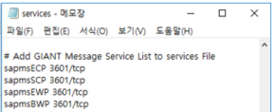
  - Restart excel application and Try log-on analysis office again.

