BW/BI – How to resolve the Analysis “Microsoft Office Installing office customization” error
- T-Code/Func./Menu
Application | Menu/Func./T-CODE | Description
SAP BW | Analysis Office | Analysis Office
- Executor & Inquiry Details
  - Executor: Analysis Office User
  - Inquiry Details: User get ‘Installing Office Customization’ error.
  - Inquiry Type
    - What should I do when the error “Microsoft Installing office customization-Installing Office customization’” error appears while installing Analysis Office?
    - An error occurred during the installation of Analysis Office.
- Error Message
  - There was an error during installation. From: file:///C:/Program files (x86)/SAP BusinessObjects/Office Addin/SapExcelAddin.vsto
  - Downloading file:///C:/Program Files (x86)/SAP BusinessObjects/Office Addin/SapExcelAddin.vsto did not succeed.
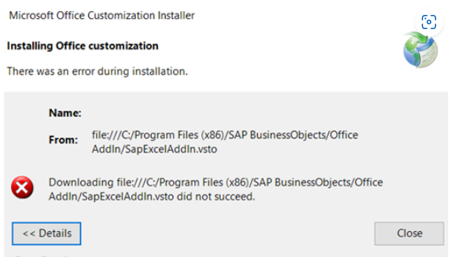

- How to modify add-ins configuration.
  - Go to [Excel] > [File] > [Options].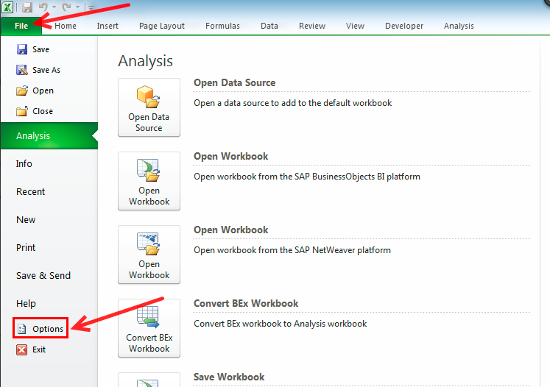

  - Go to [Add-Ins] > Change manage option as [COM Add-ins] > Go
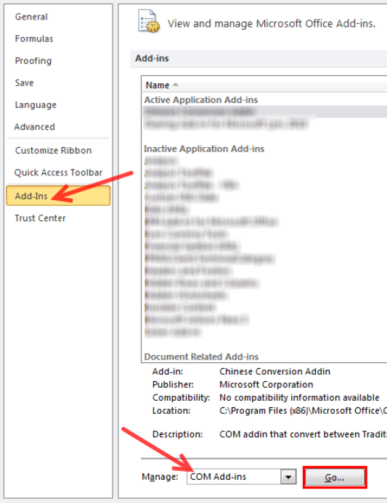
  - Select Analysis add-ins and Click [Remove].
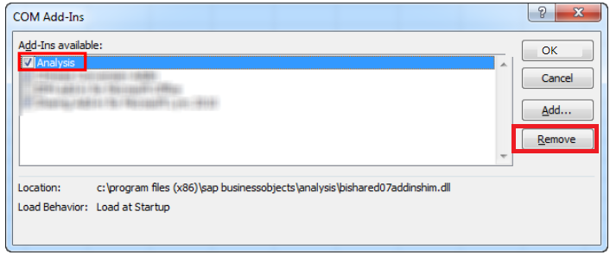

  - Click [Add] button.
  - Find [BiOfficeLauncher.exe] file at your installed directory.
    - Office 64bit User - C:\Program Files\SAP BusinessObjects\Office AddIn
    - Office 32bit User - C:\Program Files (x86)\SAP BusinessObjects\Office AddIn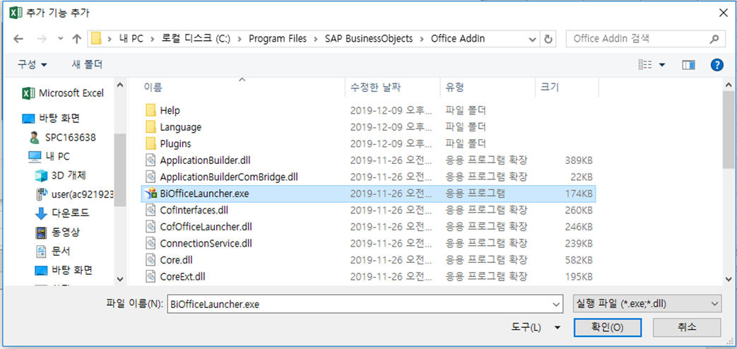
  - Analysis add-ins will be added. Check analysis option and Click [OK]. 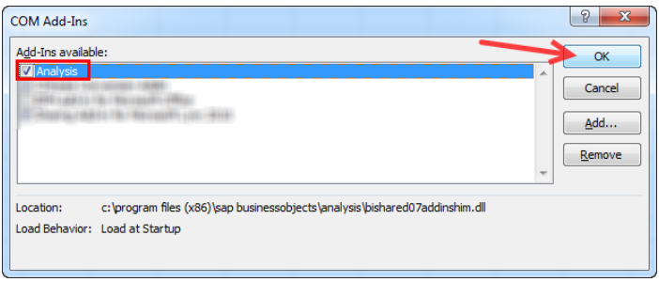

  - Quit all excel process.
  - Search & Execute [Analysis for Microsoft Excel] at windows menu.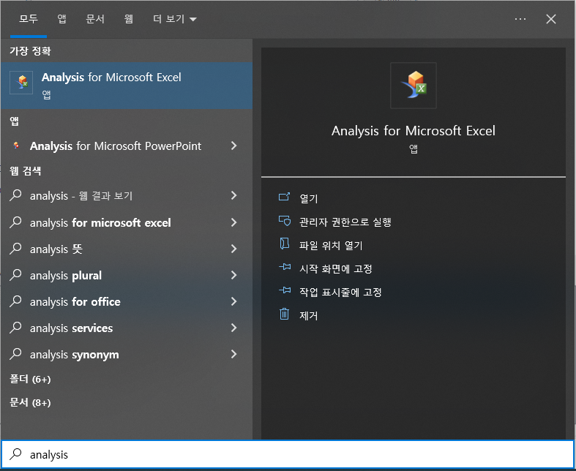
  - Analysis Add-ins will be loaded properly.
