How to resolve the issue when the contents of resignation process menu is not visible in e‑HR.
- T-Code/ Function / Menus
Application | Menu/Function/T-code Name | Description
e-HR | e-HR > My HR > Resignation | Resignation process
- Executives and execution status
  - Executives – When you want to find resignation process on e-HR.
  - execution status – not able to find resignation process on e-HR>My HR.
  - Keywords
    - “I would like to check the resignation process in e‑HR.”
    - “The Resignation process is not visible in e-HR”
- The solution
  - Menu: e-HR > My HR > Resignation
- This is a web screen used for managing resignation letters and resignation processes. The following steps describe how to find resignation process on e-HR.
- You should apply resignation letter in advance to show up resignation process.
    - Execute e-HR screen.
    - Log on with accounts that resignation process should be processed.
    - Access to My HR (Upper Menu Tab) > Resignation (Left Sidebar) > Letter of resignation (Sub Menu).
    - Press “Request approval” button on right side of the screen and then resignation process will be proceeded and founded.
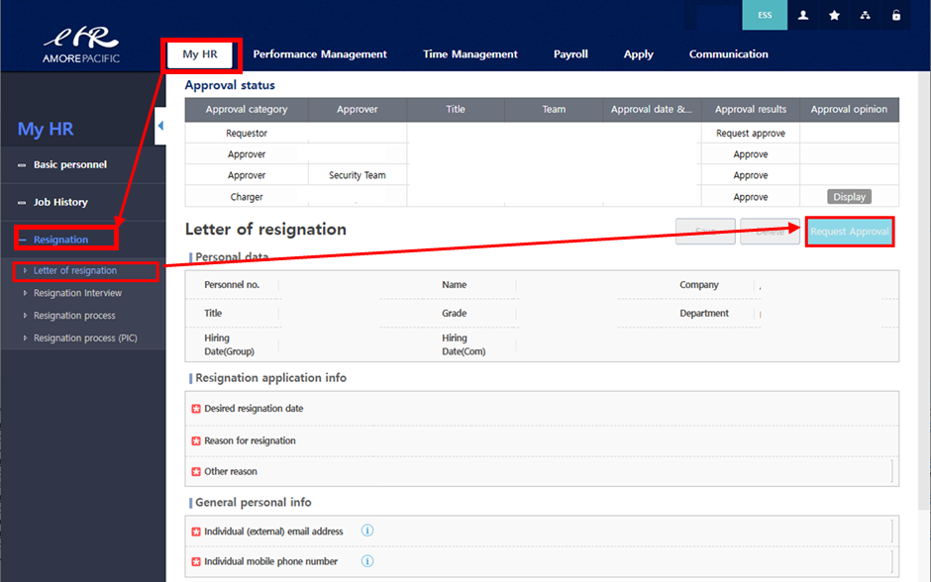
    - After completing the steps above, you can confirm that the content is displayed correctly in the 'Resignation Process' sub menu.
