MM_[India Only] How to set up tax for purchase orders in the India

T-Code/Function/Menu
Applications | Menu/Function/T-Code Name | explanation
SAP-MM | ME21N | Create Purchase Order
- Scenarios
  - Question Types ( India only)
    - “In ME21N, the PO item’s Conditions tab shows a tax rate different from the one that was intended.”
    - “Where do I view or maintain the tax classification code in the material master?”
    - “In ME21N, which tab is used for tax determination for the PO item?”
  - Error Message ( India only)
    - When using T-code ME21, an error message “Material not maintained by purchasing” occurs.
    - Even if the tax is maintained at 12% in T-code ME21, it continues to be displayed as 18% in the Conditions.
- Cause
  - Both of the following conditions must be satisfied for the tax information to be displayed correctly in the PO.
- 1) the tax code should be created by the Accounting department
- 2) the tax classification code maintained in the material master sales view. You can check using transaction code MM03 at the Sales org. 1 view
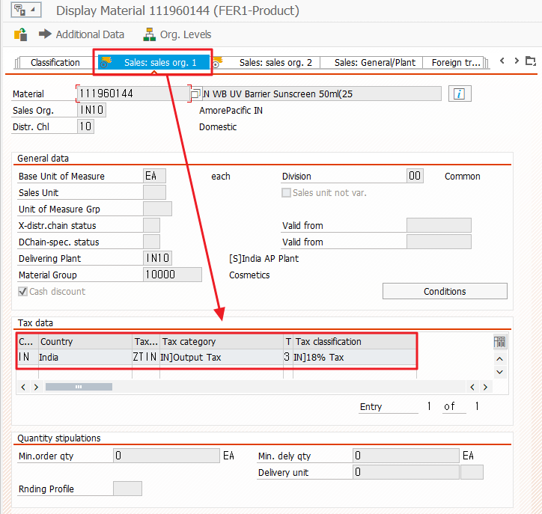
In this case, although the tax code was generated(1), the second condition was not met, resulting in an error message. Therefore, the Tax Classification must be adjusted.
- Solution
  - When setting up taxes for purchase orders in the India subsidiary specifically, you should first check the material master.
  - Correct the tax rate
    - Execute Transaction Code MM02
    - Move “Sales: Sales Org. 1”(①) tab for the material.
    - In “Tax data” window, Change the Tax classification② from “3” (18%) to “2” (12%).(this is for example)
    - Save progress by clicking save button③.
